**Github Actions 2023**

## Maximilian Schwarzmüller

**https://www.udemy.com/course/github-actions-the-complete-guide/?couponCode=D_0823**

Contents

Maximilian Schwarzmüller 1

What is GitHub 3

Git commands 5

Github Actions Fundamentals 6

First workflow 7

Events (Work Triggers) 9

Actions 9

Checkout 9

Runners 10

Install dependencies & run tests 11

Expressions & Context Objects 13

Module Summary 14

Time to Practice: The Problem 14

Time to Practice: Solution 15

Events: a closer look 17

Which Events Can You Use? 18

Introducing Event Filters & Activity Types 18

Using Activity Types 19

Using Event Filters 19

Special Behavior: Forks & Pull Request Events 20

Cancelling Workflows & Skipping Workflows 21

Module Summary 22

Job artifacts & output / caching 22

Understanding Job Artifacts 22

Uploading Job Artifacts 22

Downloading Artifacts (Manually & Automatically) 24

Understanding Job Outputs 26

Dependency Caching 28

Module Summary 30

Environment Variables & Secrets 30

Controlling Execution Flow 33

Controlling Execution via "if" 34

Working with Special Conditional Functions 35

Conditional Jobs 36

More "if" Examples 37

Ignoring Errors & Failures with "continue-on-error" 37

Understanding & Using Matrix Strategies 38

Including & Excluding Values (Matrix Strategy) 39

Saving Time & Code with Reusable Workflows 40

Adding Inputs to Reusable Workflows 41

Reusable Workflows & Secrets 42

Reusable Workflows Outputs 42

Module Summary 43

Using Containers 44

What Are Containers? 44

Adding Services (via Service Containers) 46

Communication between Jobs & Service Containers 46

Module Summary 48

Building Custom Actions 48

Why Custom Actions? 49

Understanding Different Types of Custom Actions 49

Creating Composite Actions 49

Using Custom Actions In Workflows 50

Adding Inputs to Custom Actions 51

Adding Outputs to Custom Actions 52

Custom JavaScript Actions 53

Creating a Custom Docker Action 55

Module Summary 57

Permissions & Security 57

Key Security Concerns 58

Undestanding Script Injection Attacks 58

Increasing Actions Safety 61

Understanding Permissions & Potential Issues 61

GITHUB_TOKEN & Managing Permissions 63

More Security Settings 65

Working with Third-Party Permissions & OpenID Connect 66

Example: AWS Permissions 67

# What is GitHub

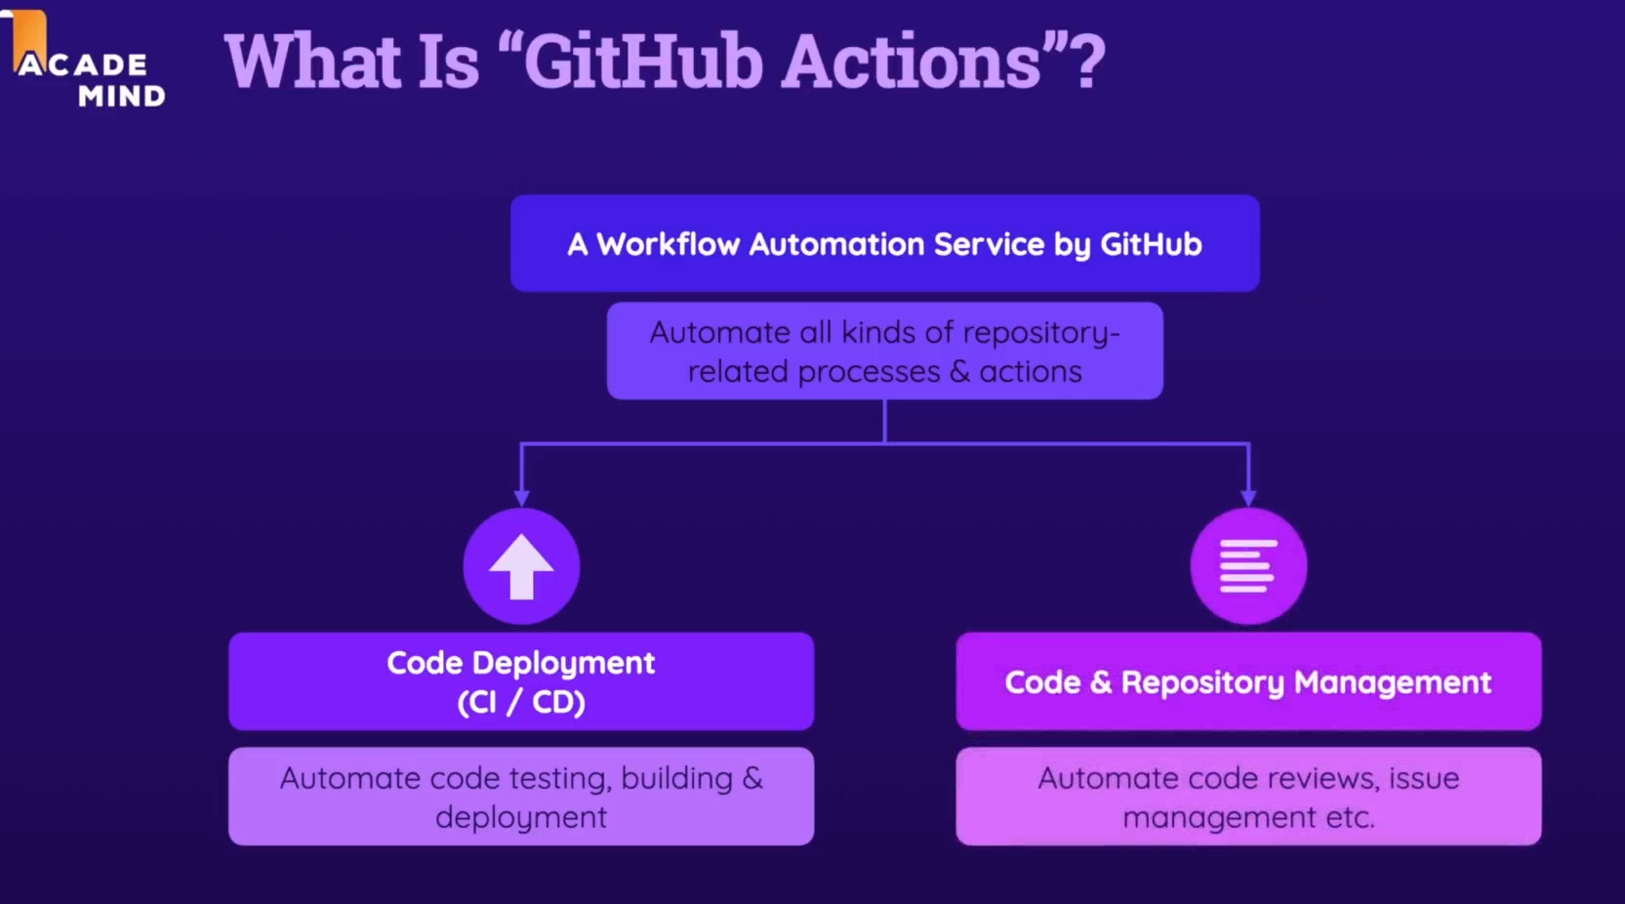

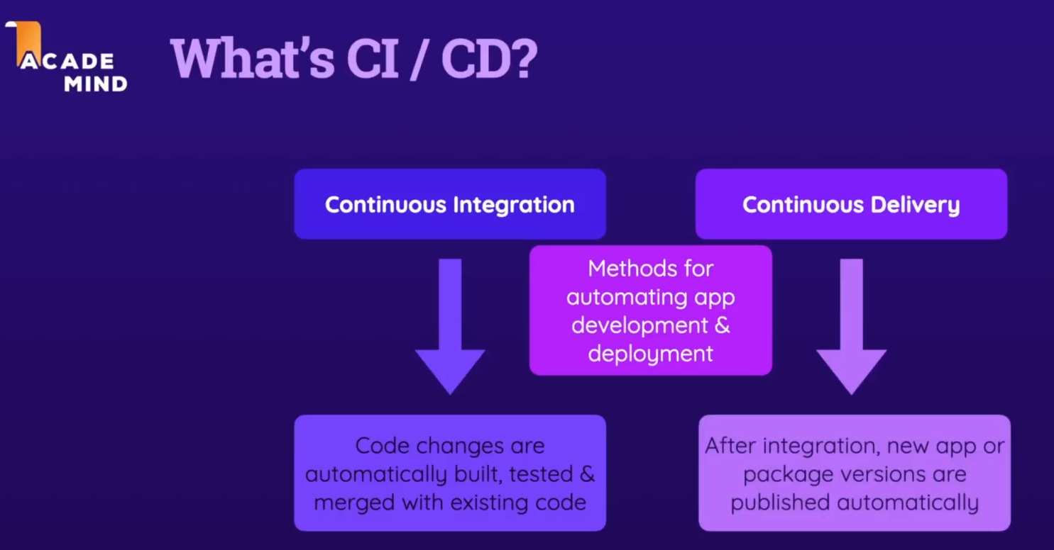

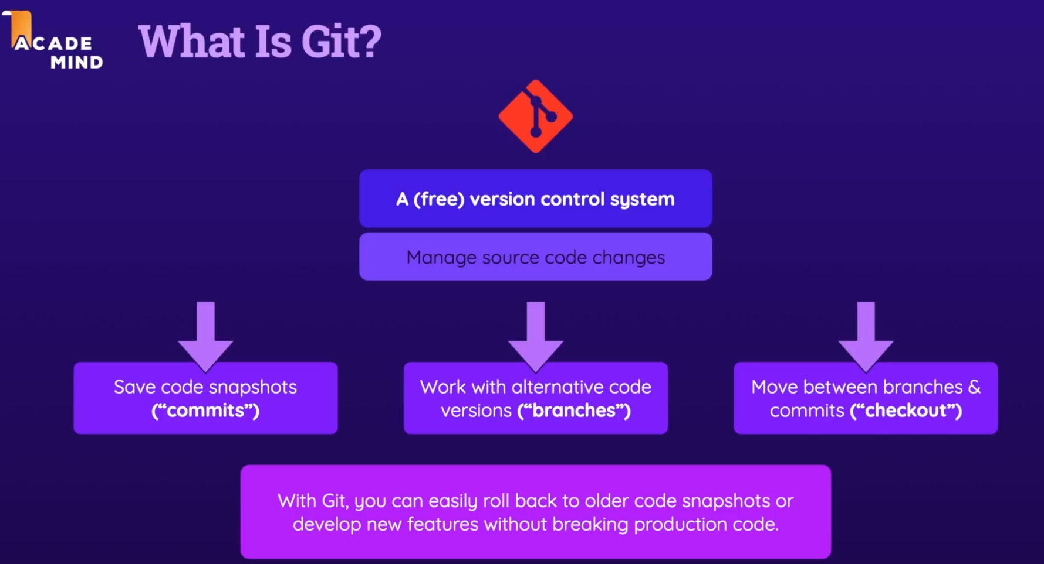

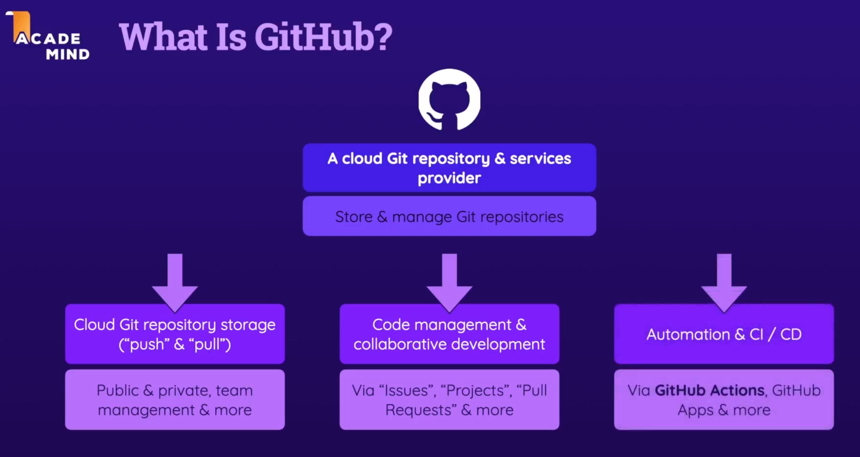

# Git commands

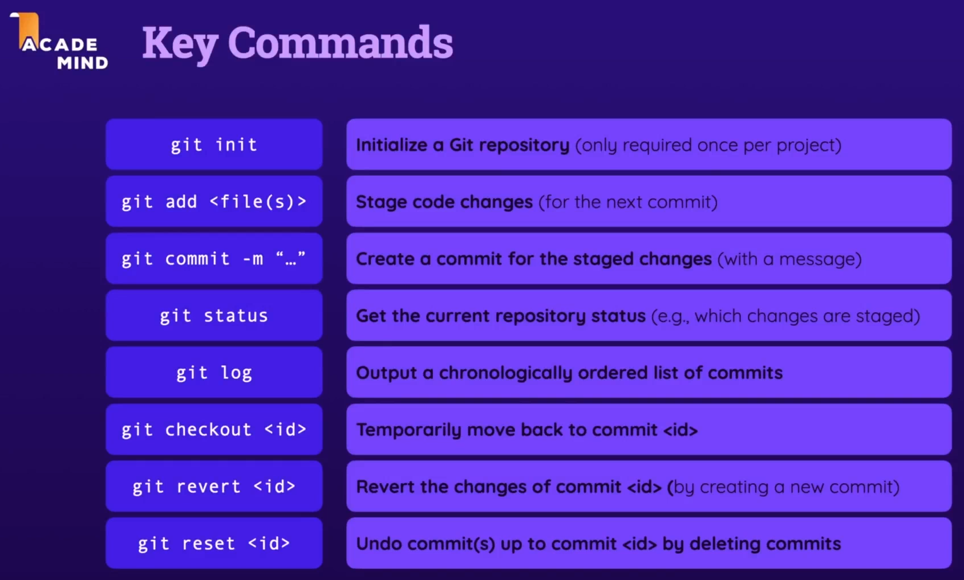

Git branch <name>

Git checkout -b <name>

Delete branch: `git branch -D <name>`

Git merge

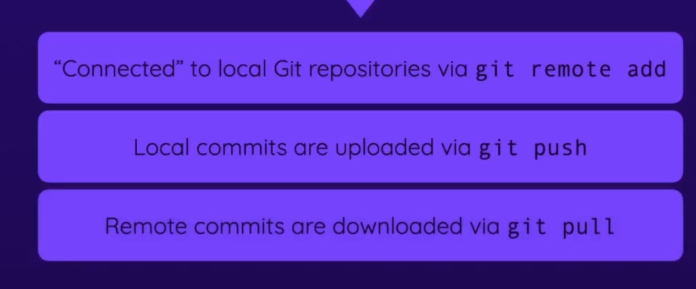



[GitHub markdown for readme file](https://docs.github.com/en/get-started/writing-on-github/getting-started-with-writing-and-formatting-on-github/basic-writing-and-formatting-syntax)

# Github Actions Fundamentals

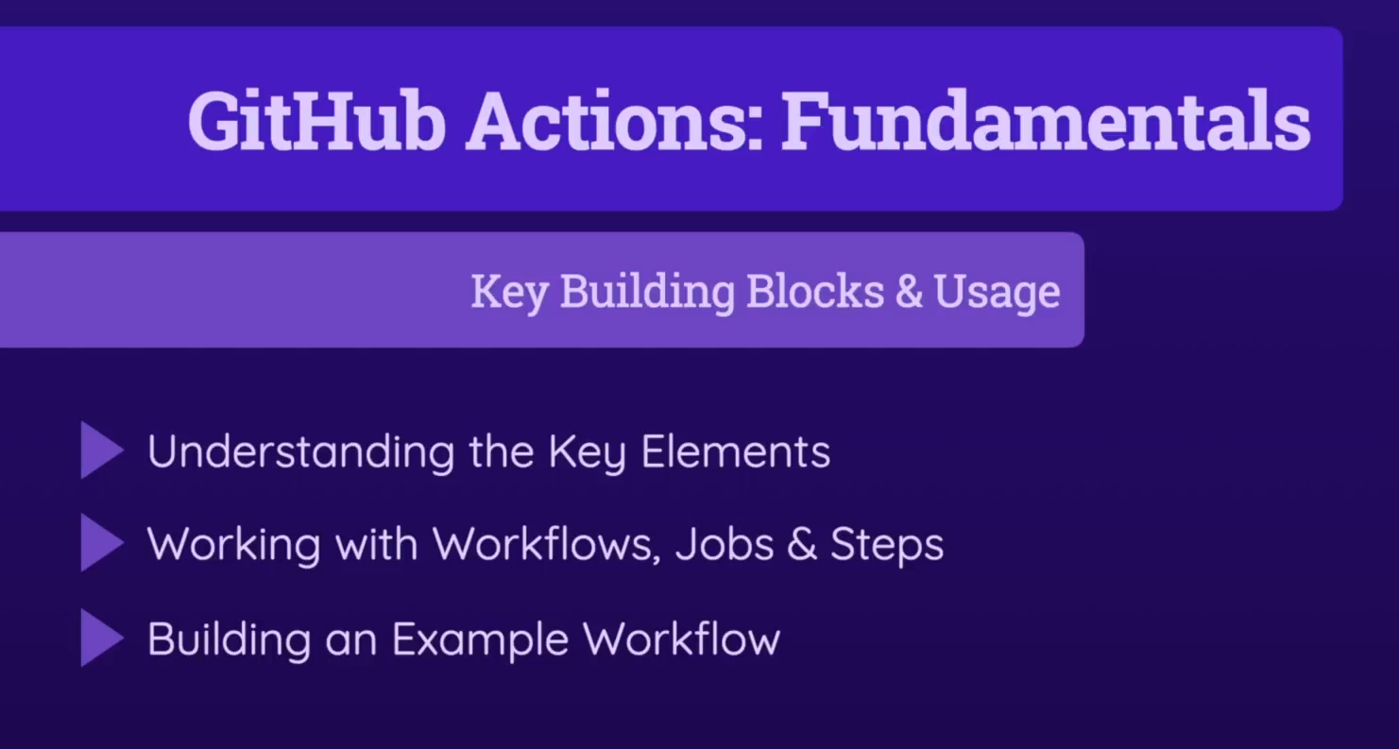

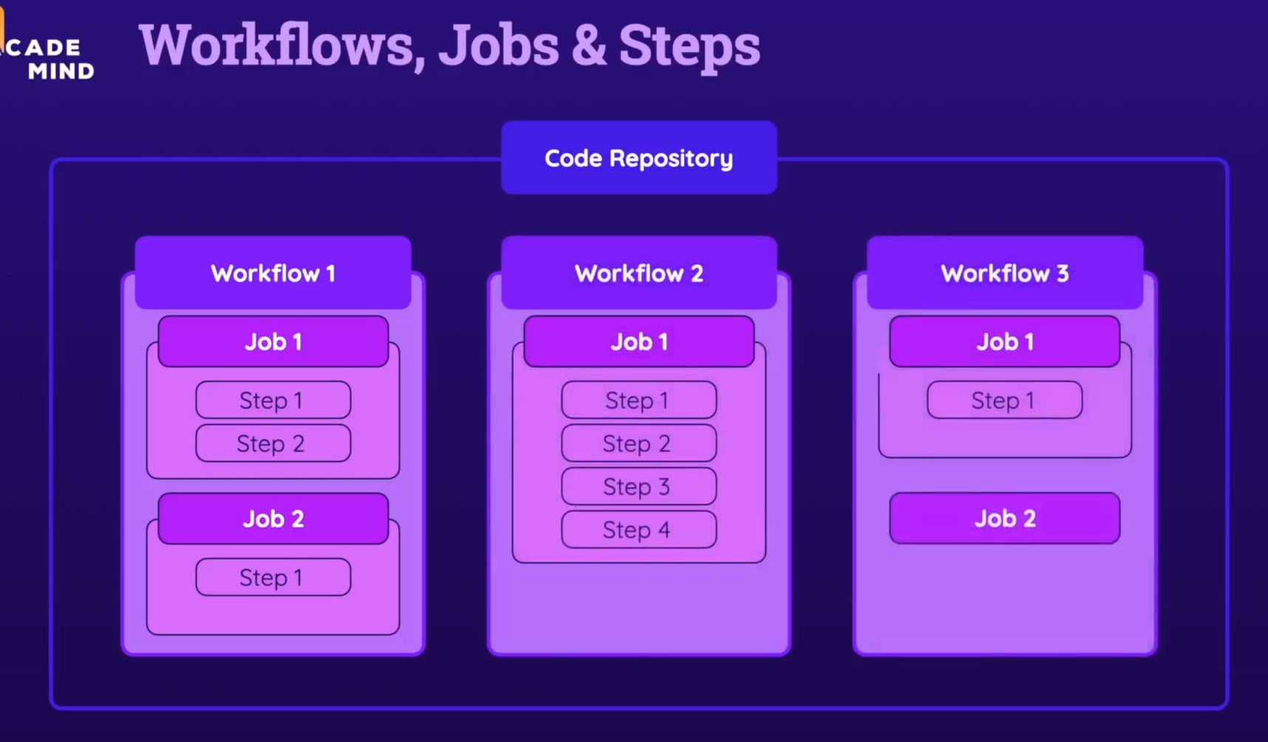

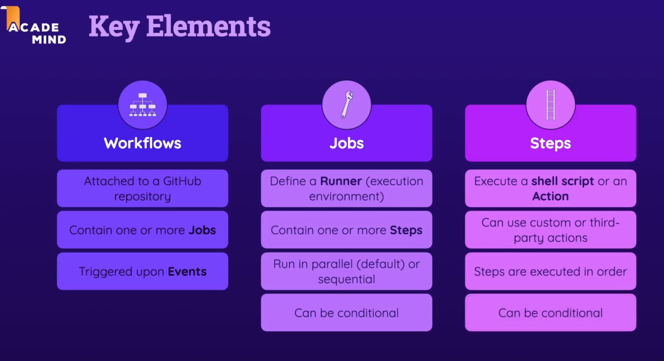

We are going to practice all in this [rep](https://github.com/eyalbor/learn-git-actions)

## First workflow

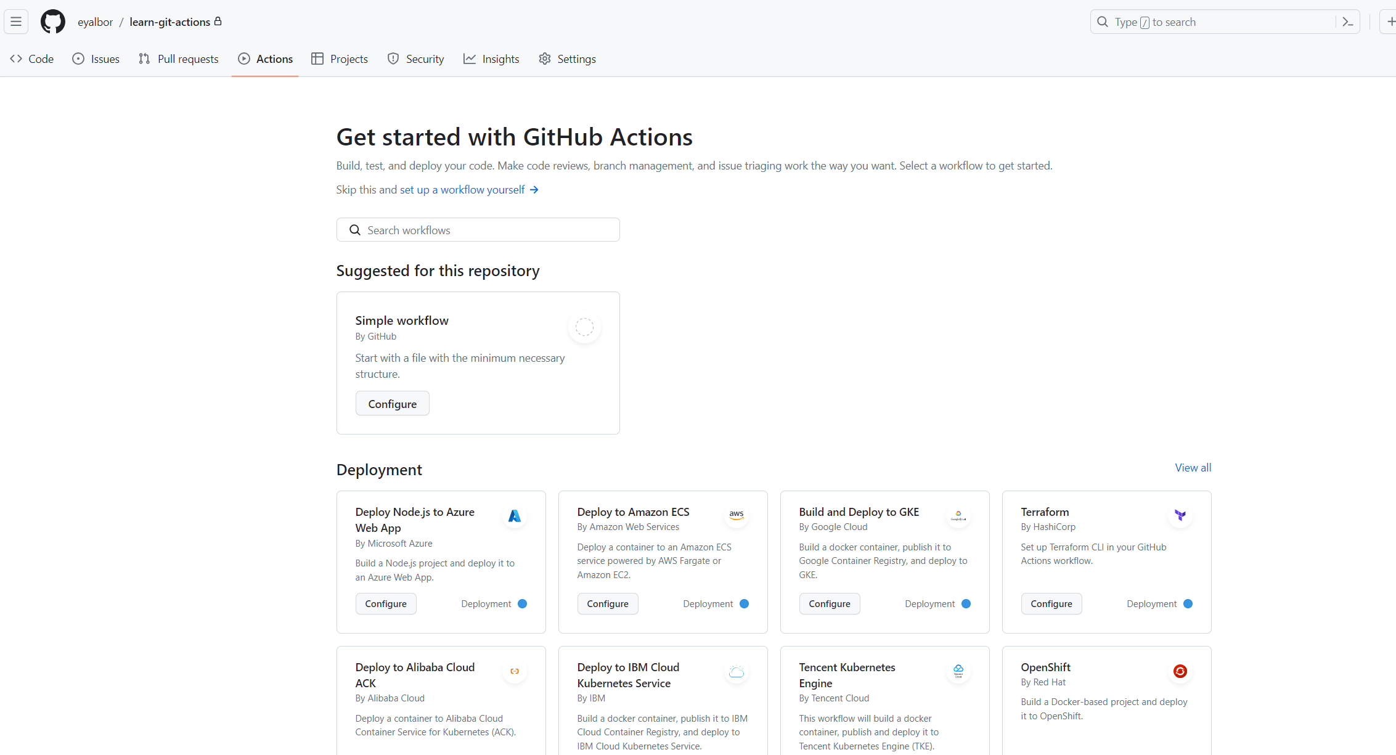

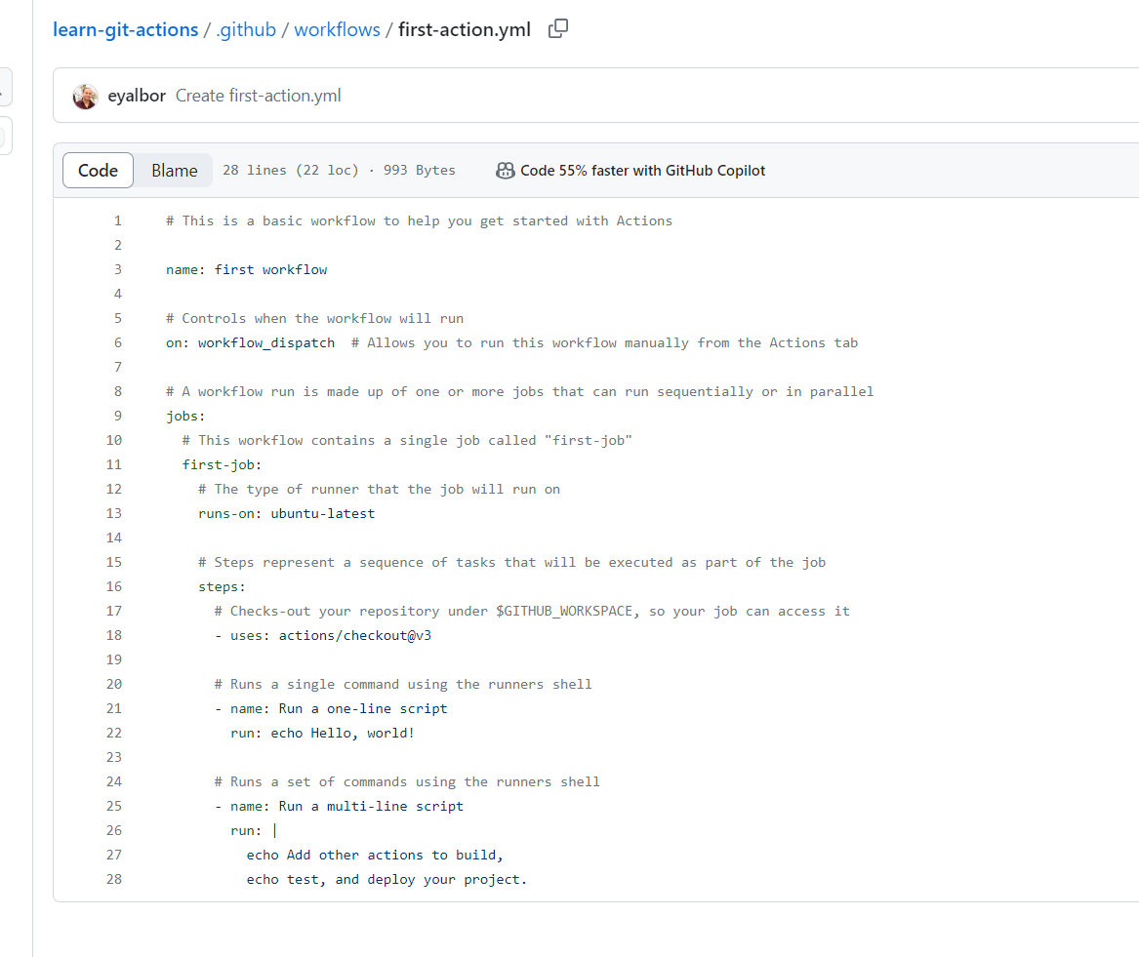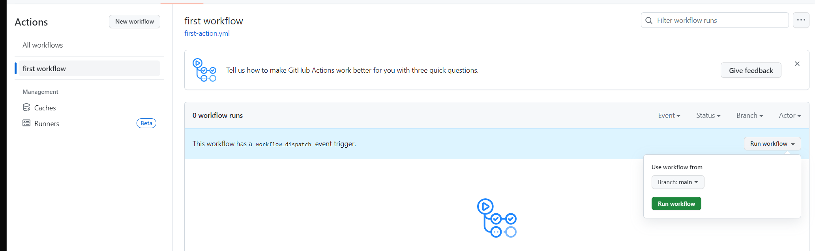

# Events (Work Triggers)

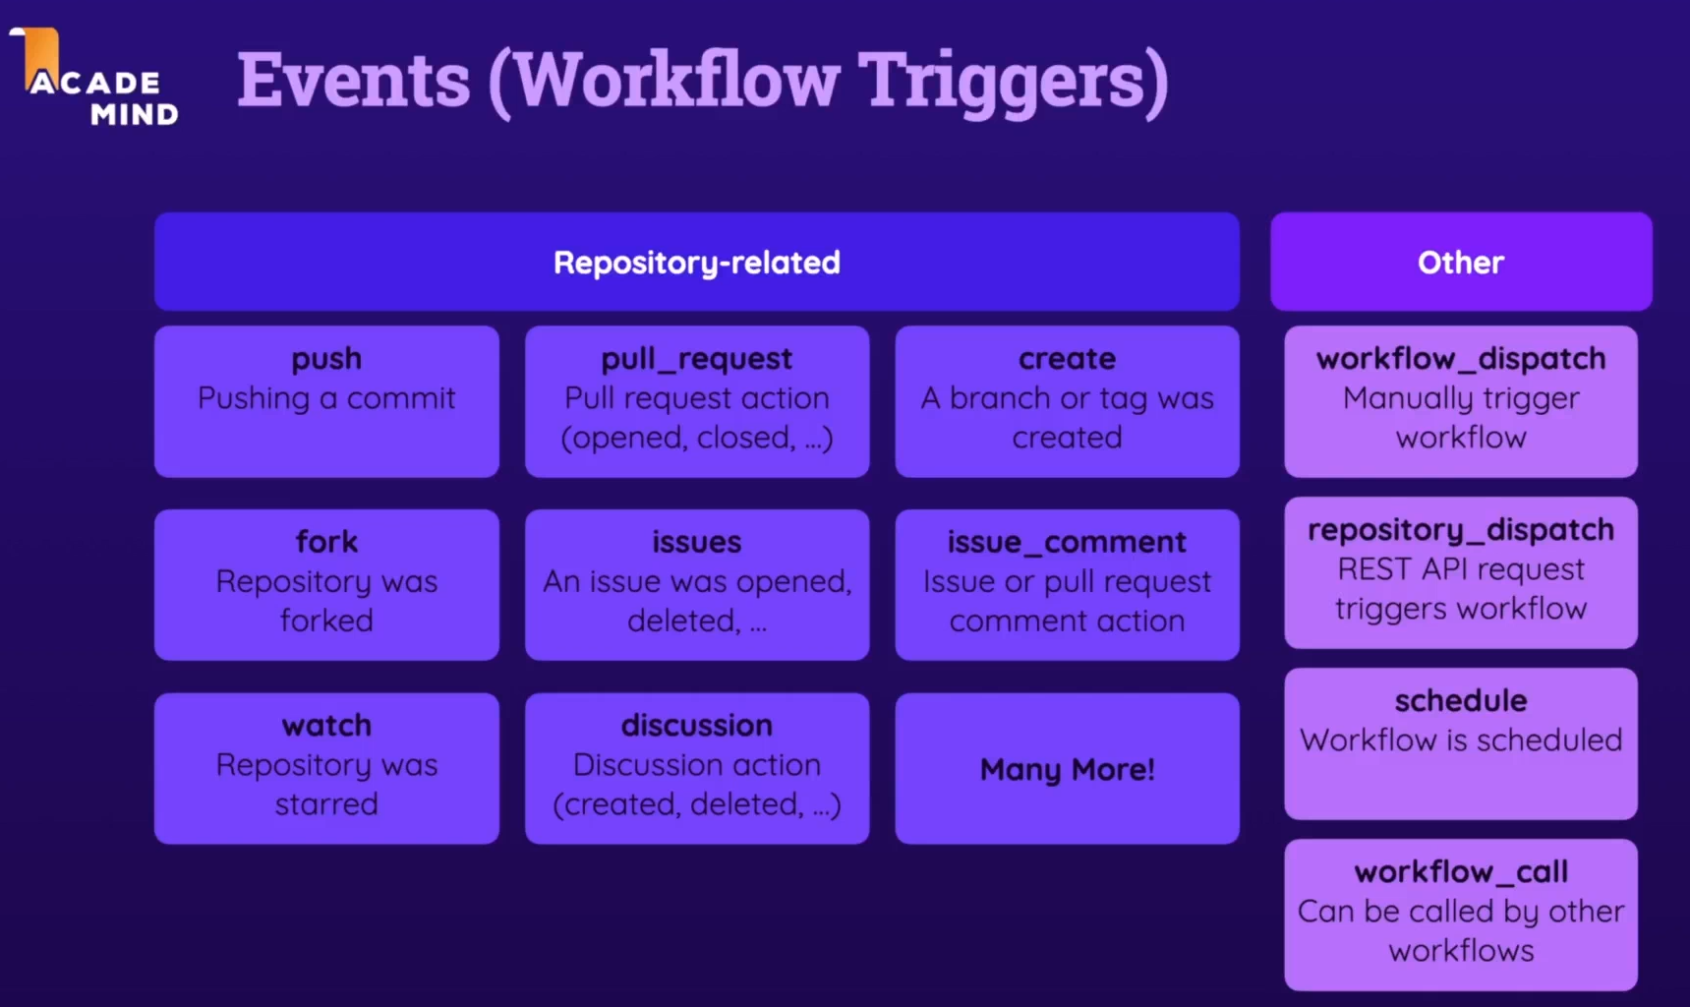

<https://docs.github.com/en/actions/using-workflows/events-that-trigger-workflows>

# [Actions](https://github.com/marketplace?type=actions)

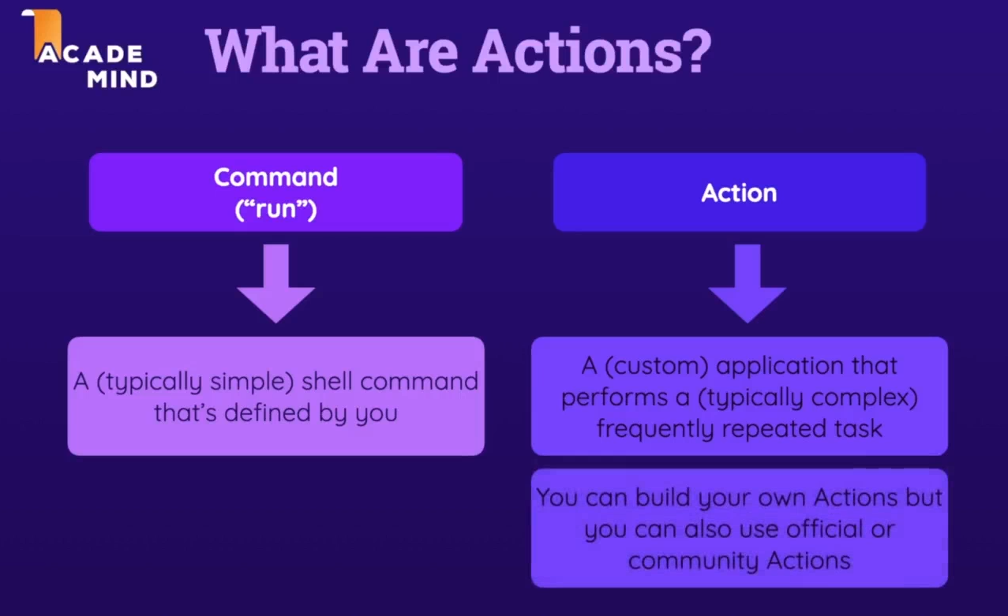

Checkout  
Git action [checkout](https://github.com/actions/checkout), [marketplace](https://github.com/marketplace/actions/checkout)

‘With’ keyword is for configuration

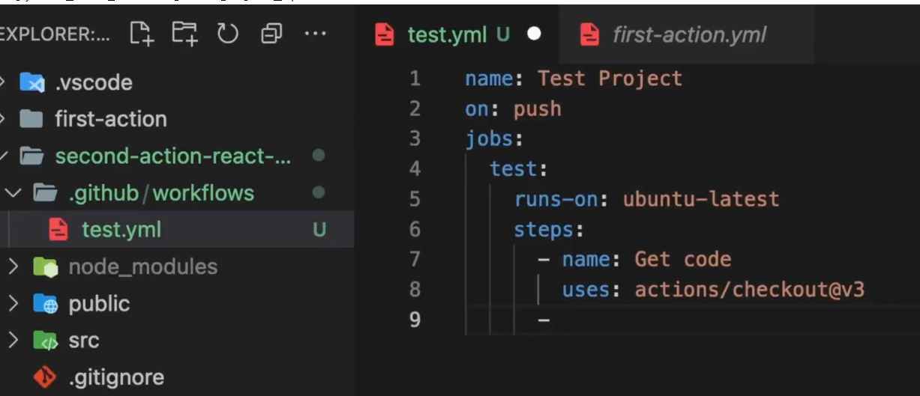

## Runners

Have some pre install packages like Ubuntu 22.04 have node 18, so we don’t need to install

<https://github.com/actions/runner-images/blob/main/images/linux/Ubuntu2204-Readme.md>

buy we can install it too if we want different version:

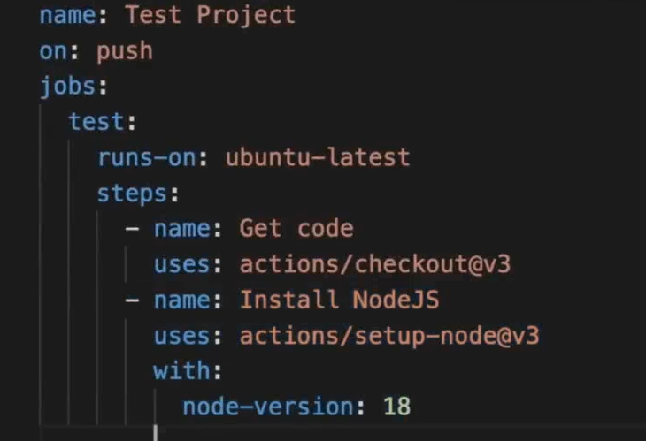

## Install dependencies & run tests

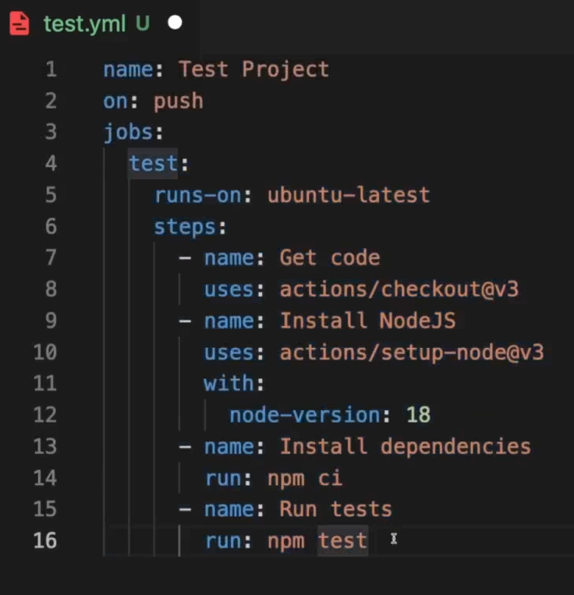

After we push the code the workflow runs:

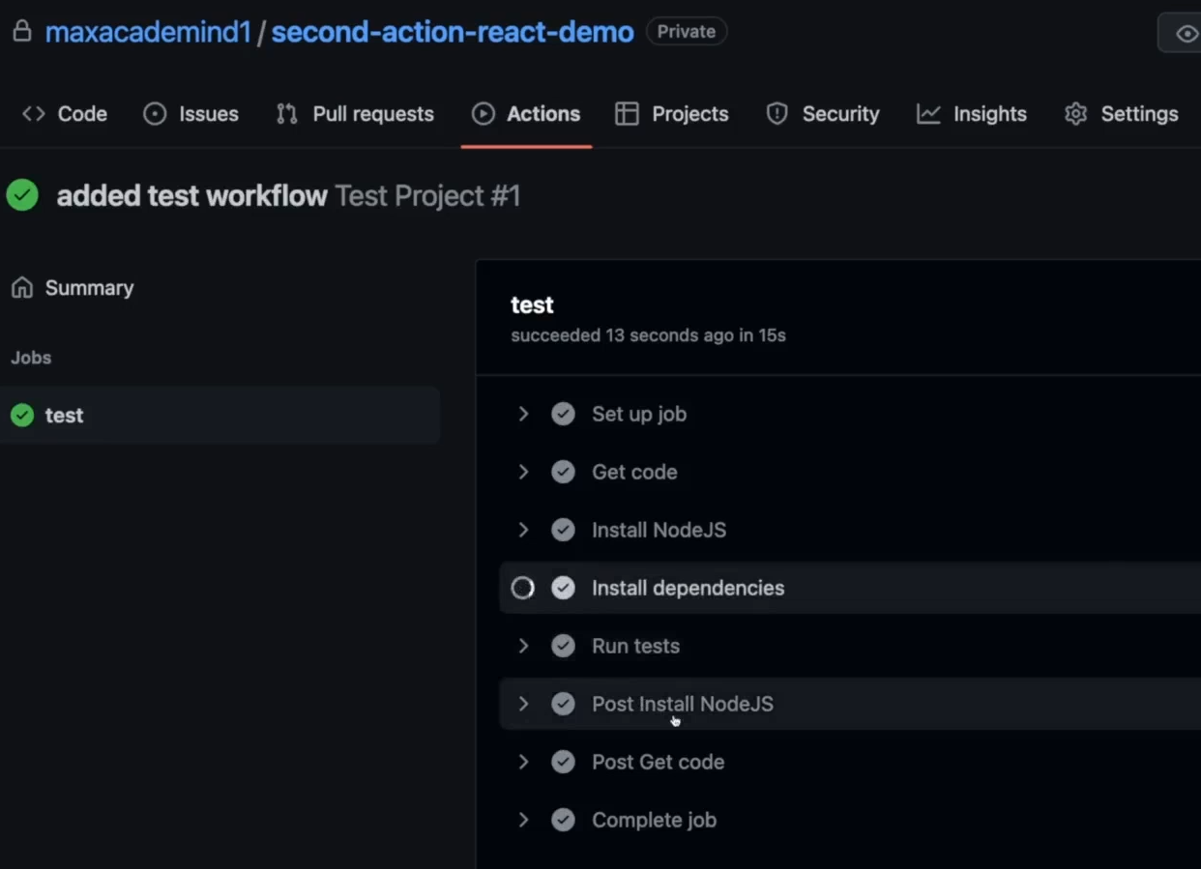

Adding Multiple Jobs

If we remove the need: test, the 2 jobs will run in **parallel**

name: Deploy Project

on: [push, workflow_dispatch]

jobs:

  test:

    runs-on: ubuntu-latest

    steps:

      - name: Get code

        uses: actions/checkout@v3

      - name: Install NodeJS

        uses: actions/setup-node@v3

        with:

          node-version: 18

      - name: Install dependencies

        run: npm ci

      - name: Run tests

        run: npm test

  deploy:

    needs: test

    runs-on: ubuntu-latest

    steps:

      - name: Get code

        uses: actions/checkout@v3

      - name: Install NodeJS

        uses: actions/setup-node@v3

        with:

          node-version: 18

      - name: Install dependencies

        run: npm ci

      - name: Build project

        run: npm run build

      - name: Deploy

        run: echo "Deploying ..."

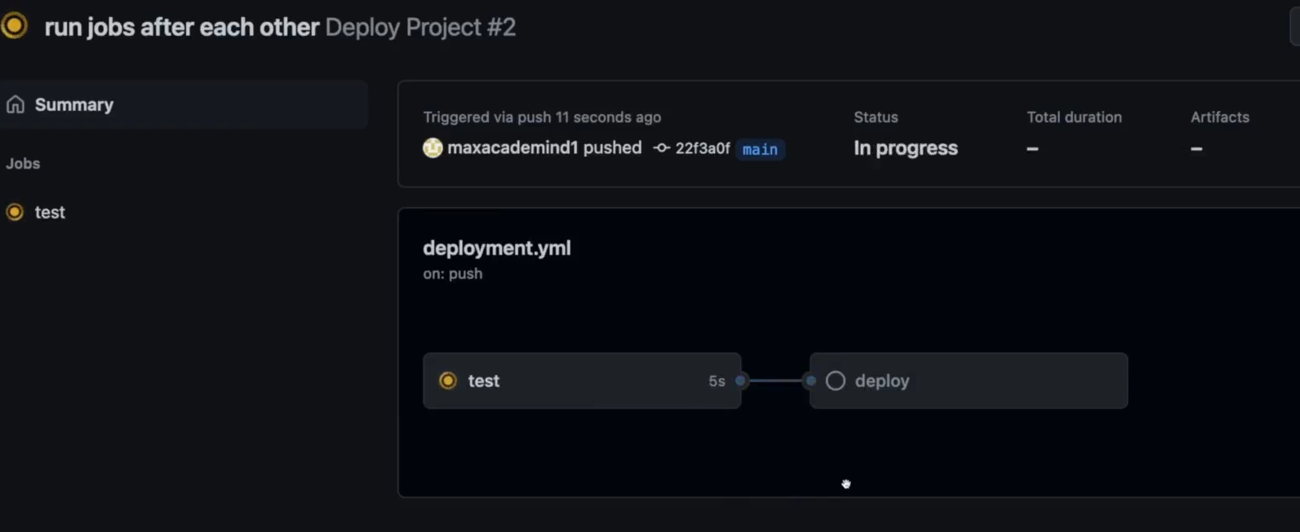

If the test job will fail, then the deploy job won’t started

Using Multiple Triggers (Events)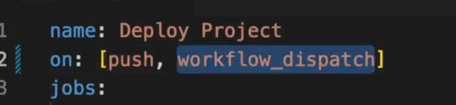

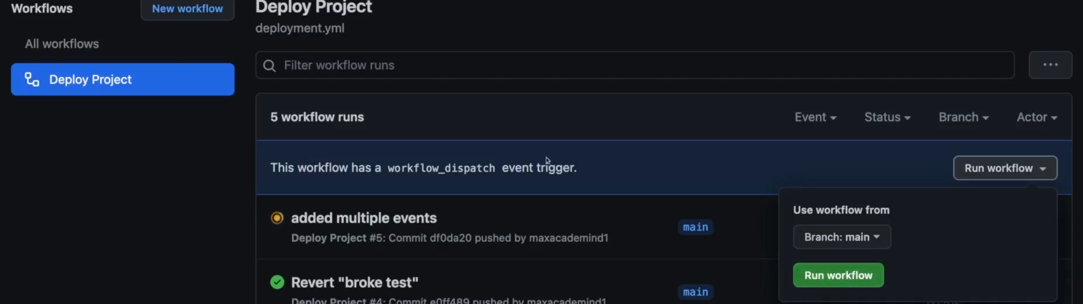

We can configure that this events, like only for push for specific branch a workflow will be trigger

## Expressions & Context Objects

name: Output information

on: workflow_dispatch

jobs:

  info:

    runs-on: ubuntu-latest

    steps:

      - name: Output GitHub context

        run: echo "${{ toJSON(github) }}"

<https://docs.github.com/en/actions/learn-github-actions/contexts>

<https://docs.github.com/en/actions/learn-github-actions/expressions>

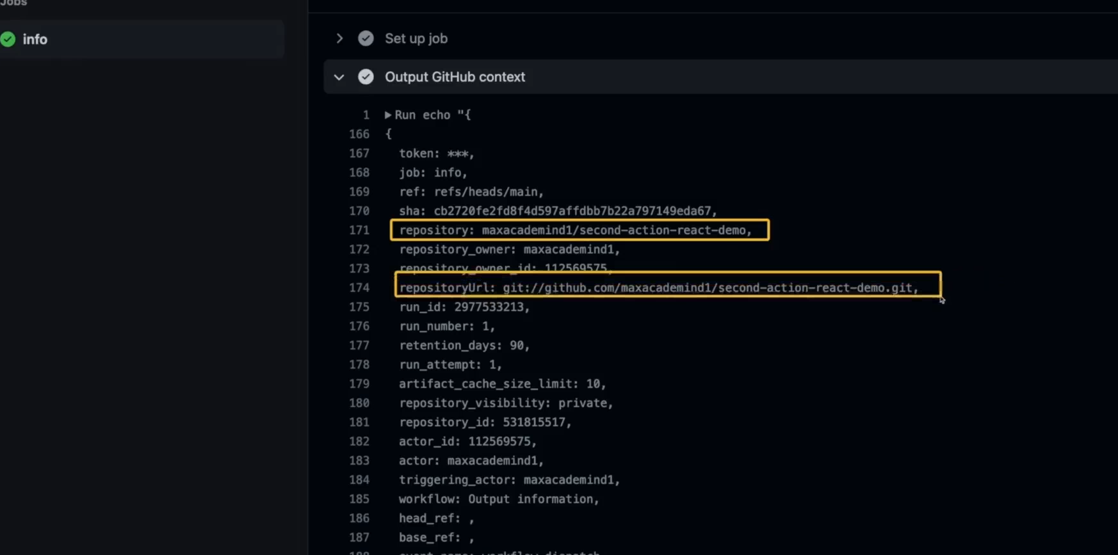

## Module Summary

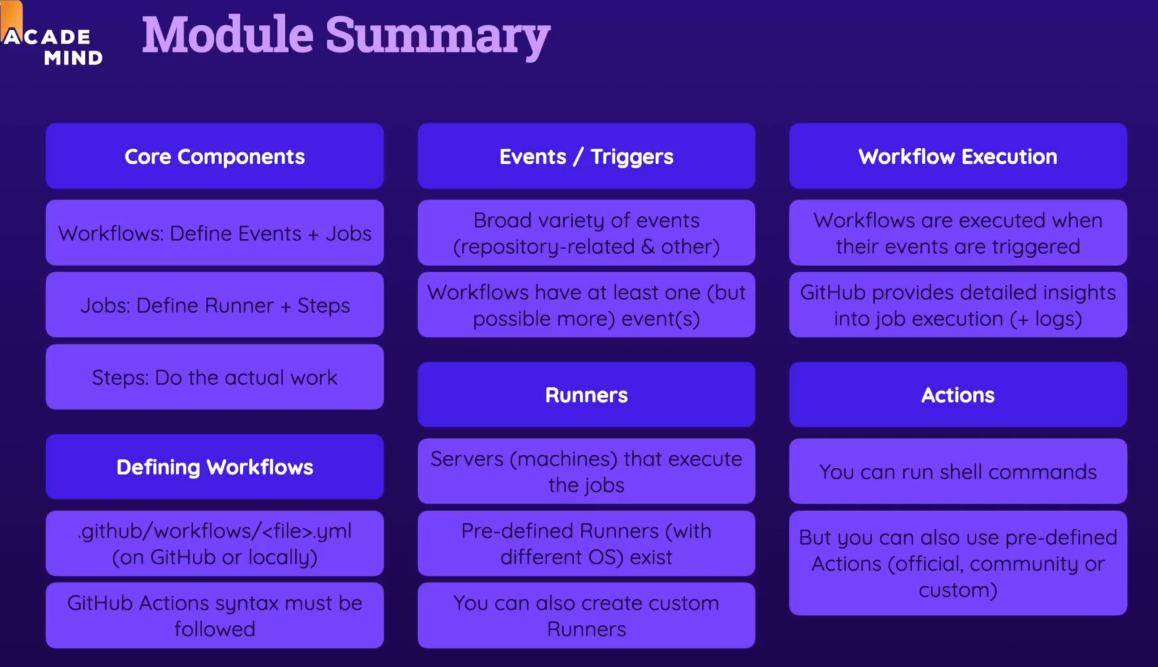

## Time to Practice: The Problem

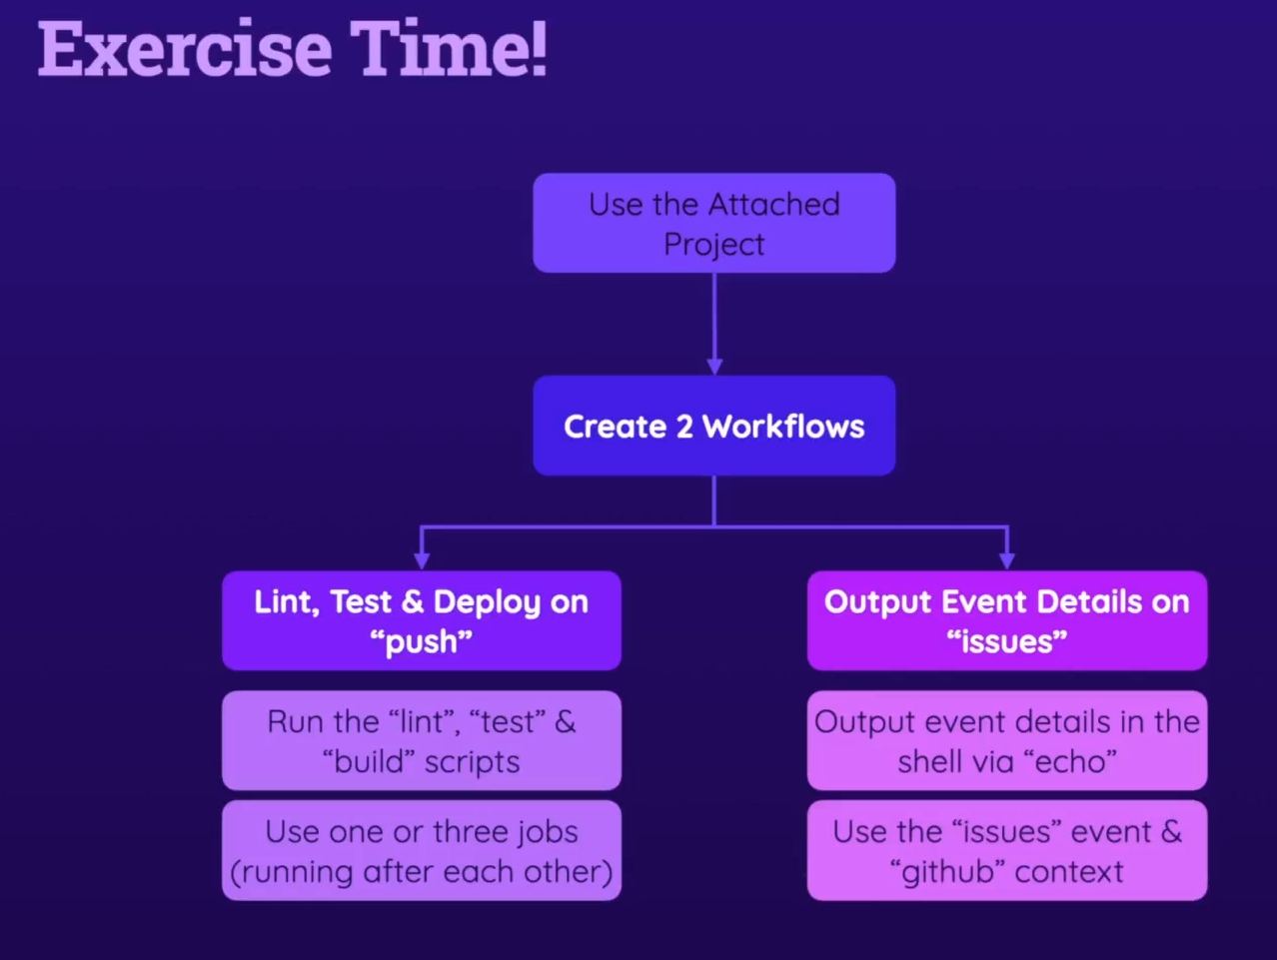

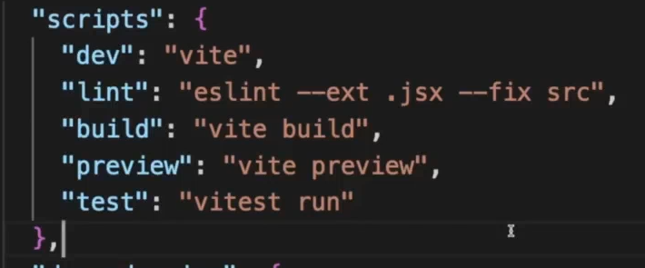

## Time to Practice: Solution

One job

name: Deployment Exercise 1

on: push

jobs:

  deploy:

    runs-on: ubuntu-latest

    steps:

      - name: Get code

        uses: actions/checkout@v3

      - name: Install dependencies

        run: npm ci

      - name: Lint

        run: npm run lint

      - name: Test code

        run: npm run test

      - name: Build code

        run: npm run build

      - name: Deploy code

        run: echo "Deploying..."

3 jobs

name: Deployment Exercise 2

on: push

jobs:

  lint:

    runs-on: ubuntu-latest

    steps:

      - name: Get code

        uses: actions/checkout@v3

      - name: Install dependencies

        run: npm ci

      - name: Lint

        run: npm run lint

  test:

    needs: lint

    runs-on: ubuntu-latest

    steps:

      - name: Get code

        uses: actions/checkout@v3

      - name: Install dependencies

        run: npm ci

      - name: Test code

        run: npm run test

  deploy:

    needs: test

    runs-on: ubuntu-latest

    steps:

      - name: Get code

        uses: actions/checkout@v3

      - name: Install dependencies

        run: npm ci

      - name: Build code

        run: npm run build

      - name: Deploy code

        run: echo "Deploying..."

issues

name: Handle issues

on: issues

jobs:

  output-info:

    runs-on: ubuntu-latest

    steps:

      - name: Output event details

        run: echo "${{ toJSON(github.event) }}"

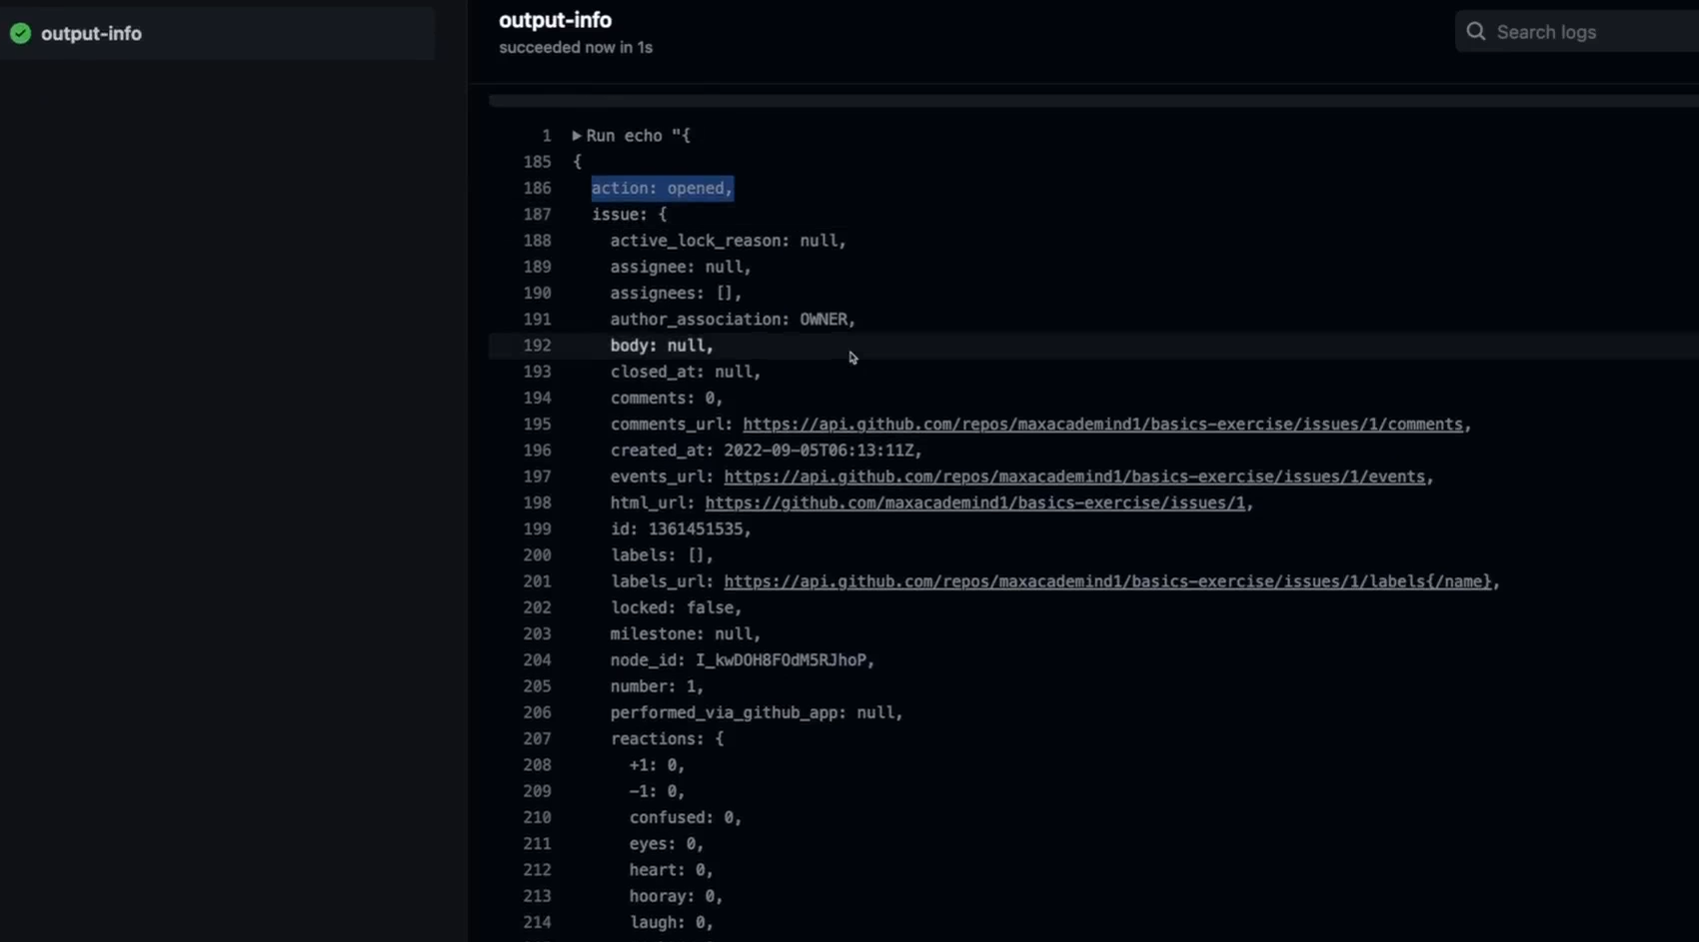

# Events: a closer look

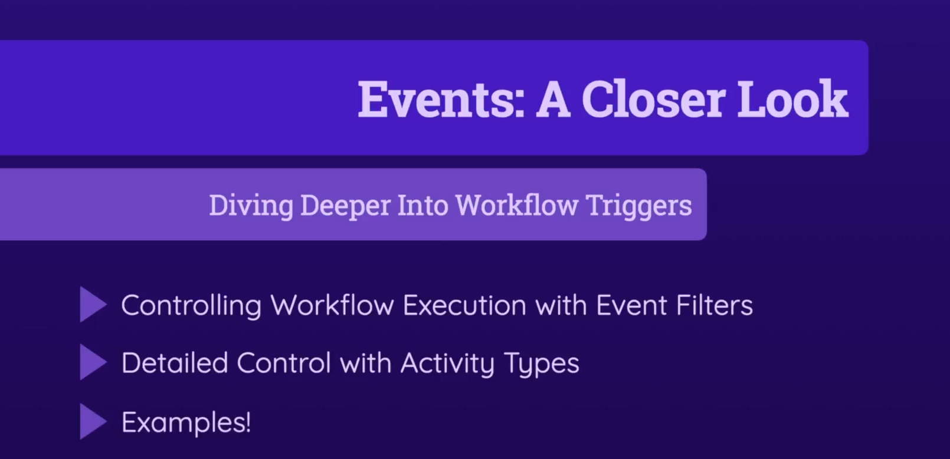

## Which Events Can You Use?

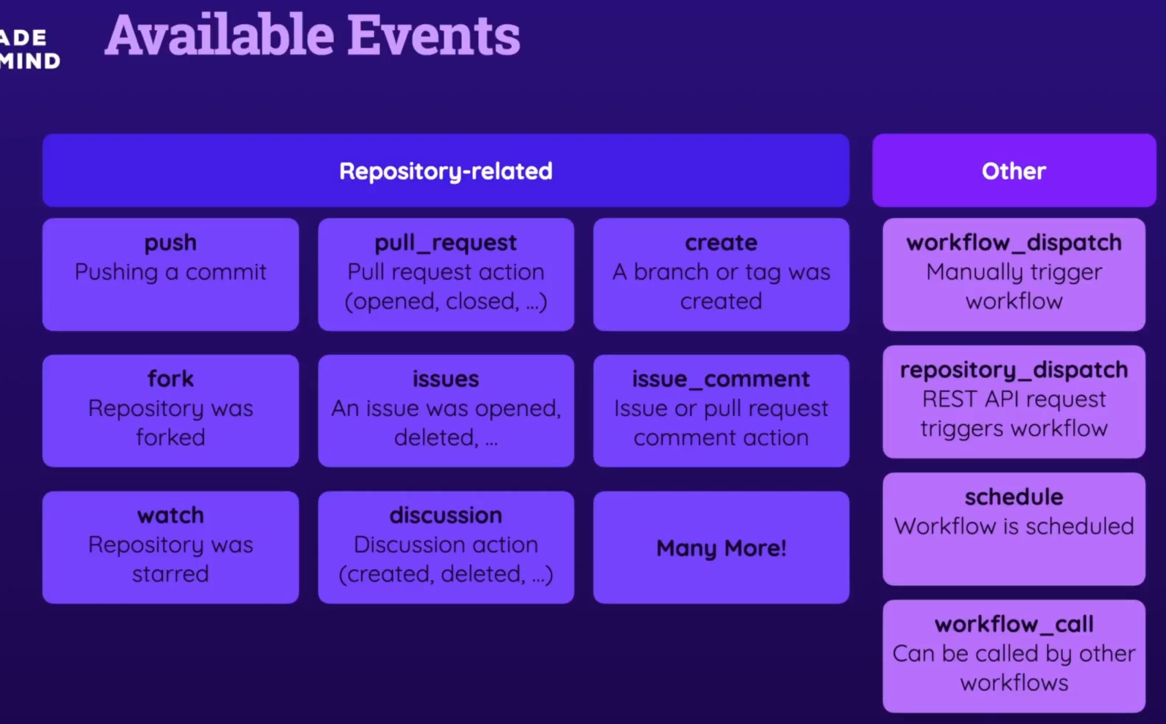

<https://docs.github.com/en/actions/using-workflows/events-that-trigger-workflows>

## Introducing Event Filters & Activity Types

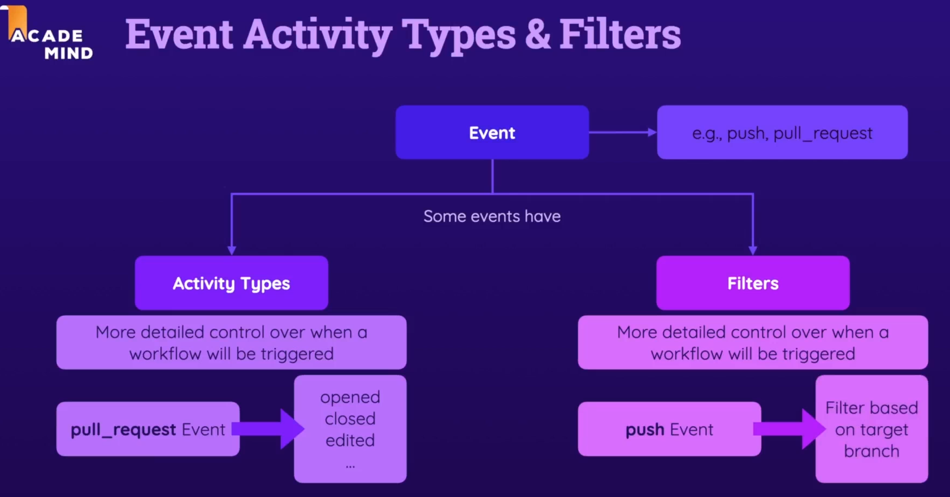

## Using Activity Types

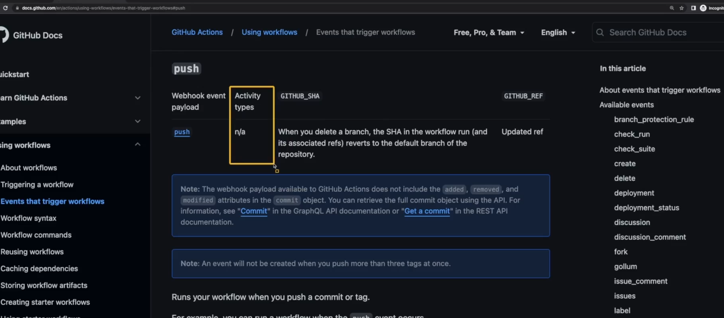

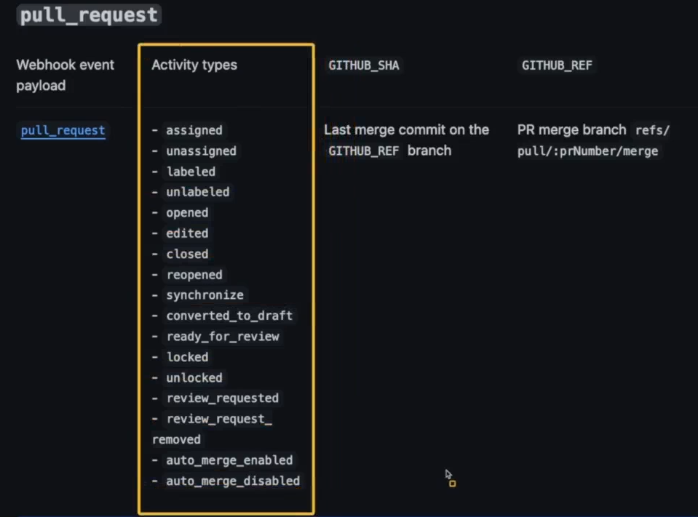

## Using Event Filters

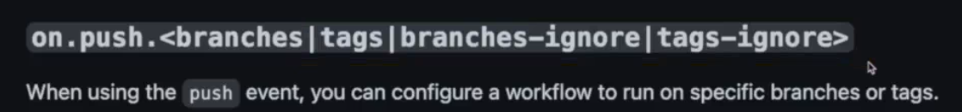

<https://docs.github.com/en/actions/using-workflows/workflow-syntax-for-github-actions>

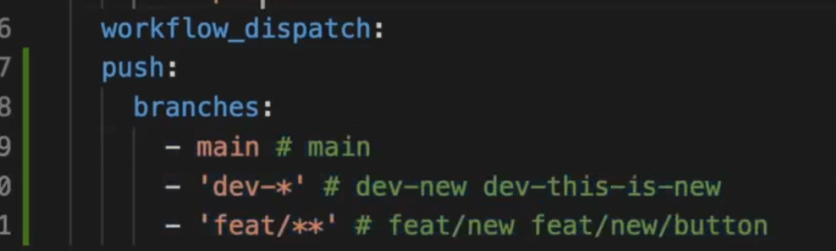

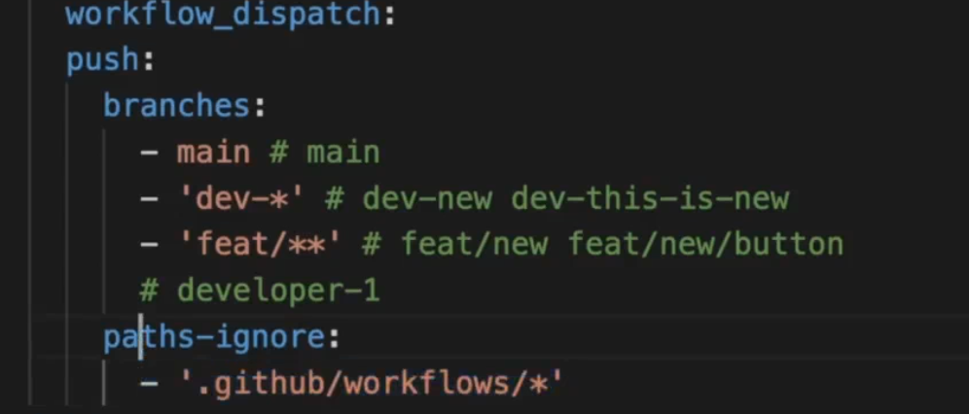

## Special Behavior: Forks & Pull Request Events

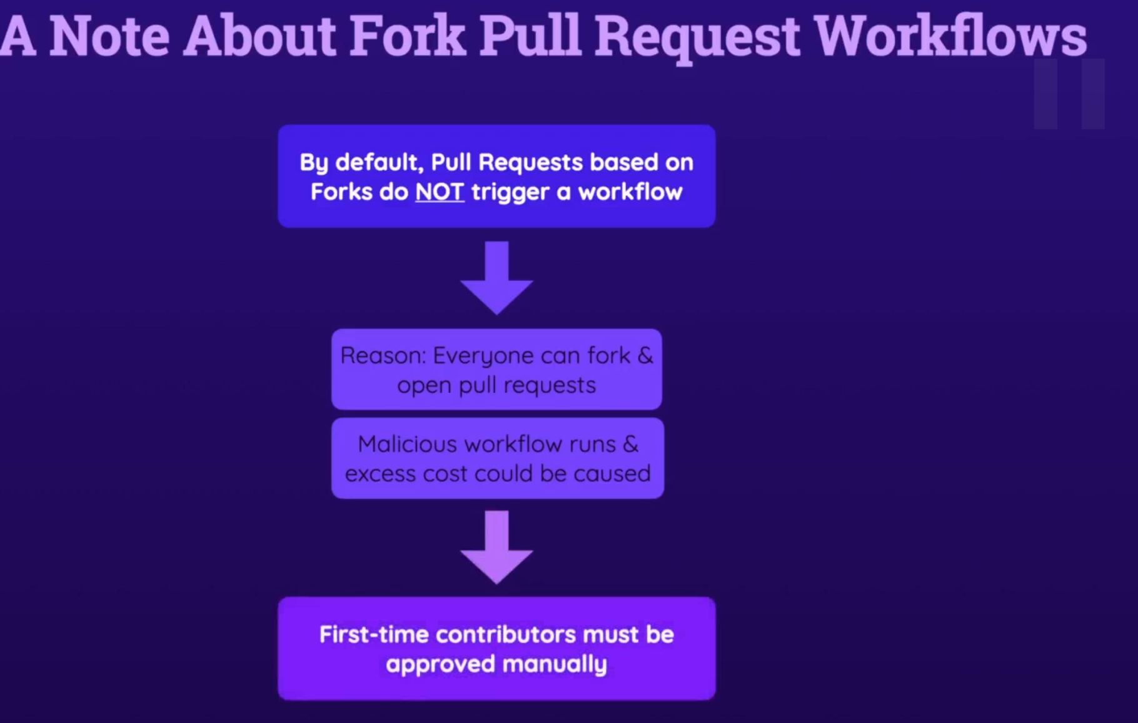

## Cancelling Workflows & Skipping Workflows

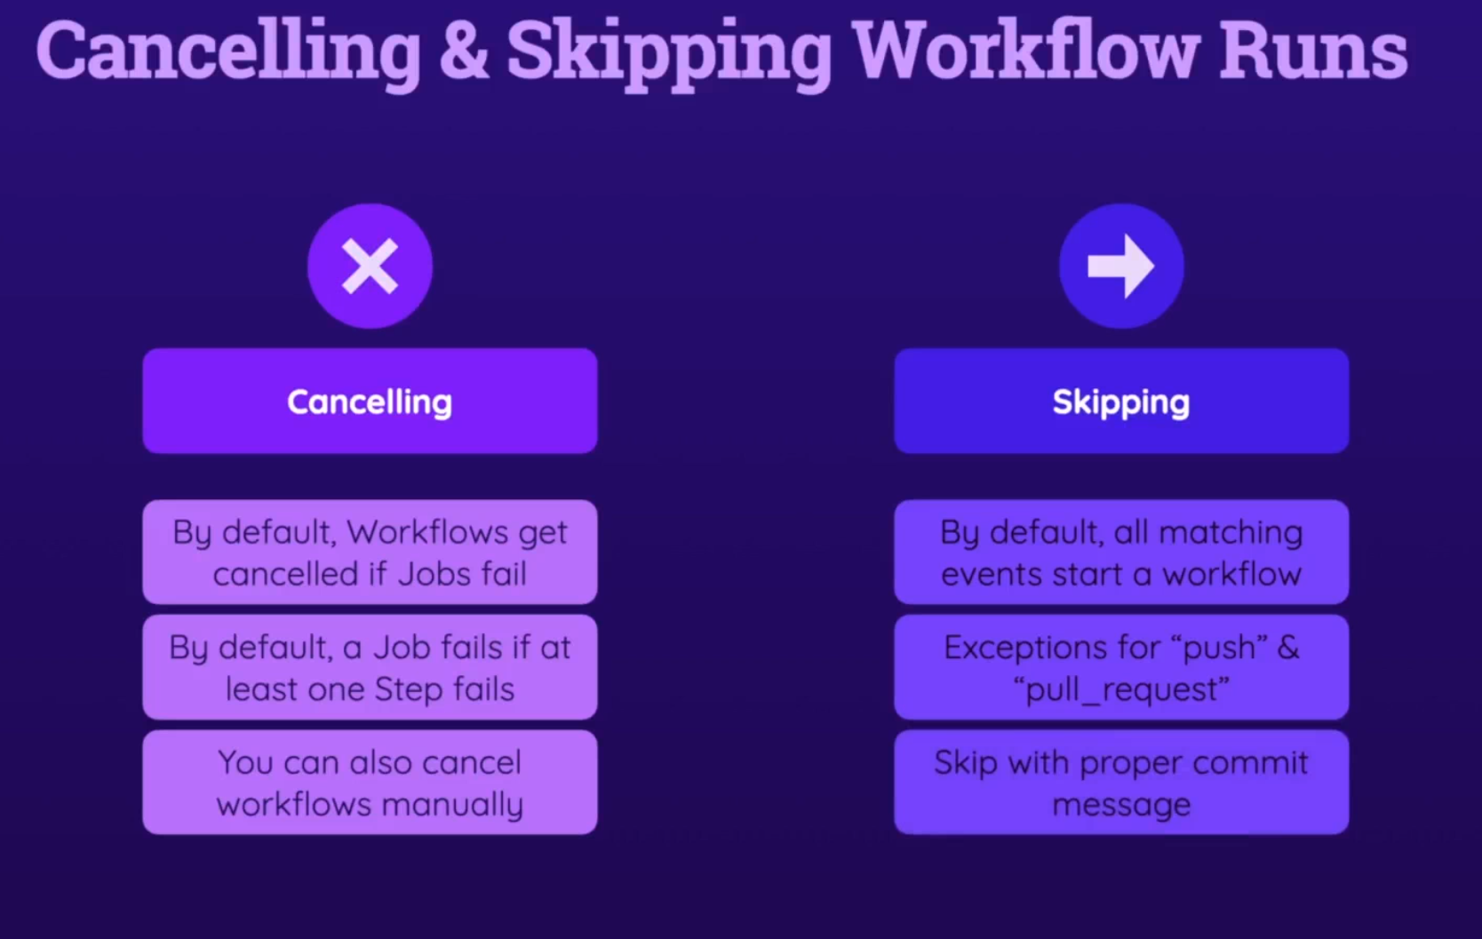

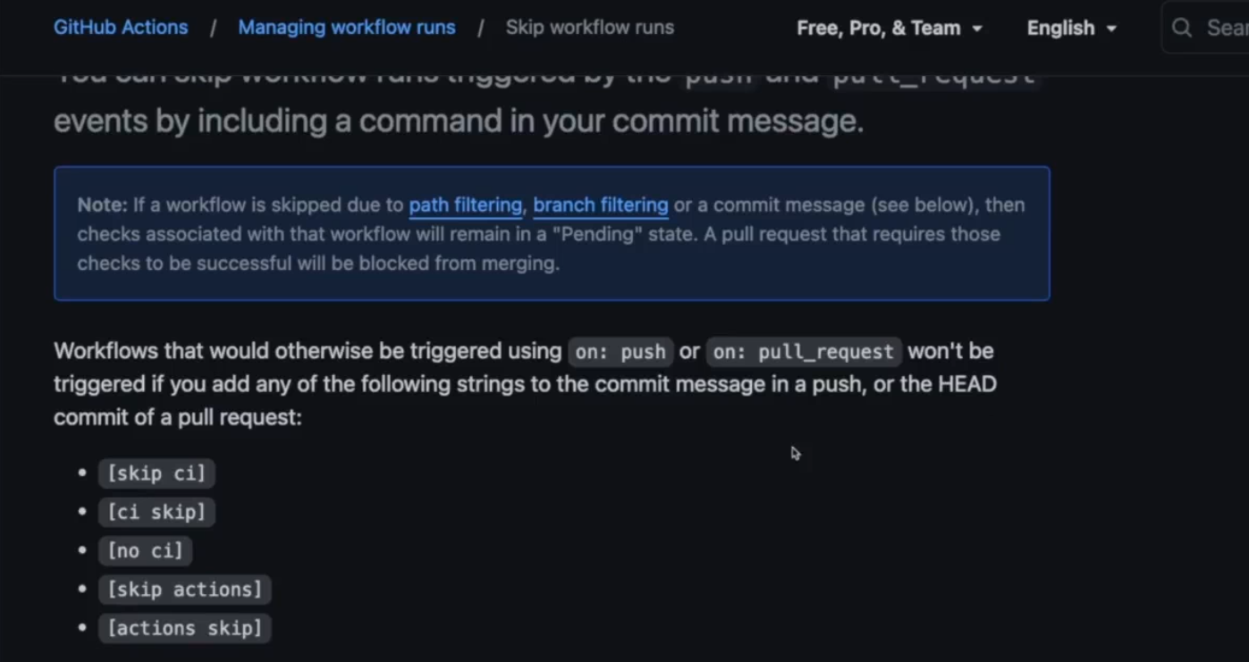

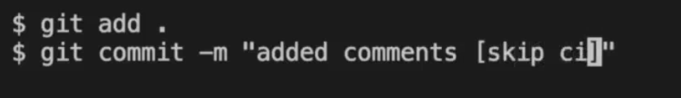

## Module Summary

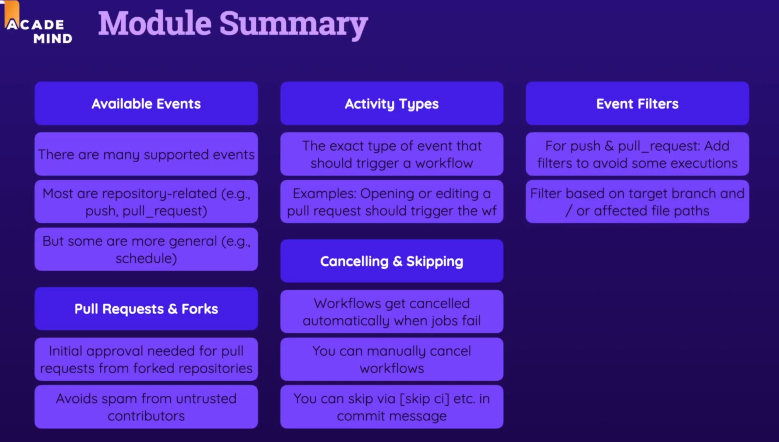

# Job artifacts & output / caching

## Understanding Job Artifacts

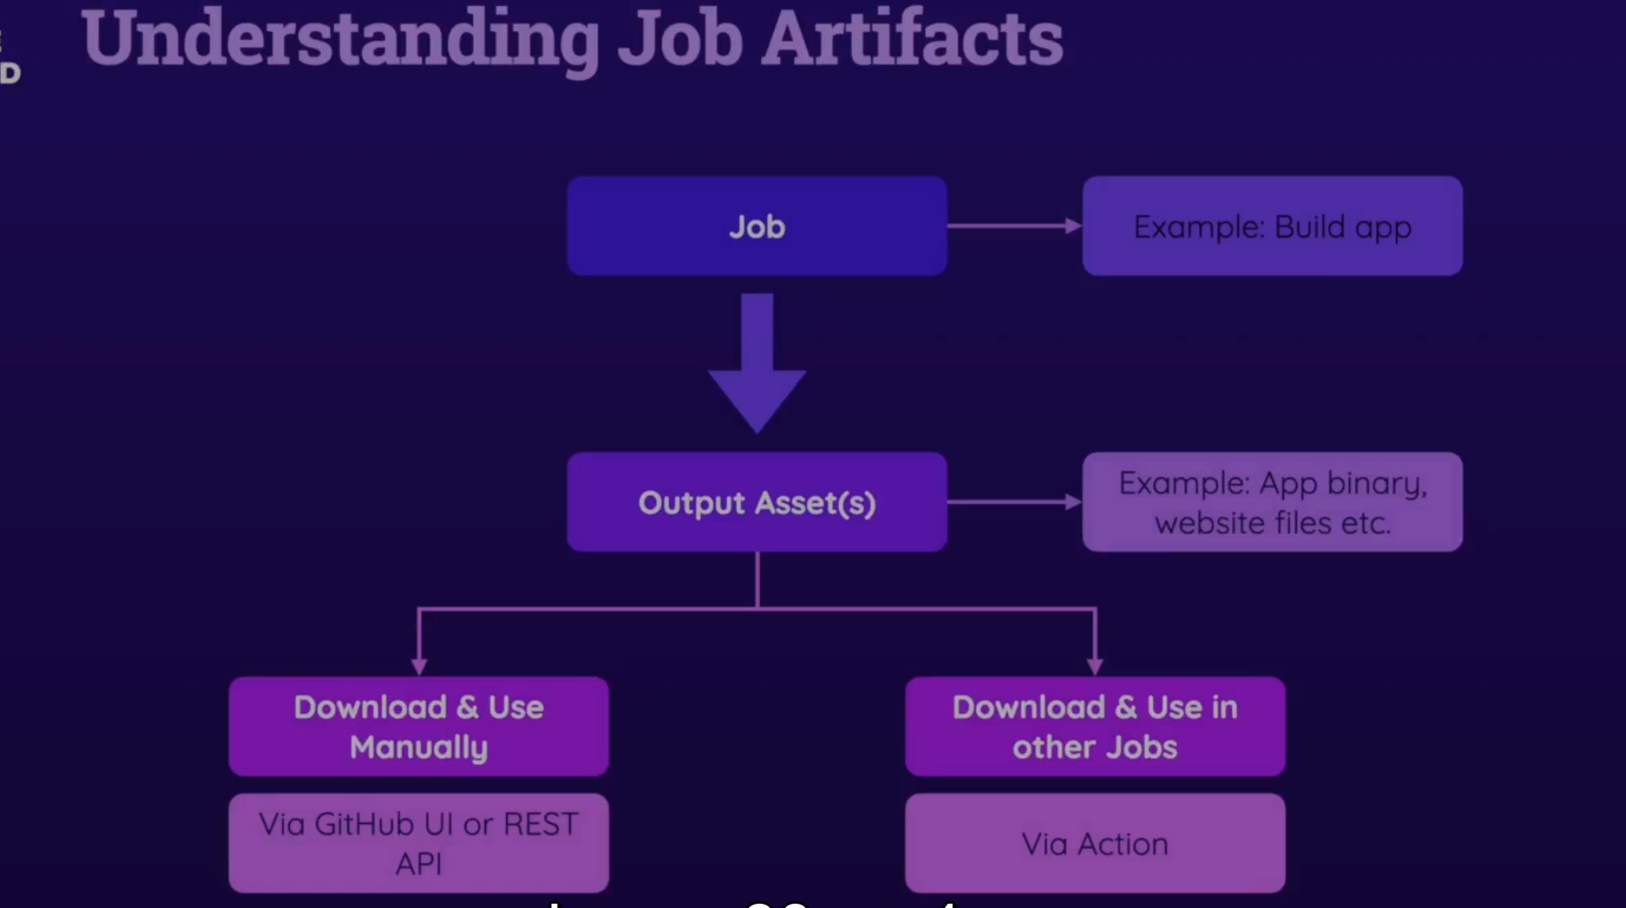

Example: `Dist` folder is an ouput of the npm build

## Uploading Job Artifacts

<https://github.com/actions/upload-artifact>

      - name: Upload artifacts

        uses: actions/upload-artifact@v3

        with:

          name: dist-files

          path: dist

          # path: |

          #   dist

          #   package.json

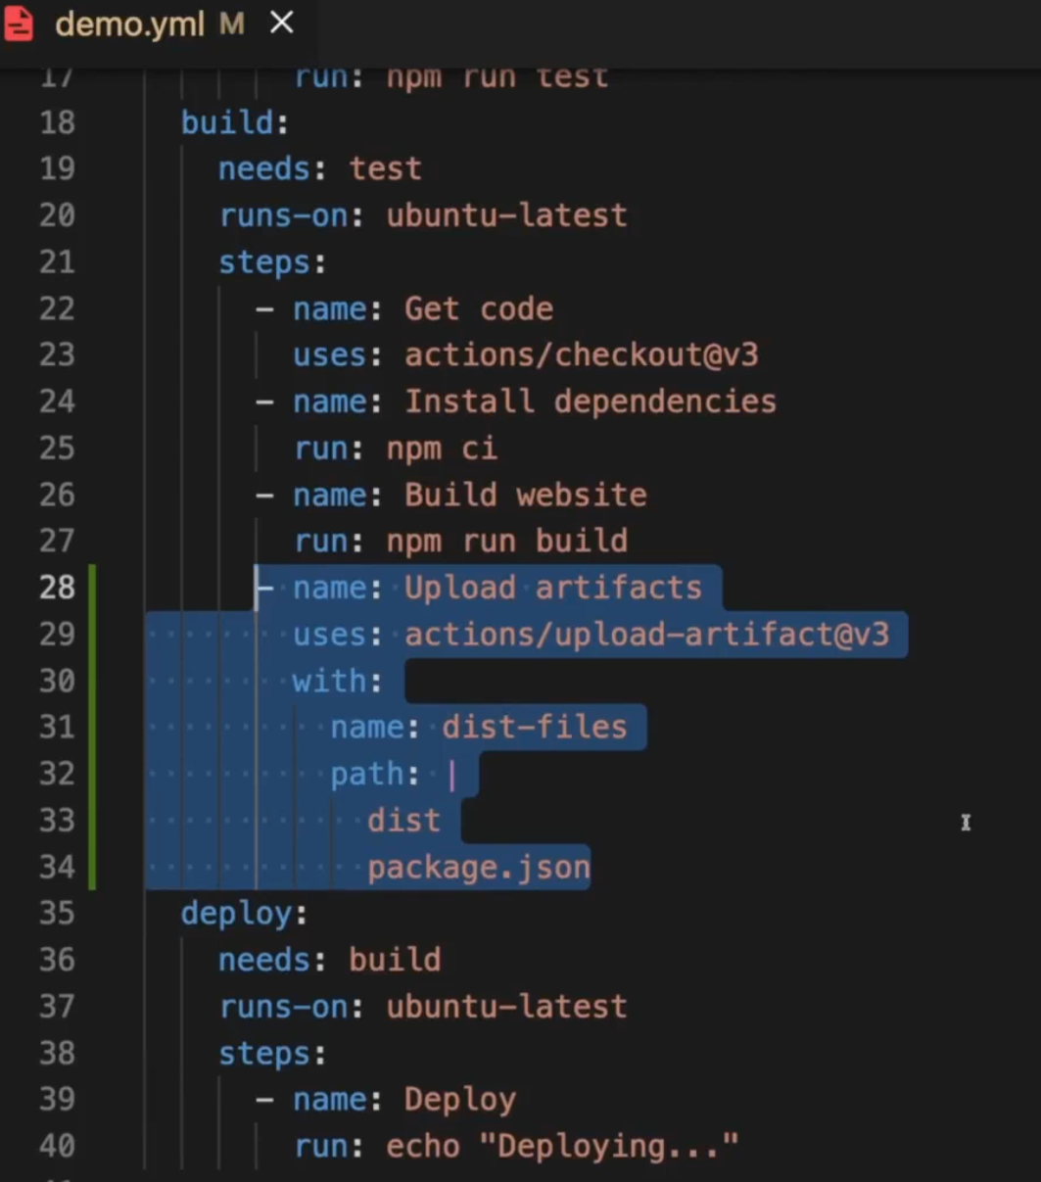

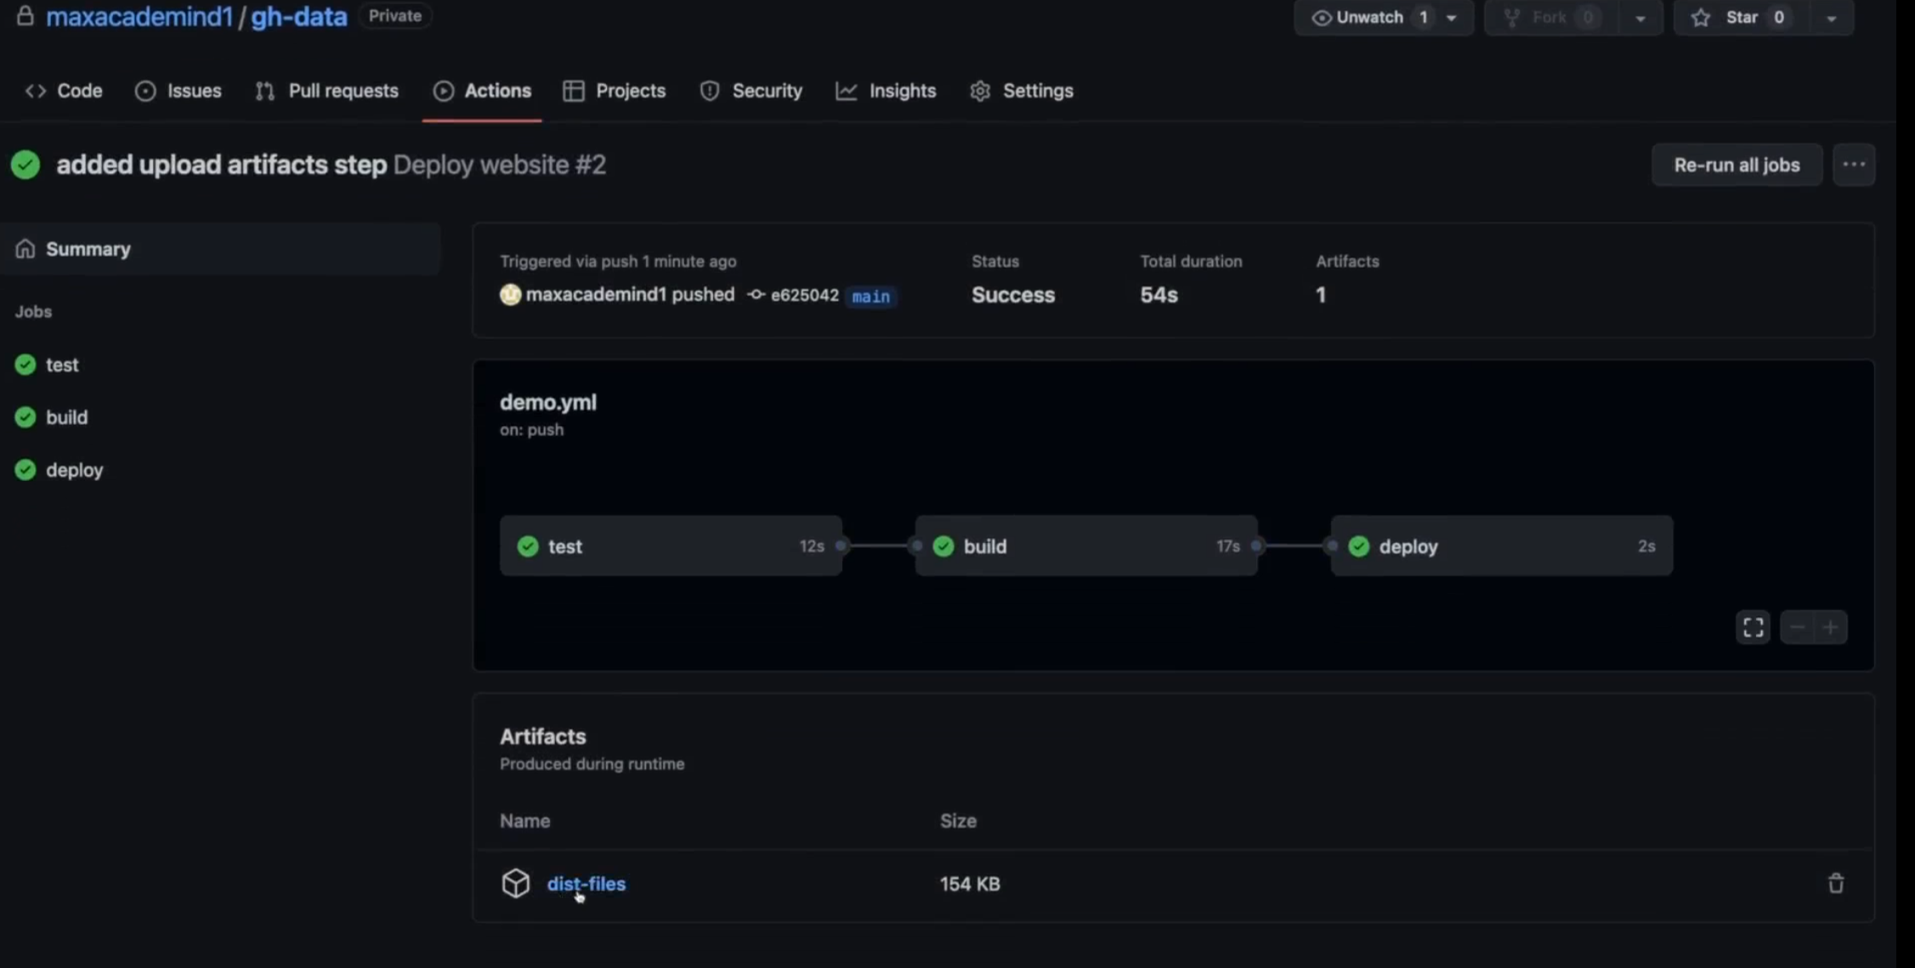

## Downloading Artifacts (Manually & Automatically)

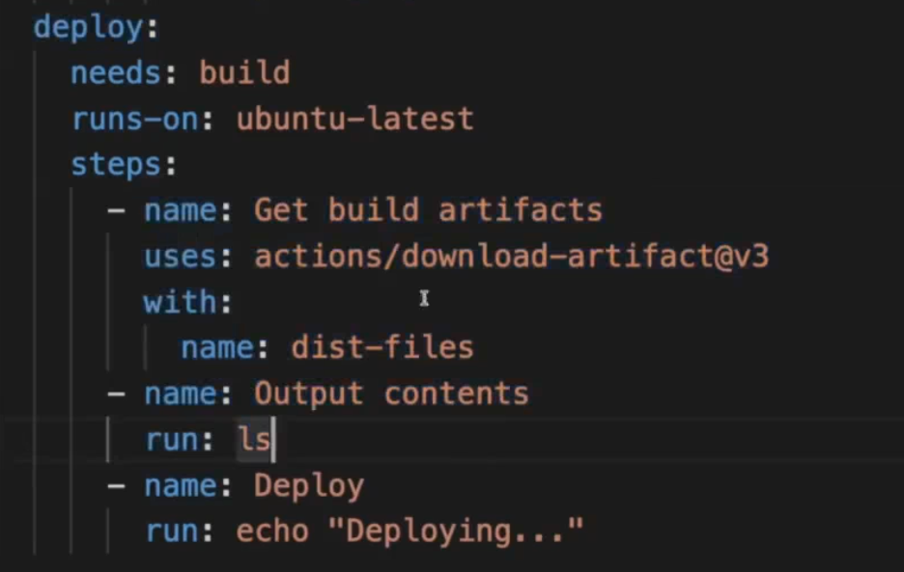

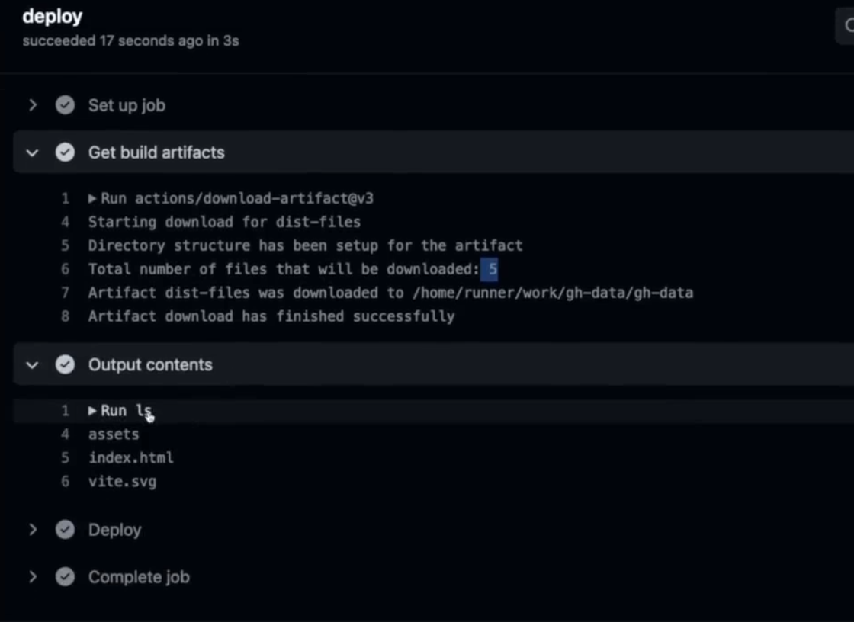

## Understanding Job Outputs

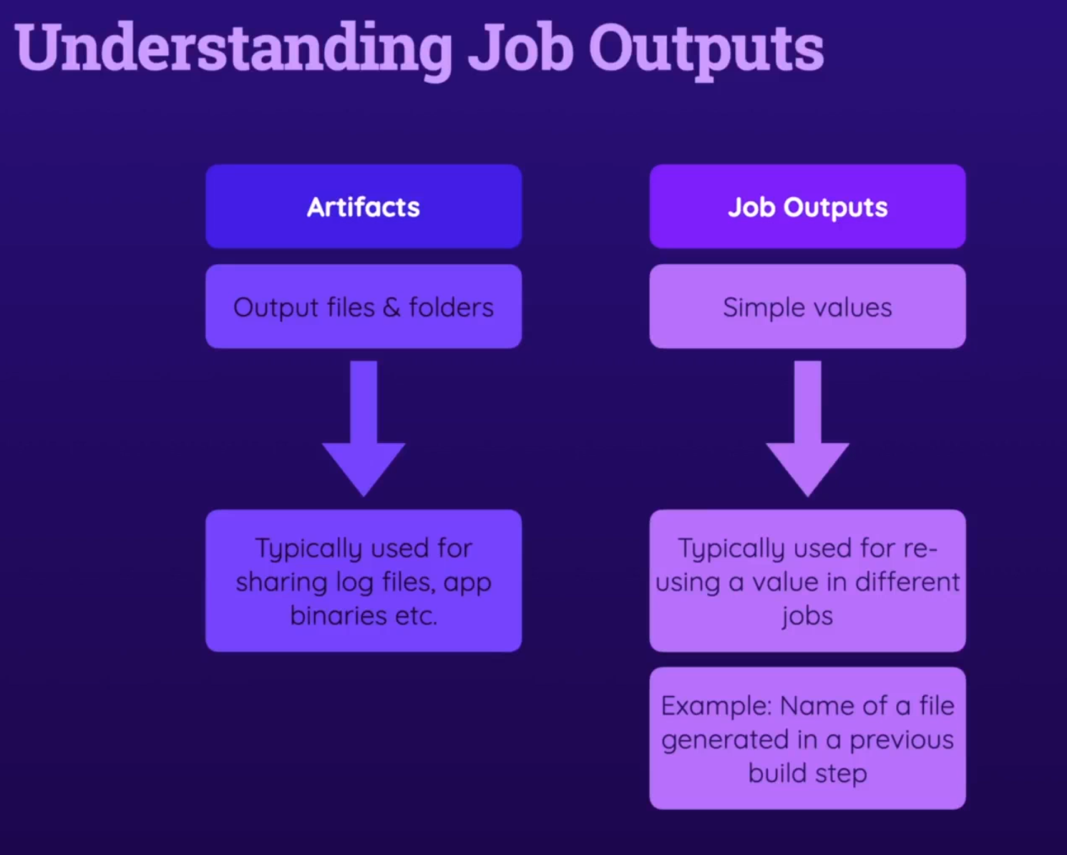

Publish Example:

   build:

    needs: test

    runs-on: ubuntu-latest

    outputs:

      script-file: ${{ steps.publish.outputs.script-file }}

    steps:

      - name: Publish JS filename

        id: publish

        run: find dist/assets/*.js -type f -execdir echo 'script-file={}' >> $GITHUB_OUTPUT ';'

or:



<https://docs.github.com/en/actions/learn-github-actions/contexts>

Using Job Outputs In Other Jobs:

  deploy:

    needs: build

    runs-on: ubuntu-latest

    steps:

      - name: Get build artifacts

        uses: actions/download-artifact@v3

        with:

          name: dist-files

      - name: Output contents

        run: ls

      - name: Output filename

        run: echo "${{ needs.build.outputs.script-file }}"

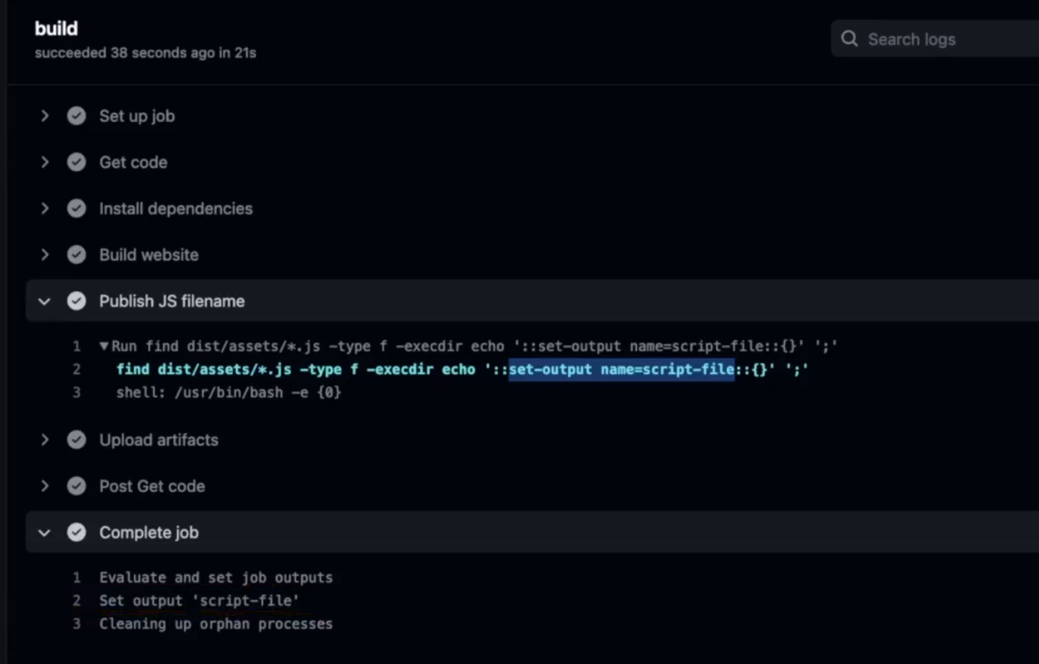

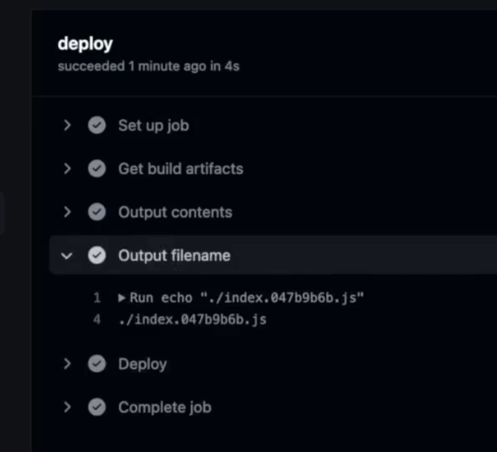

## Dependency Caching

Taking time:



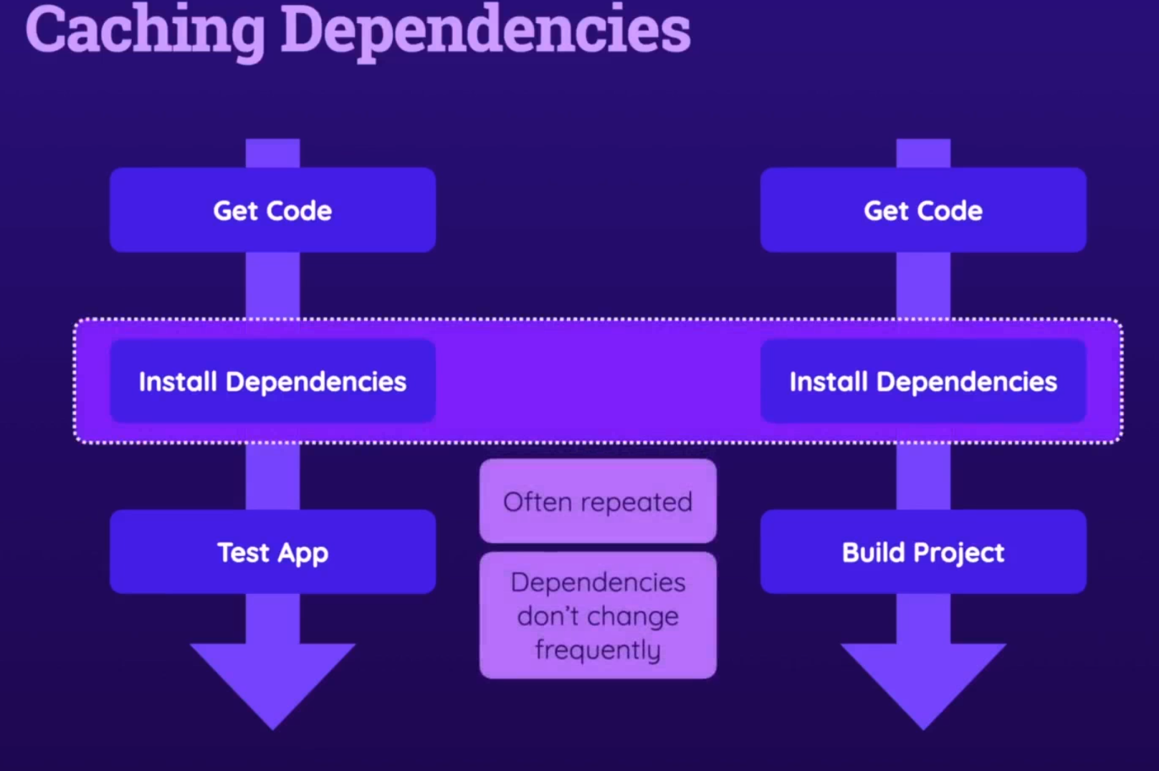

<https://github.com/actions/cache>

- name: Cache dependencies

        uses: actions/cache@v3

        with:

          path: ~/.npm

          key: deps-node-modules-${{ hashFiles('**/package-lock.json') }}

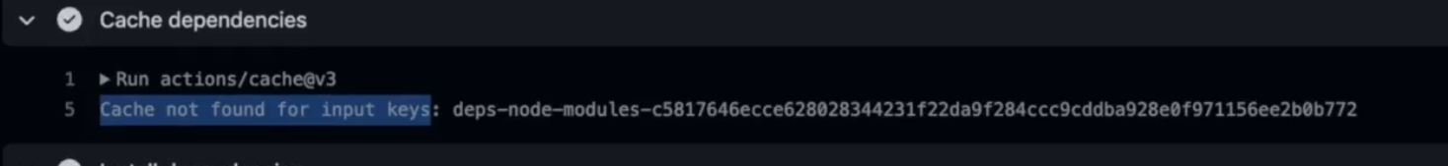

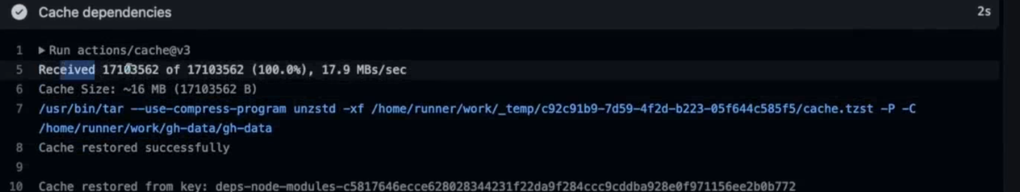

## Module Summary

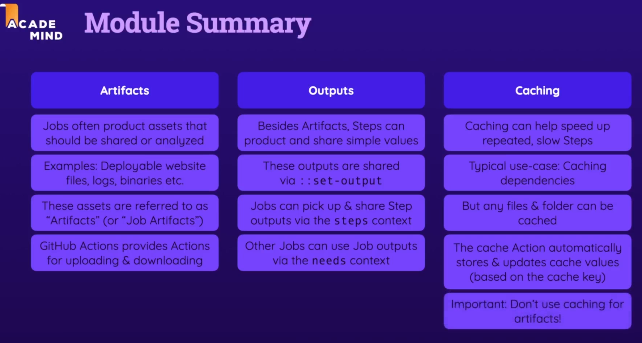

# Environment Variables & Secrets

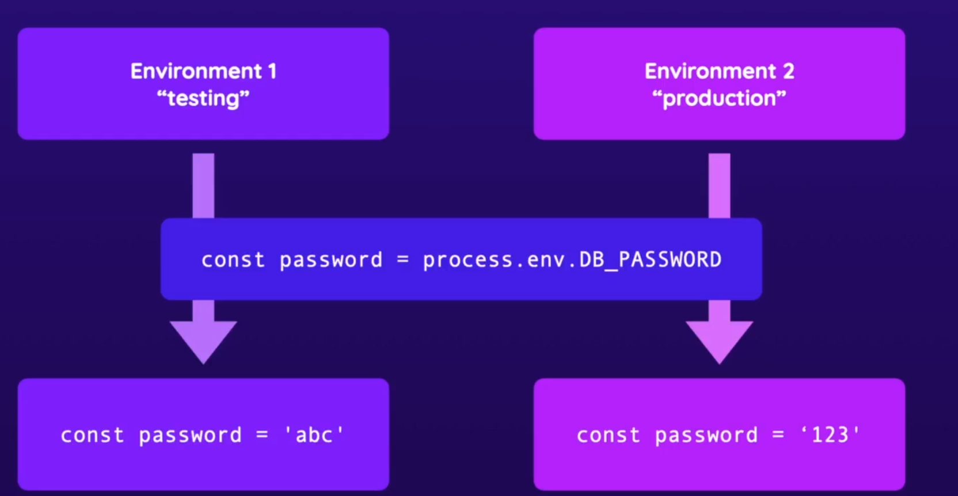

env:

      MONGODB_CLUSTER_ADDRESS: cluster0.ntrwp.mongodb.net

      MONGODB_USERNAME: ${{ secrets.MONGODB_USERNAME }}

      MONGODB_PASSWORD: ${{ secrets.MONGODB_PASSWORD }}

      PORT: 8080

 - name: Run server

        run: npm start & npx wait-on http://127.0.0.1:$PORT

echo "${{ env.PORT }}"

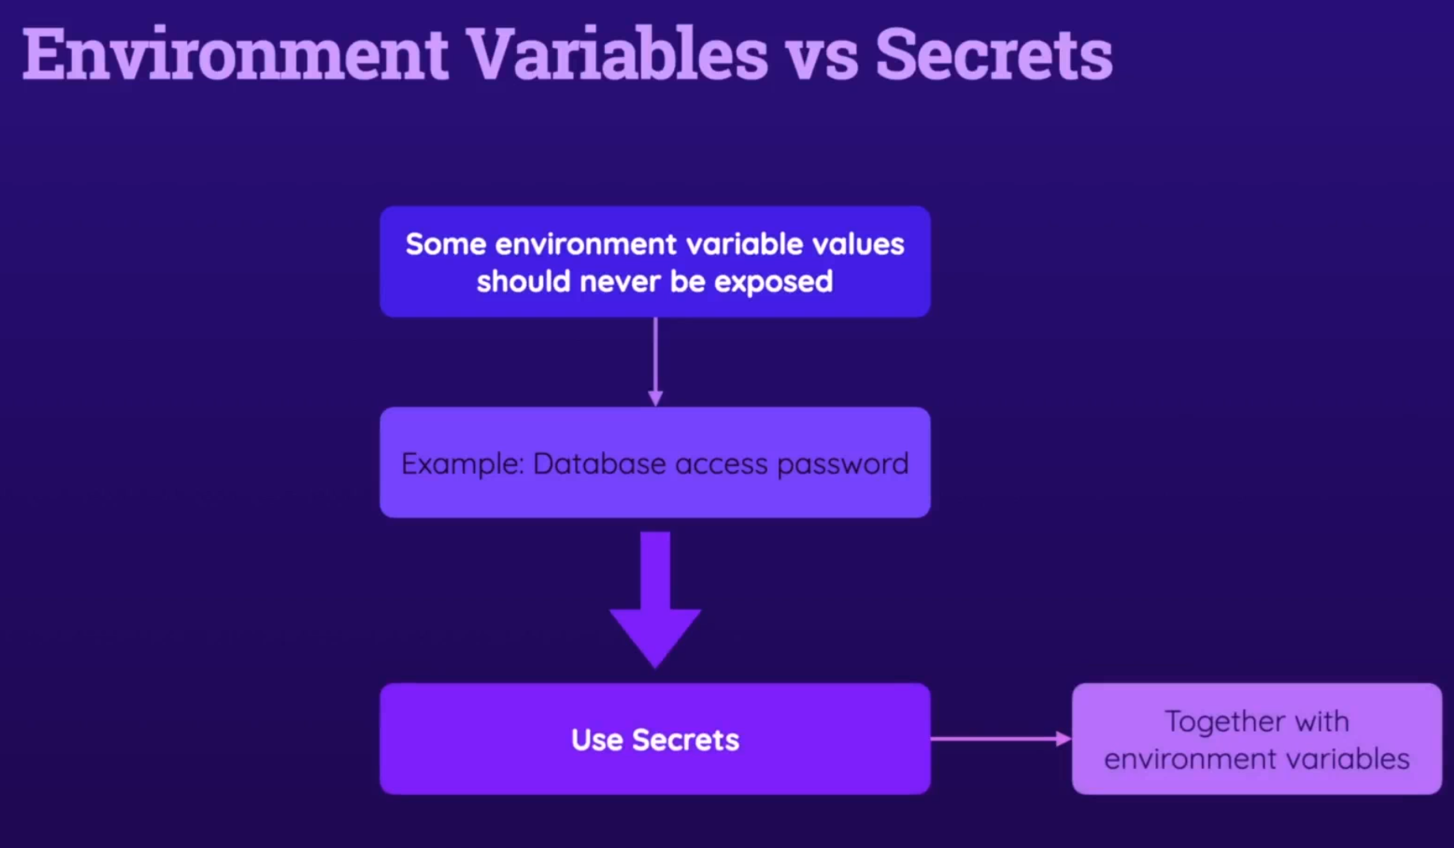

If u organization you can hold them in the O setting, if not under repo settings

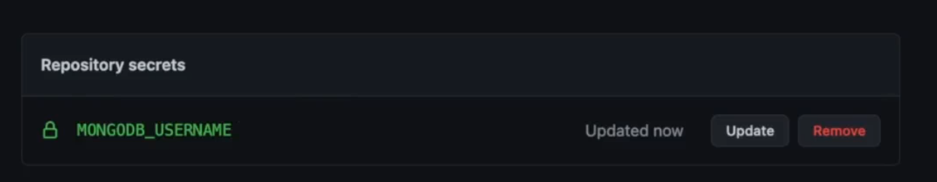

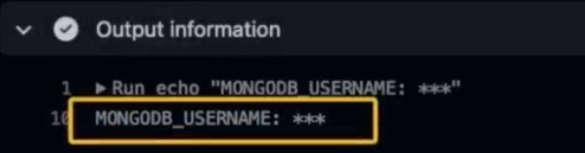

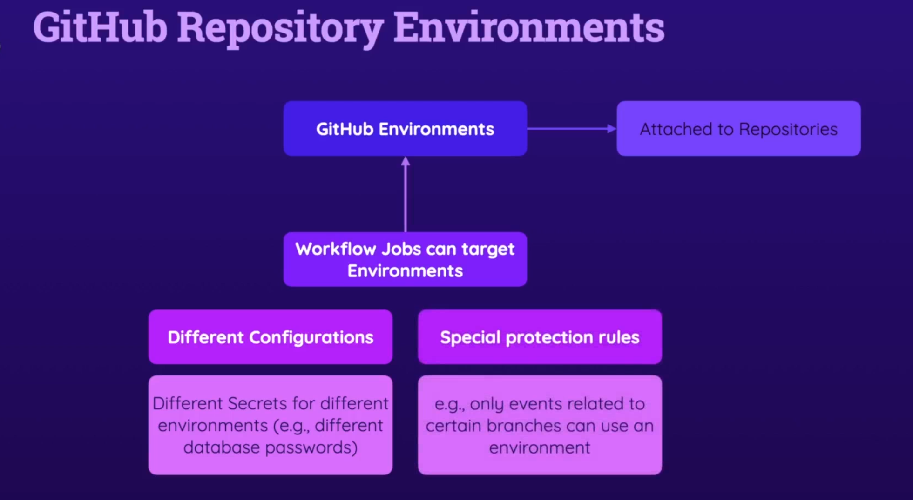

  test:

    environment: testing

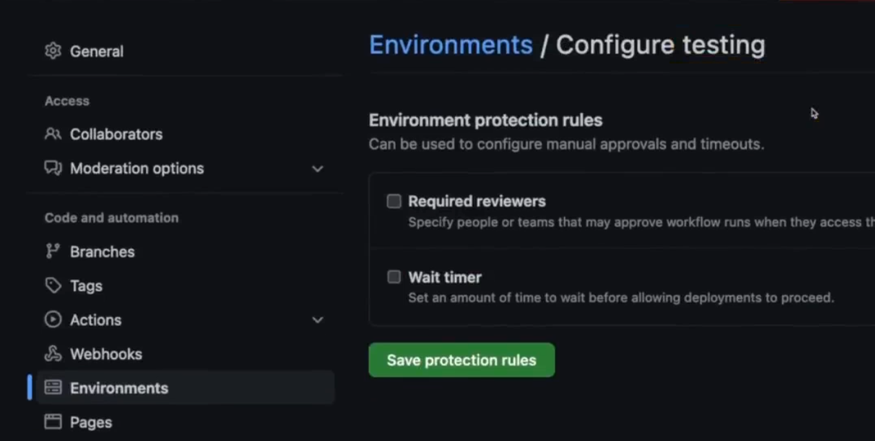

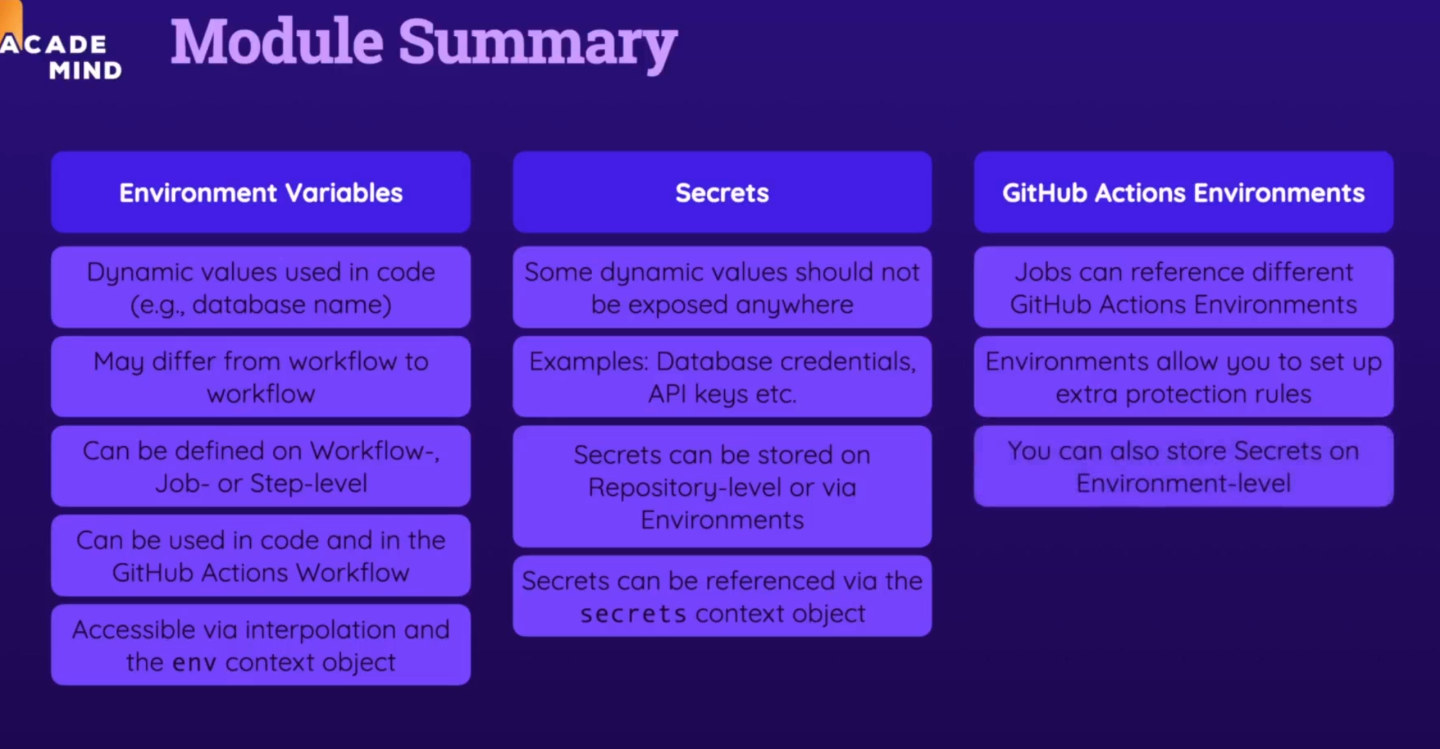

# Controlling Execution Flow

The default behavior:

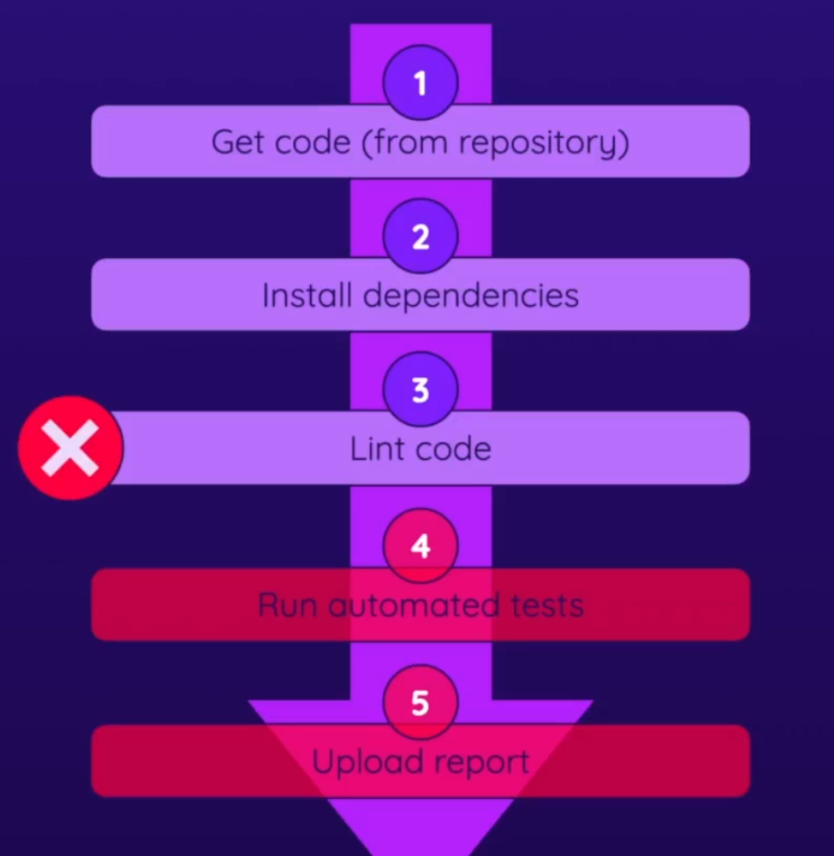

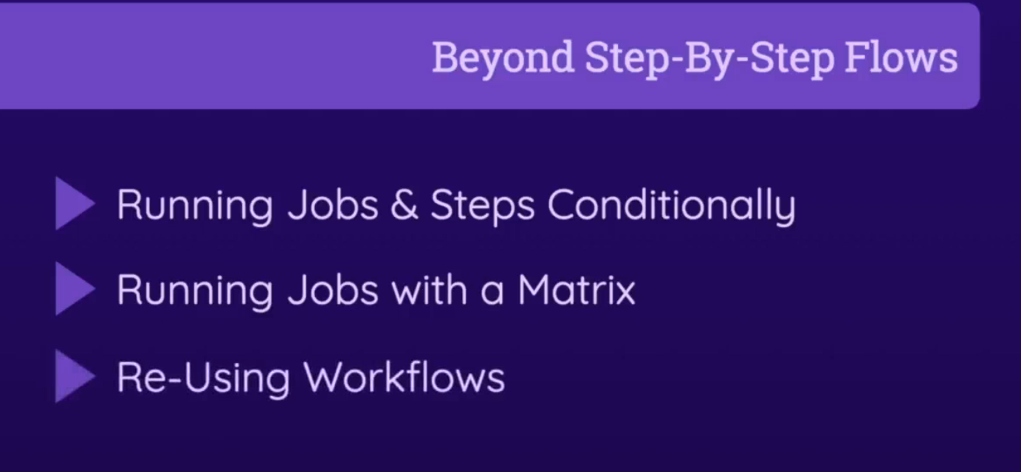

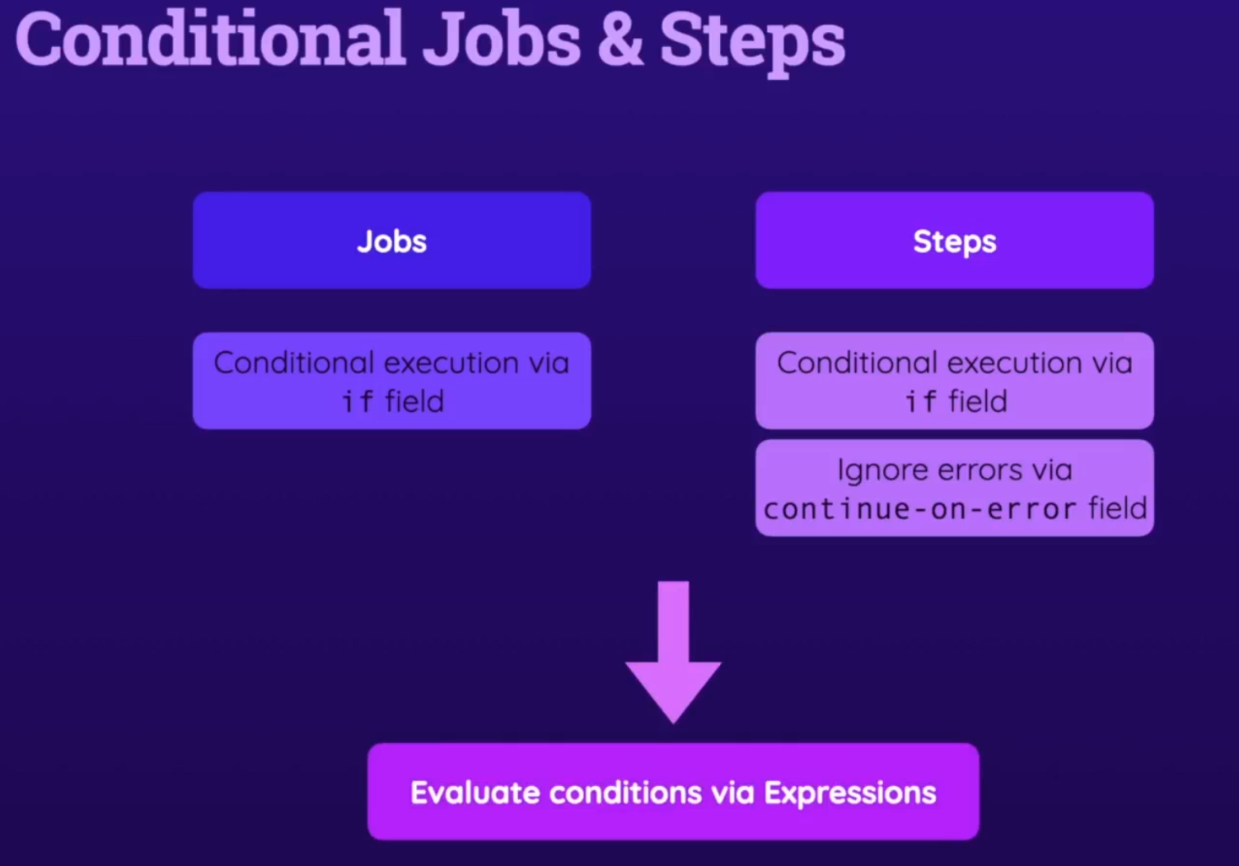

## Controlling Execution via "if"

      - name: Test code

        id: run-tests

        run: npm run test

      - name: Upload test report

        if: failure() && steps.run-tests.outcome == 'failure'

        uses: actions/upload-artifact@v3

        with:

          name: test-report

          path: test.json

## Working with Special Conditional Functions

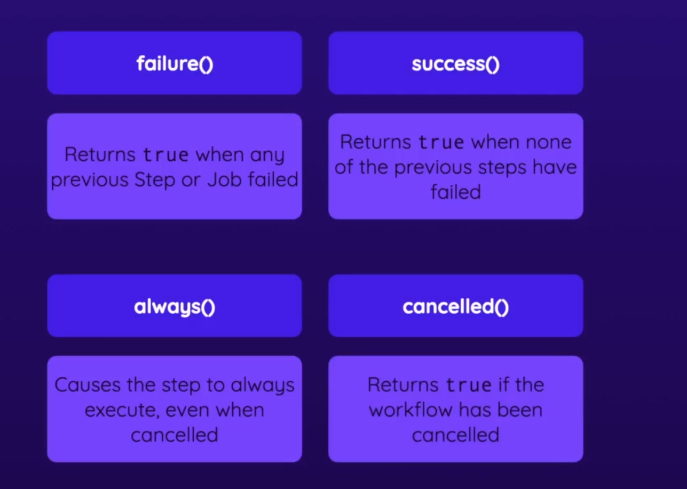

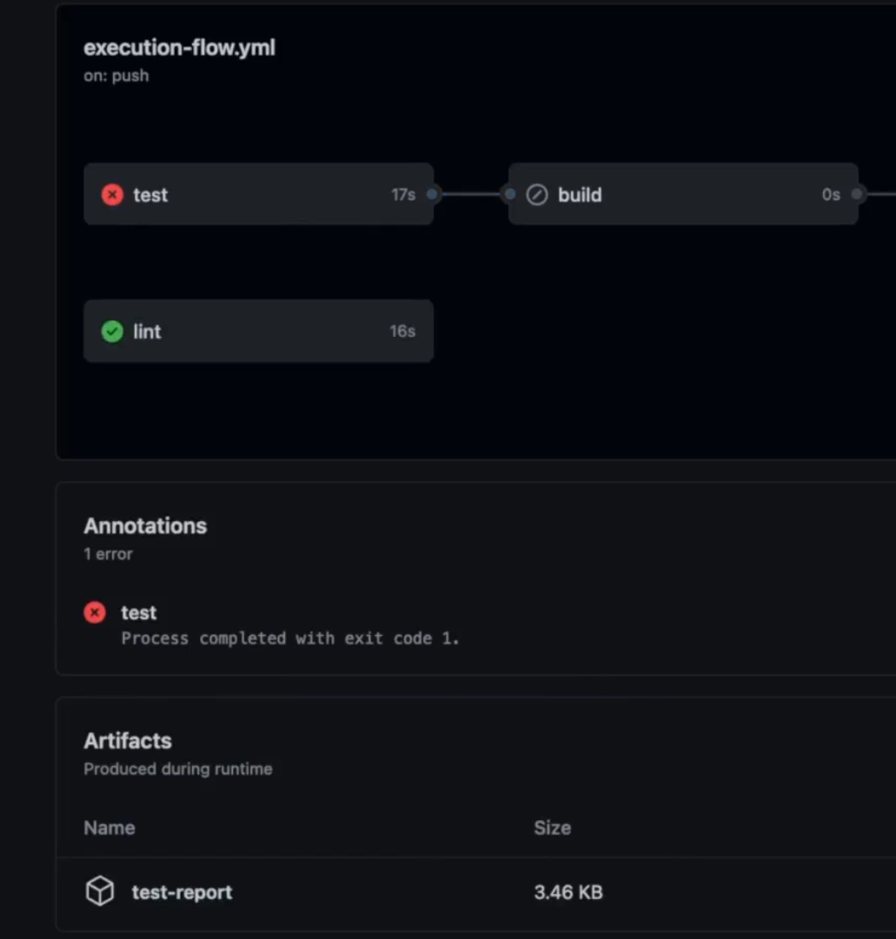

## Conditional Jobs

  report:

    needs: [lint, deploy]

    if: failure()

    runs-on: ubuntu-latest

    steps:

      - name: Output information

        run: |

          echo "Something went wrong"

          echo "${{ toJSON(github) }}"

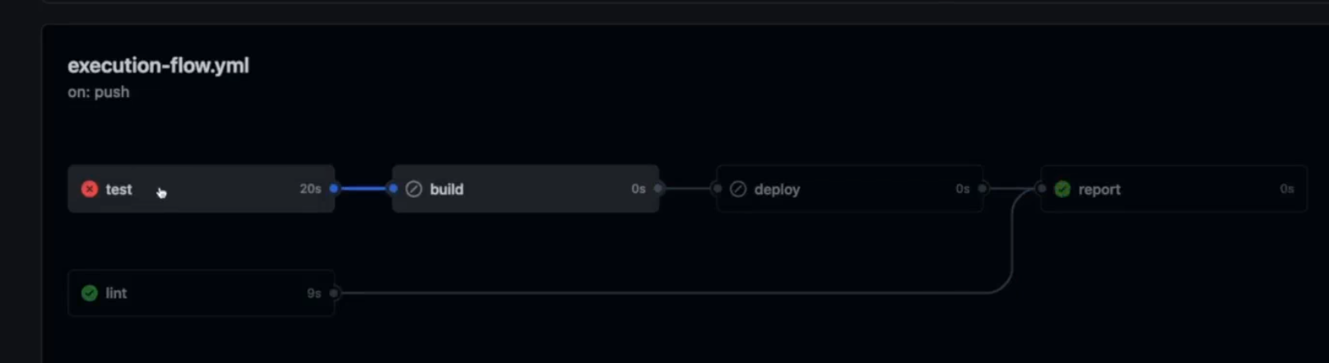

## More "if" Examples

- name: Cache dependencies

        id: cache

        uses: actions/cache@v3

        with:

          path: node_modules

          key: deps-node-modules-${{ hashFiles('**/package-lock.json') }}

      - name: Install dependencies

        if: steps.cache.outputs.cache-hit != 'true'

        run: npm ci

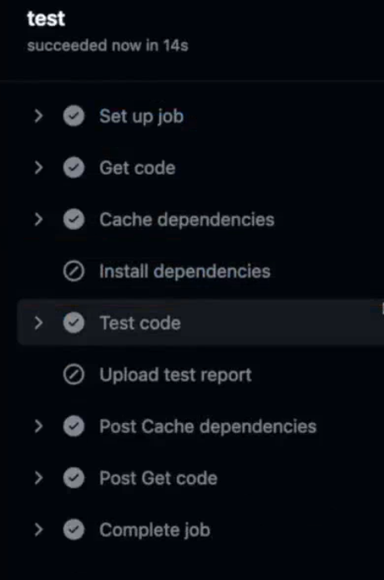

## Ignoring Errors & Failures with "continue-on-error"

- name: Test code

        continue-on-error: true

        id: run-tests

        run: npm run test

this step will pass even if test failing, then all other jobs will continue.

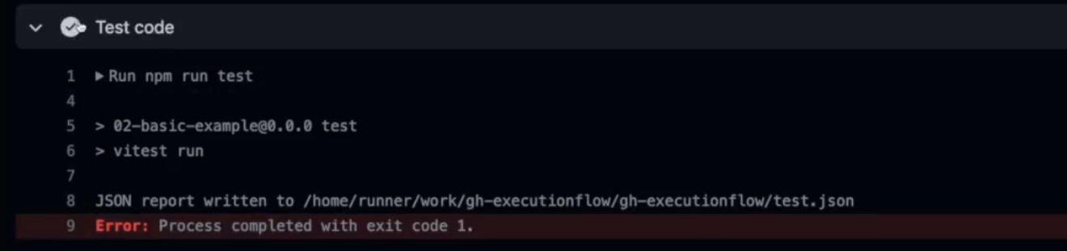

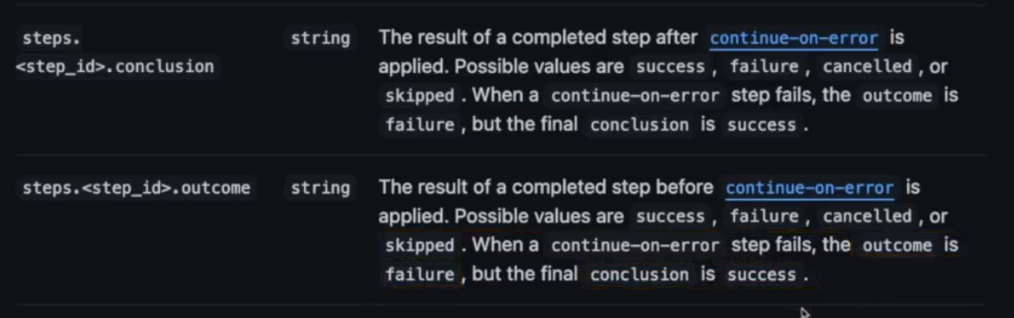

## Understanding & Using Matrix Strategies

name: Matrix Demo

on: push

jobs:

  build:

    continue-on-error: true

    strategy:

      matrix:

        node-version: [12, 14, 16]

        operating-system: [ubuntu-latest, windows-latest]

    runs-on: ${{ matrix.operating-system }}

    steps:

      - name: Get Code

        uses: actions/checkout@v3

      - name: Install NodeJS

        uses: actions/setup-node@v3

        with:

          node-version: ${{ matrix.node-version }}

      - name: Install Dependencies

        run: npm ci

      - name: Build project

        run: npm run build

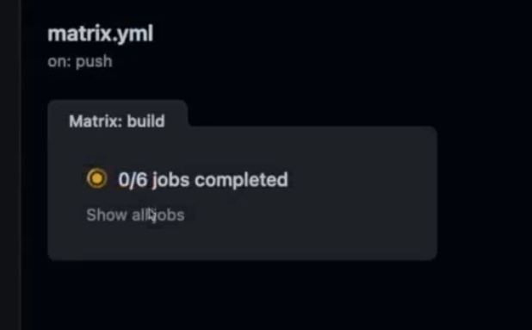

In matrix if one job will fail the other won’t execute

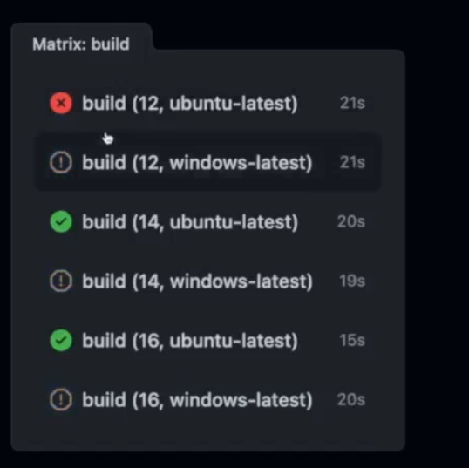

But u can use :

continue-on-error: true

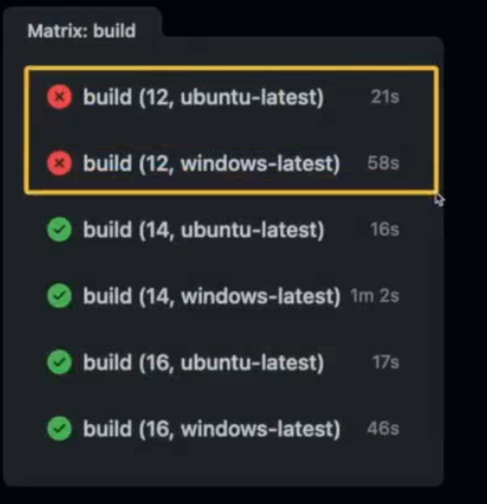

## Including & Excluding Values (Matrix Strategy)

    continue-on-error: true

    strategy:

      matrix:

        node-version: [12, 14, 16]

        operating-system: [ubuntu-latest, windows-latest]

        include:

          - node-version: 18

            operating-system: ubuntu-latest

        exclude:

          - node-version: 12

            operating-system: windows-latest

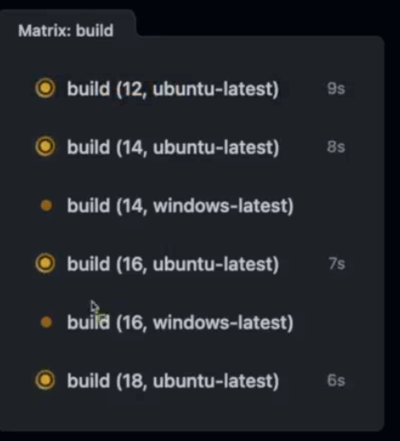

## Saving Time & Code with Reusable Workflows

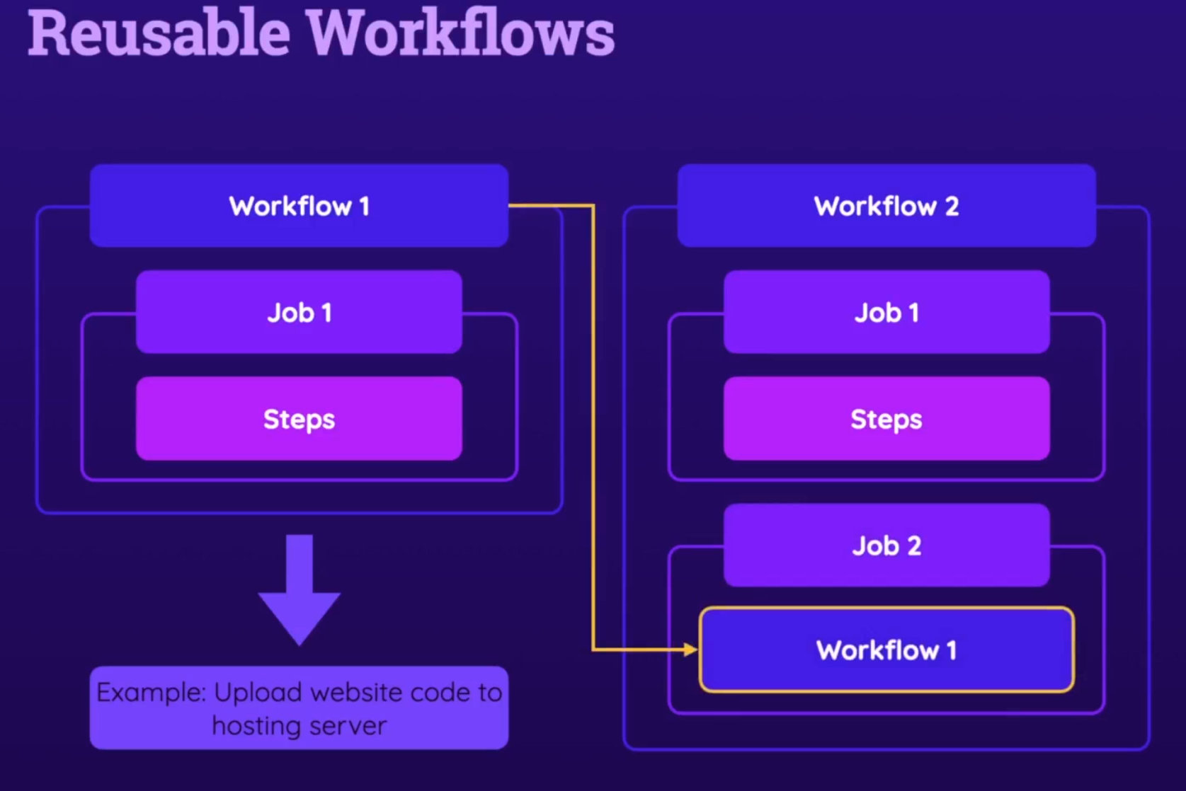

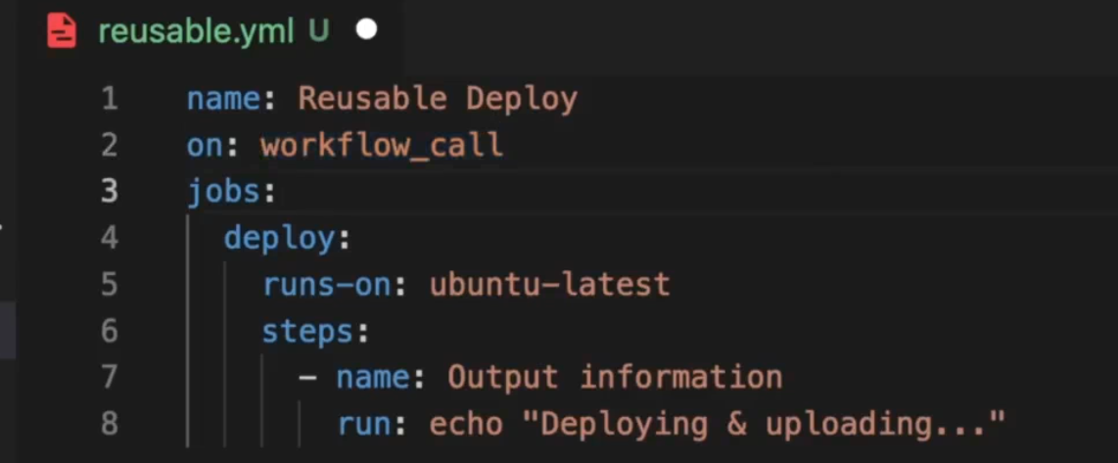

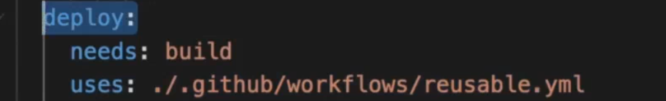

## Adding Inputs to Reusable Workflows

deploy:

    needs: build

    uses: ./.github/workflows/reusable.yml

    with:

      artifact-name: dist-files

name: Reusable Deploy

on:

  workflow_call:

    inputs:

      artifact-name:

        description: The name of the deployable artifact files

        required: false

        default: dist

        type: string

jobs:

  deploy:

    runs-on: ubuntu-latest

    steps:

      - name: Get Code

        uses: actions/download-artifact@v3

        with:

          name: ${{ inputs.artifact-name }}

      - name: List files

        run: ls

      - name: Output information

        run: echo "Deploying & uploading..."

## Reusable Workflows & Secrets

  deploy:

    needs: build

    uses: ./.github/workflows/reusable.yml

    with:

      artifact-name: dist-files

    secrets:

      some-secret: ${{ secrets.some-secret }}

name: Reusable Deploy

on:

  workflow_call:

    inputs:

      artifact-name:

        description: The name of the deployable artifact files

        required: false

        default: dist

        type: string

    outputs:

      result:

        description: The result of the deployment operation

        value: ${{ jobs.deploy.outputs.outcome }}

    secrets:

      some-secret:

        required: false

## Reusable Workflows Outputs

name: Reusable Deploy

on:

  workflow_call:

    inputs:

      artifact-name:

        description: The name of the deployable artifact files

        required: false

        default: dist

        type: string

    outputs:

      result:

        description: The result of the deployment operation

        value: ${{ jobs.deploy.outputs.outcome }}

    # secrets:

      # some-secret:

        # required: false

jobs:

  deploy:

    outputs:

      outcome: ${{ steps.set-result.outputs.step-result }}

    runs-on: ubuntu-latest

    steps:

      - name: Get Code

        uses: actions/download-artifact@v3

        with:

          name: ${{ inputs.artifact-name }}

      - name: List files

        run: ls

      - name: Output information

        run: echo "Deploying & uploading..."

      - name: Set result output

        id: set-result

        run: echo "step-result=success" >> $GITHUB_OUTPUT

  deploy:

    needs: build

    uses: ./.github/workflows/reusable.yml

    with:

      artifact-name: dist-files

    # secrets:

      # some-secret: ${{ secrets.some-secret }}

  print-deploy-result:

    needs: deploy

    runs-on: ubuntu-latest

    steps:

      - name: Print deploy output

        run: echo "${{ needs.deploy.outputs.result }}"

## Module Summary

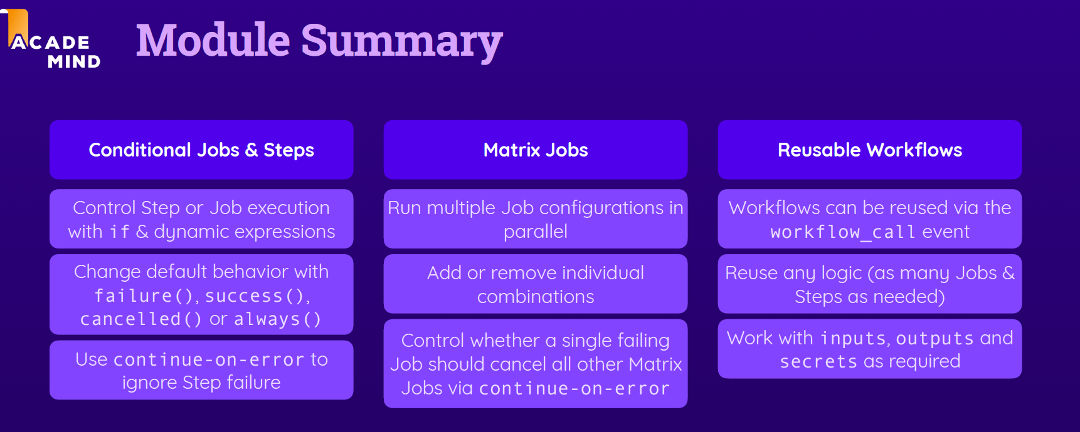

# Using Containers

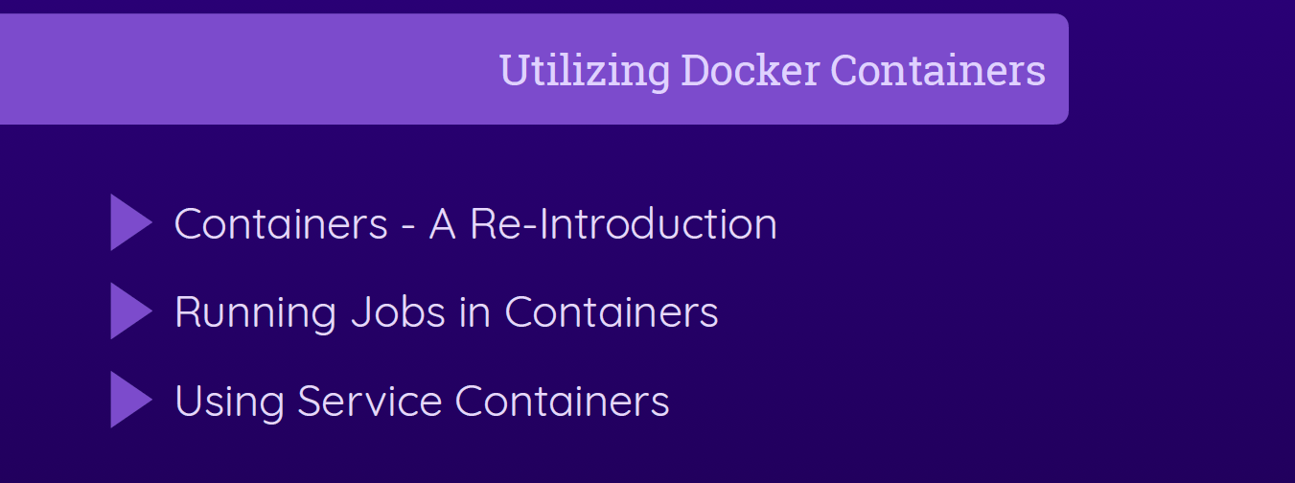

## What Are Containers?

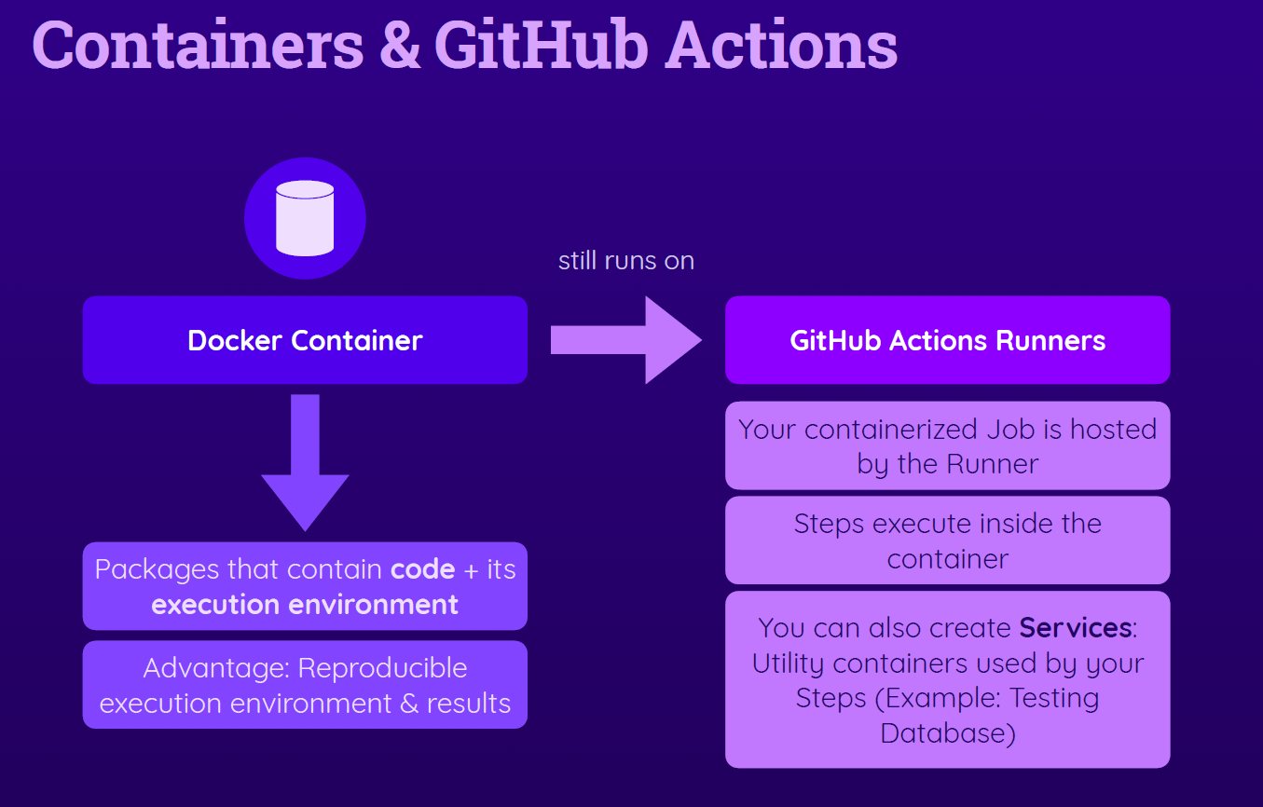

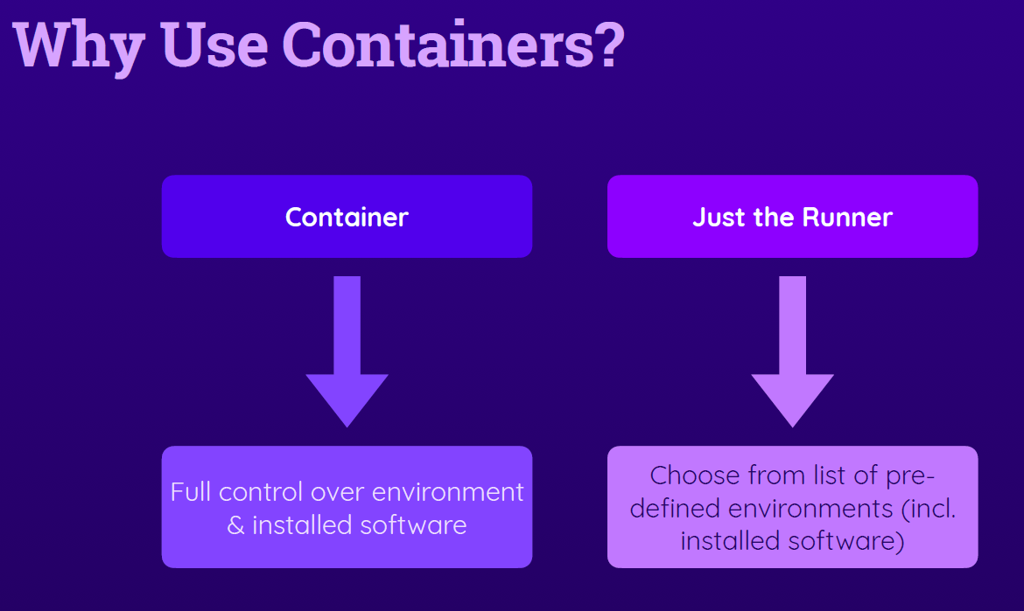

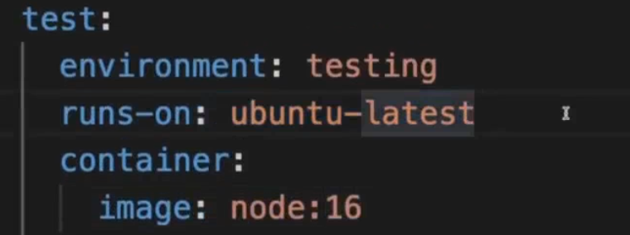

Service Containers - Theory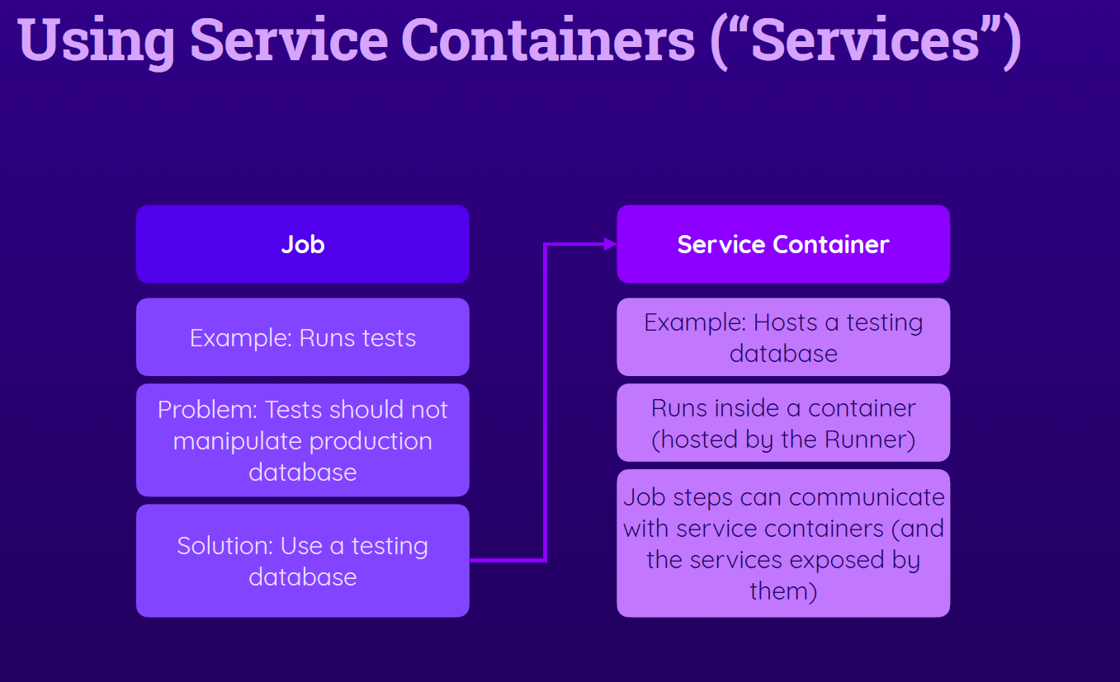

## Adding Services (via Service Containers)

    services:

      mongodb:

        image: mongo

        ports:

          - 27017:27017

        env:

          MONGO_INITDB_ROOT_USERNAME: root

          MONGO_INITDB_ROOT_PASSWORD: example

## Communication between Jobs & Service Containers

If job run in a container:

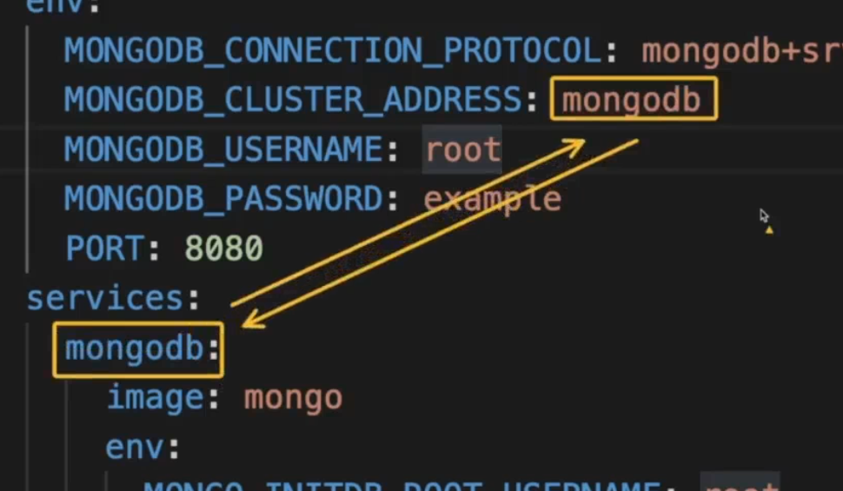

If job runs not in a co    env:

      MONGODB_CONNECTION_PROTOCOL: mongodb

      MONGODB_CLUSTER_ADDRESS: 127.0.0.1:27017

      MONGODB_USERNAME: root

      MONGODB_PASSWORD: example

      PORT: 8080

    services:

      mongodb:

        image: mongo

        ports:

          - 27017:27017

        env:

          MONGO_INITDB_ROOT_USERNAME: root

          MONGO_INITDB_ROOT_PASSWORD: example

ntainer:

## Module Summary

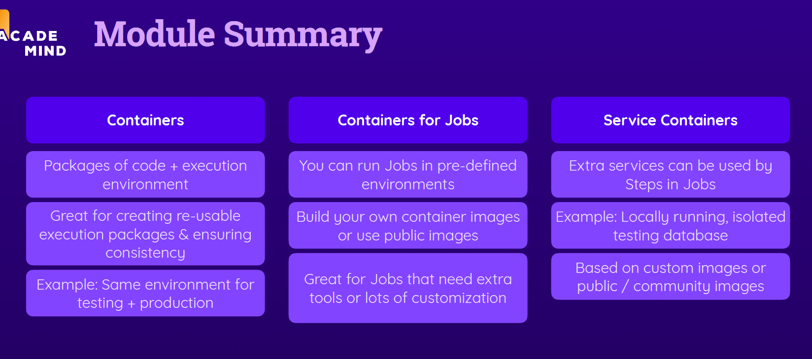

# Building Custom Actions

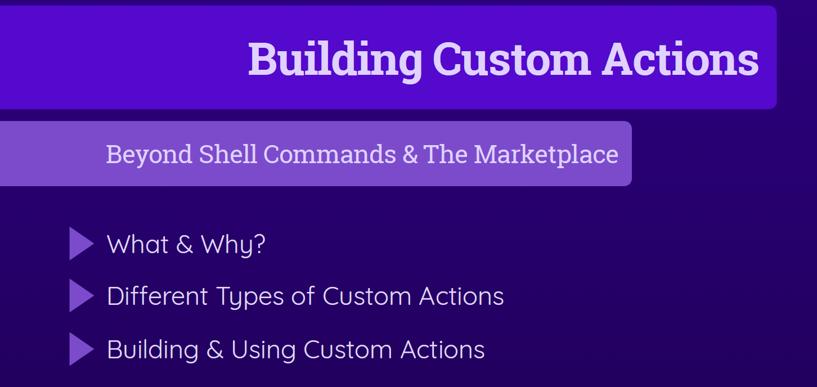

## Why Custom Actions?

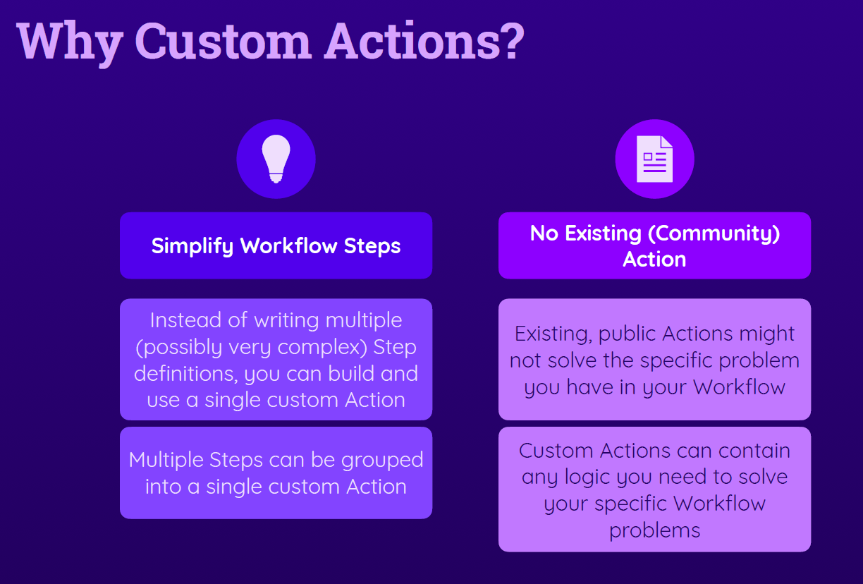

## Understanding Different Types of Custom Actions

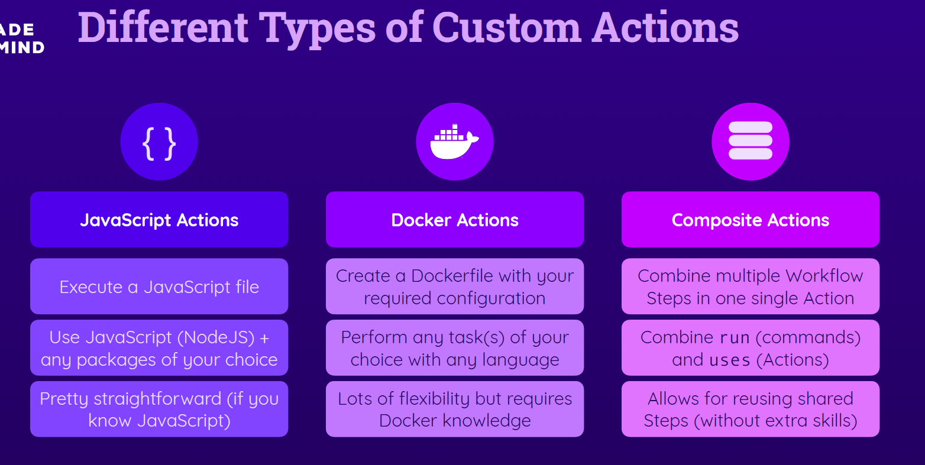

## Creating Composite Actions

You can put all your shared action in a repository and use them in others.

We will put them in the service repository

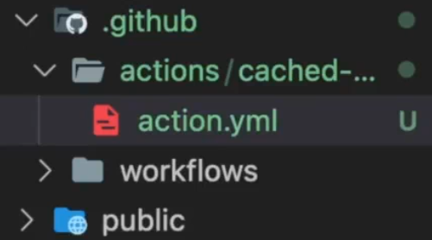

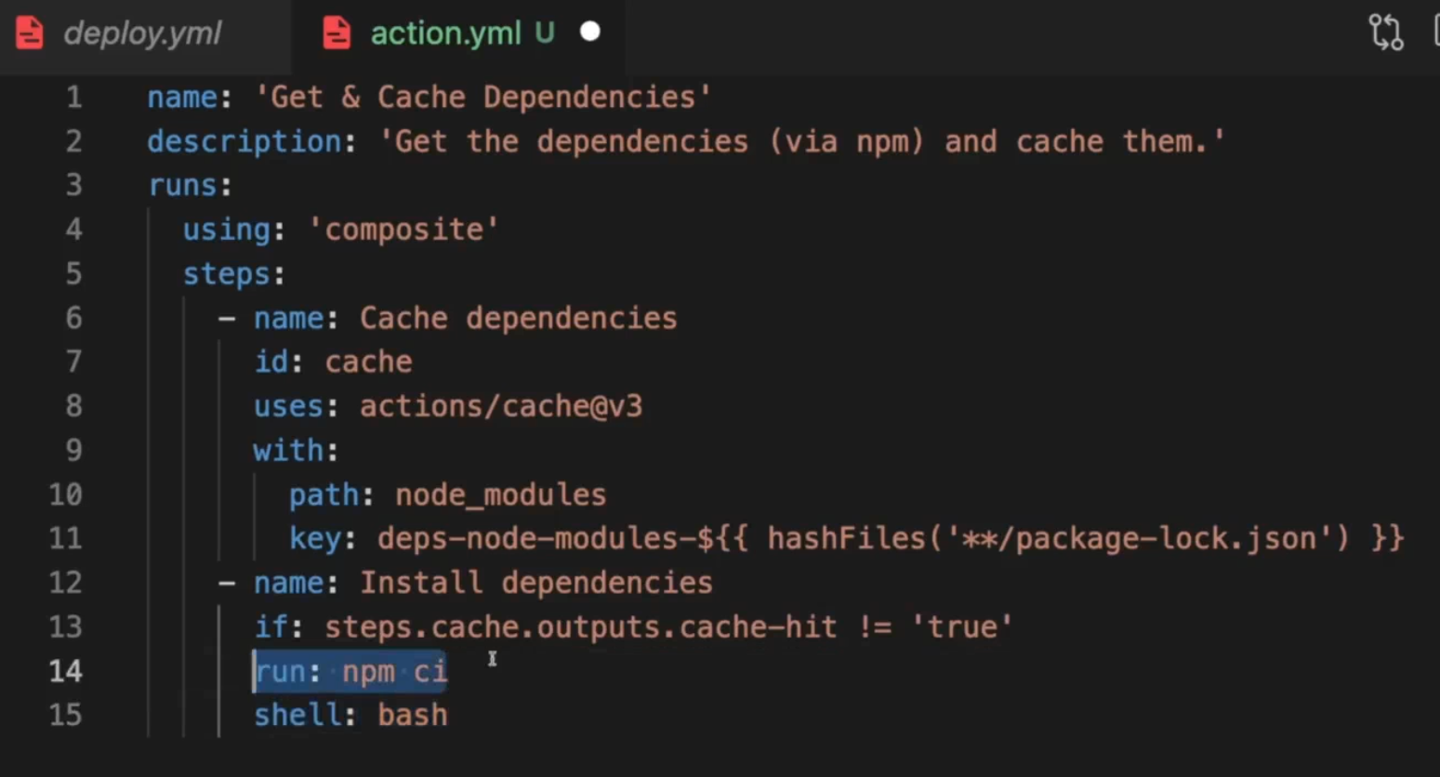

## Using Custom Actions In Workflows

To use action from your own repo:

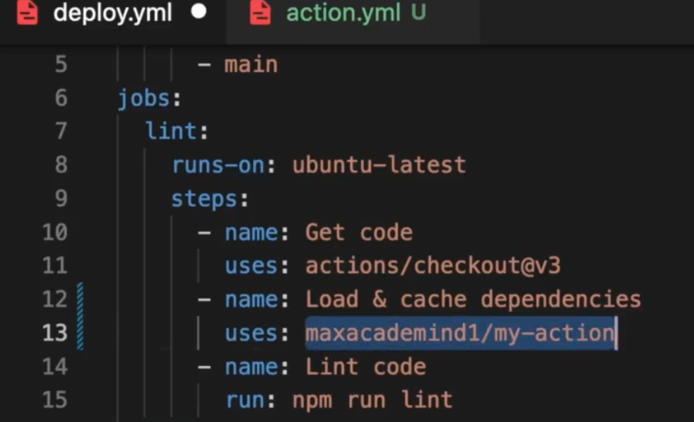

With the same folder:

The path is relevant to the repo folder

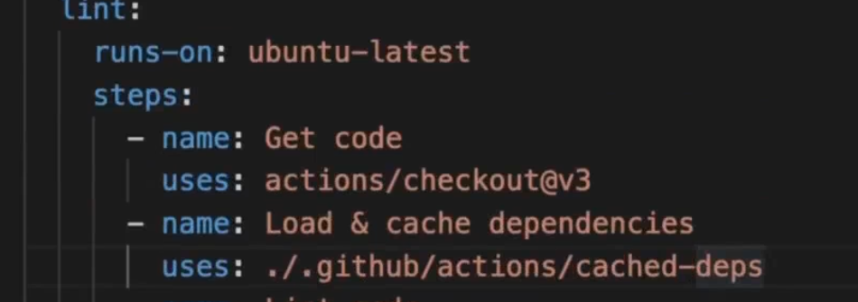

## Adding Inputs to Custom Actions

Maybe we want to turn off cache

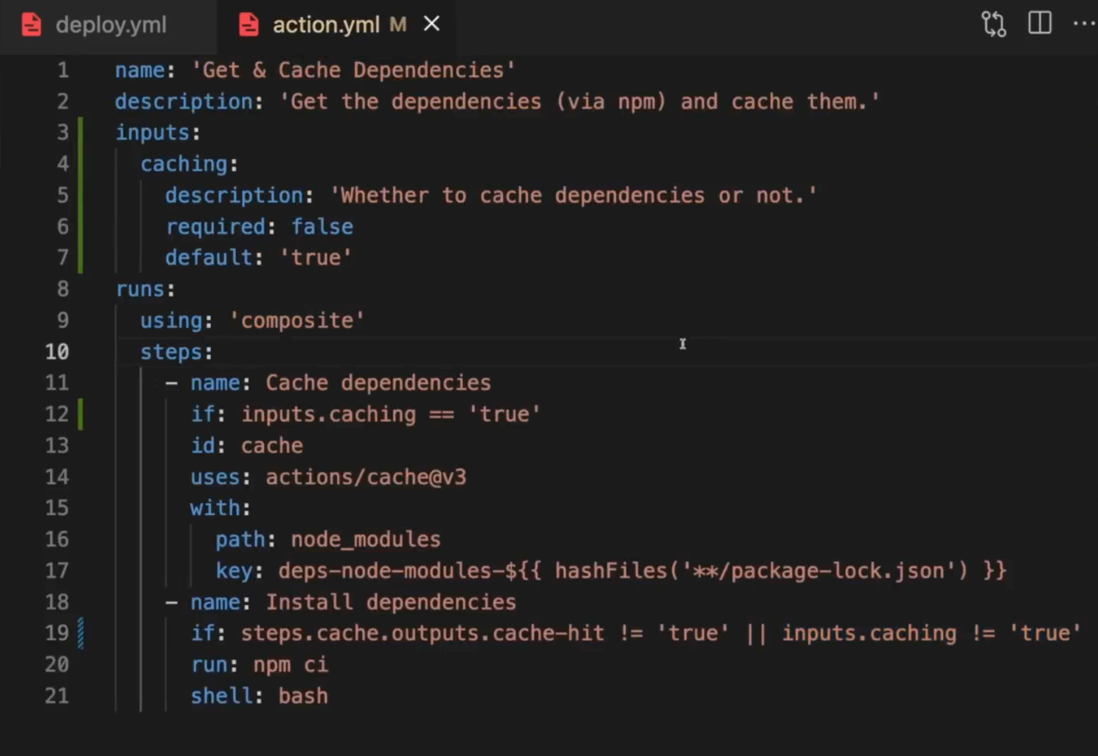

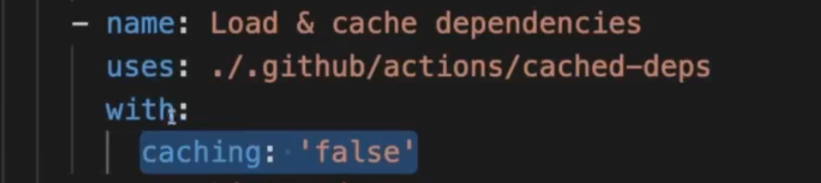

## Adding Outputs to Custom Actions

name: 'Get & Cache Dependencies'

description: 'Get the dependencies (via npm) and cache them.'

inputs:

  caching:

    description: 'Whether to cache dependencies or not.'

    required: false

    default: 'true'

outputs:

  used-cache:

    description: 'Whether the cache was used.'

    value: ${{ steps.install.outputs.cache }}

runs:

  using: 'composite'

  steps:

    - name: Cache dependencies

      if: inputs.caching == 'true'

      id: cache

      uses: actions/cache@v3

      with:

        path: node_modules

        key: deps-node-modules-${{ hashFiles('**/package-lock.json') }}

    - name: Install dependencies

      id: install

      if: steps.cache.outputs.cache-hit != 'true' || inputs.caching != 'true'

      run: |

        npm ci

        echo "cache='${{ inputs.caching }}'" >> $GITHUB_OUTPUT

      shell: bash

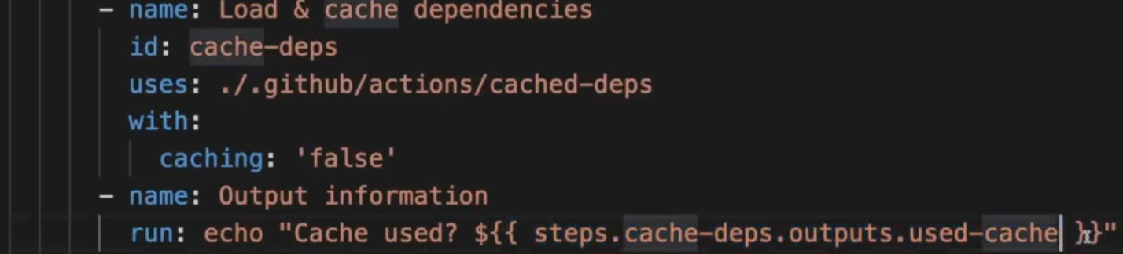

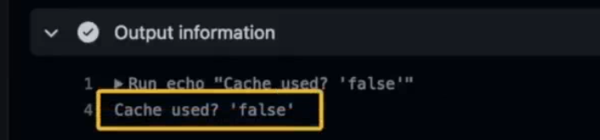

## Custom JavaScript Actions

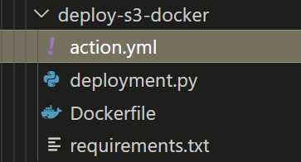

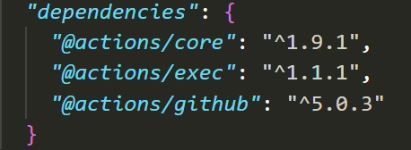.

name: 'Deploy to AWS S3'

description: 'Deploy a static website via AWS S3.'

inputs:

  bucket:

    description: 'The S3 bucket name.'

    required: true

  bucket-region:

    description: 'The region of the S3 bucket.'

    required: false

    default: 'us-east-1'

  dist-folder:

    description: 'The folder containing the deployable files.'

    required: true

outputs:

  website-url:

    description: 'The URL of the deployed website.'

runs:

  using: 'node16'

  main: 'main.js'

*const* core = require('@actions/core');

// const github = require('@actions/github');

*const* exec = require('@actions/exec');

*function* run() {

  // 1) Get some input values

*const* bucket = core.getInput('bucket', { required: true });

*const* bucketRegion = core.getInput('bucket-region', { required: true });

*const* distFolder = core.getInput('dist-folder', { required: true });

  // 2) Upload files

*const* s3Uri = `s3://${bucket}`;

  //using aws cli

  exec.exec(`aws s3 sync ${distFolder} ${s3Uri} --region ${bucketRegion}`);

*const* websiteUrl = `http://${bucket}.s3-website-${bucketRegion}.amazonaws.com`;

  core.setOutput('website-url', websiteUrl); // echo "website-url=..." >> $GITHUB_OUTPUT

}

run();

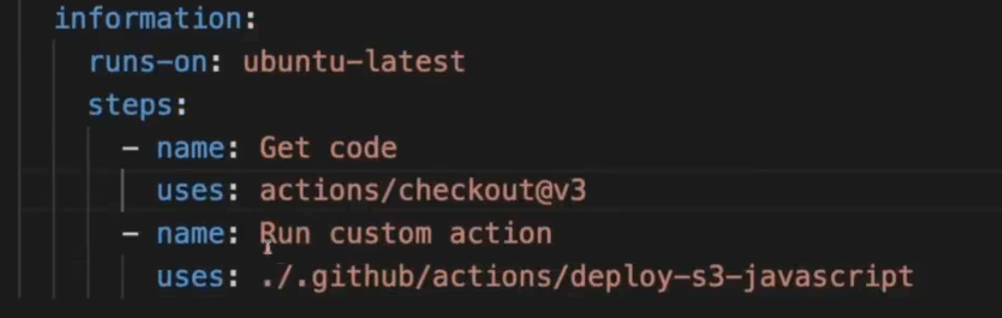

      - name: Deploy site

        id: deploy

        uses: ./.github/actions/deploy-s3-docker

        env:

          AWS_ACCESS_KEY_ID: ${{ secrets.AWS_ACCESS_KEY_ID }}

          AWS_SECRET_ACCESS_KEY: ${{ secrets.AWS_SECRET_ACCESS_KEY }}

        with:

          bucket: gha-security-hosting-demo

          dist-folder: ./dist

          # bucket-region: us-east-2

      - name: Output information

        run: |

          echo "Live URL: ${{ steps.deploy.outputs.website-url }}"

## Creating a Custom Docker Action

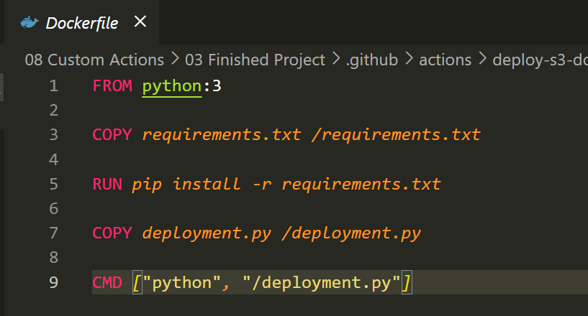

name: 'Deploy to AWS S3'

description: 'Deploy a static website via AWS S3.'

inputs:

  bucket:

    description: 'The S3 bucket name.'

    required: true

  bucket-region:

    description: 'The region of the S3 bucket.'

    required: false

    default: 'us-east-1'

  dist-folder:

    description: 'The folder containing the deployable files.'

    required: true

outputs:

  website-url:

    description: 'The URL of the deployed website.'

runs:

  using: 'docker'

  image: 'Dockerfile'

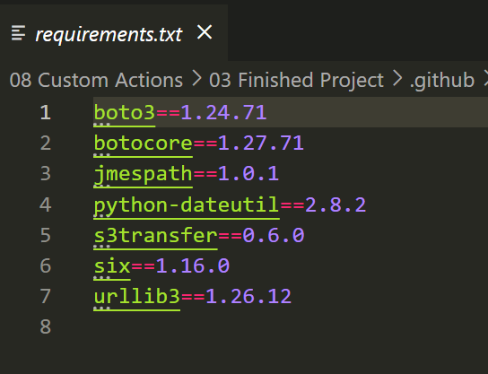

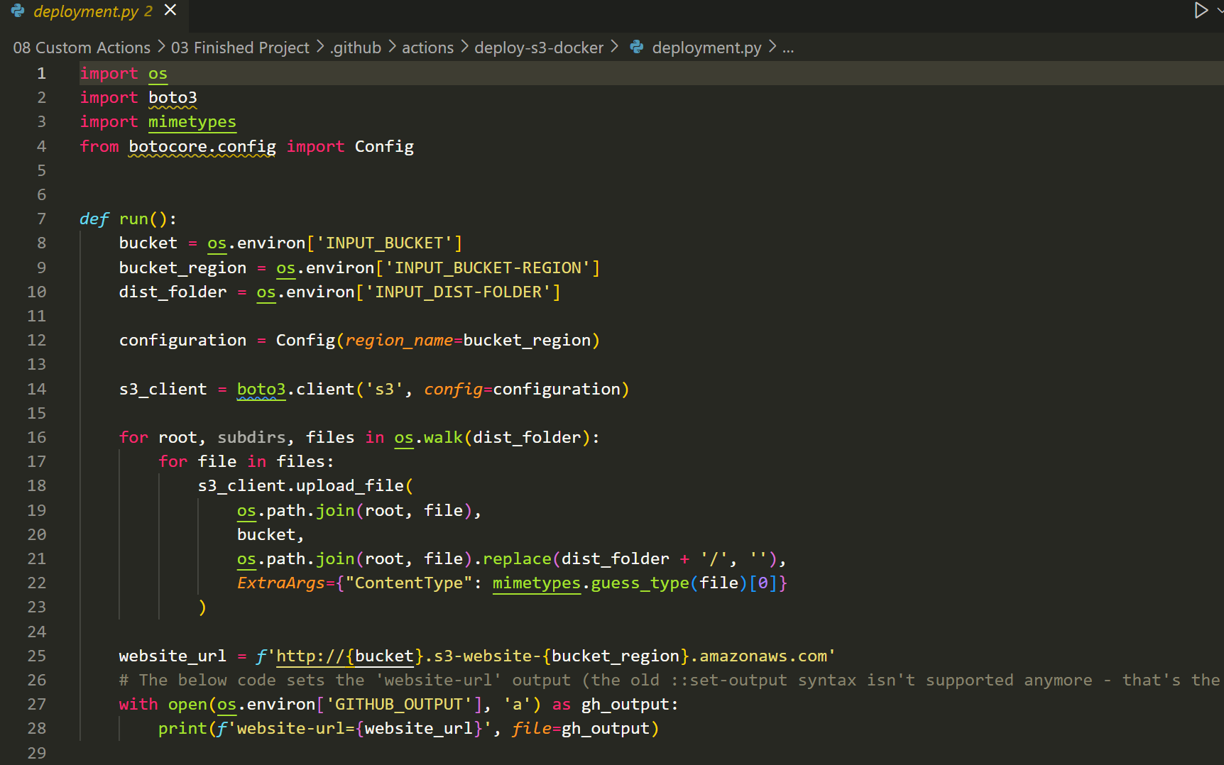

## Module Summary

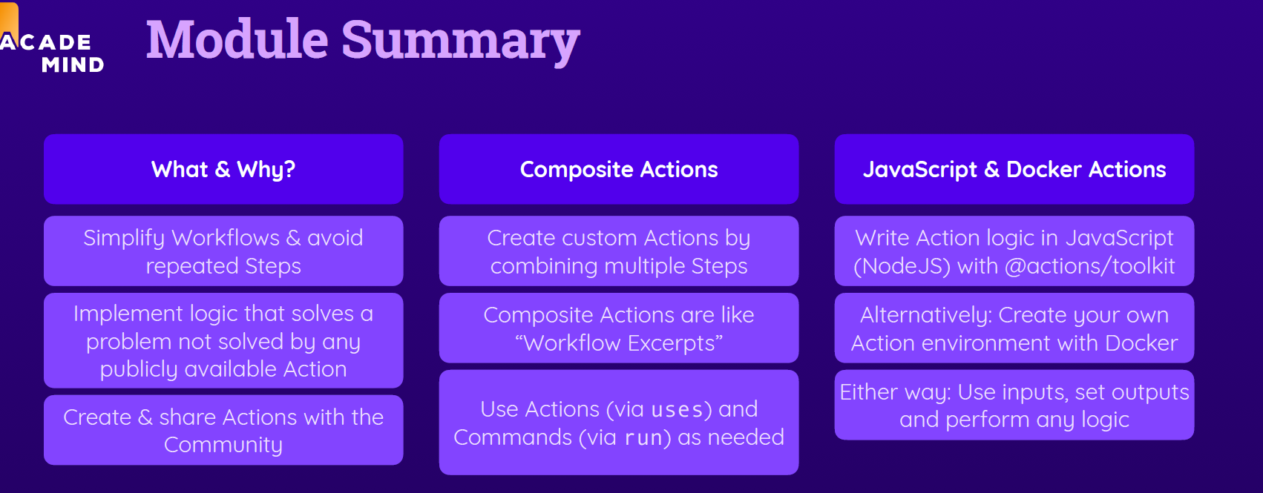

# Permissions & Security



## Key Security Concerns

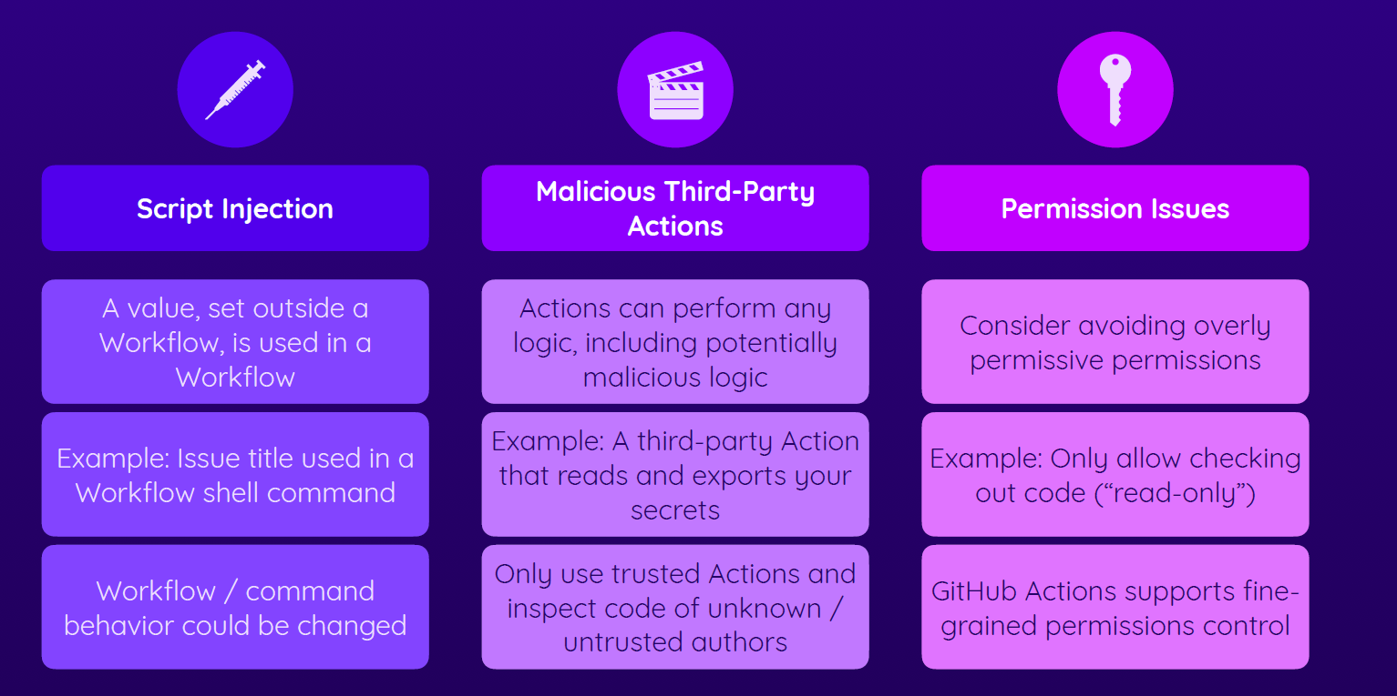

## Undestanding Script Injection Attacks

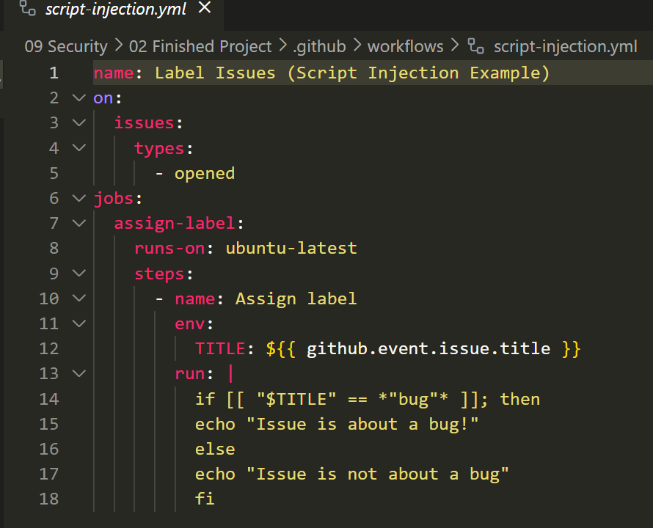

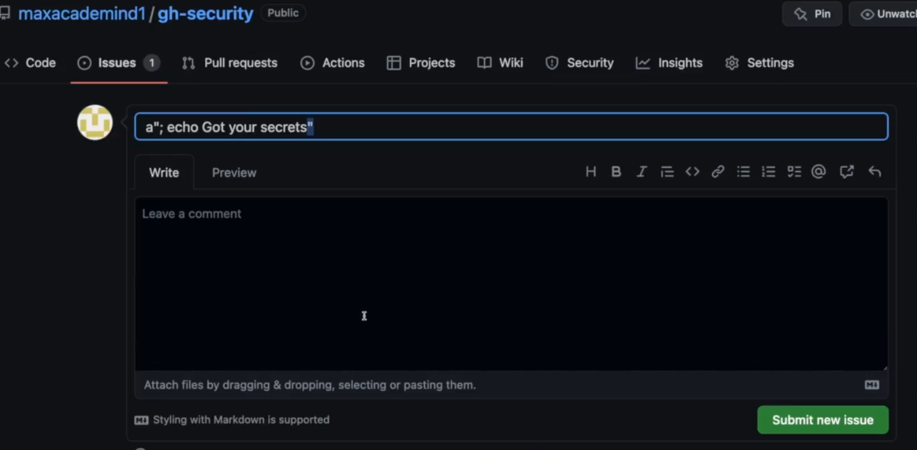

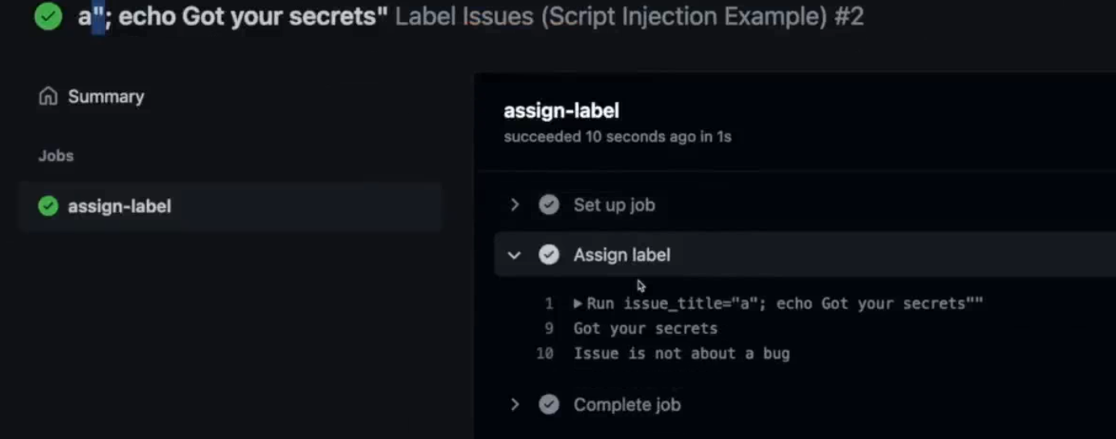

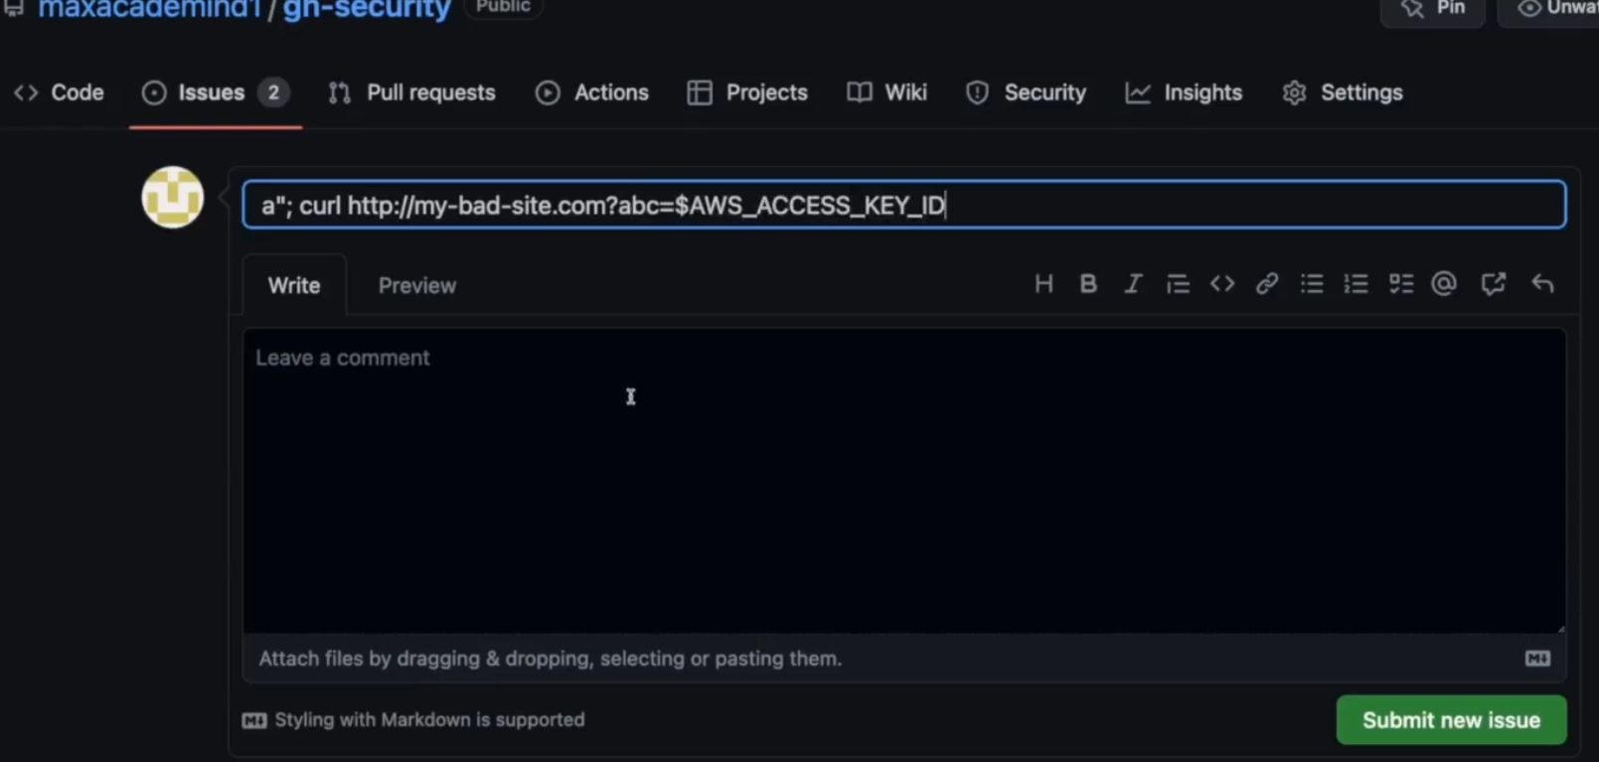

It is better to do:

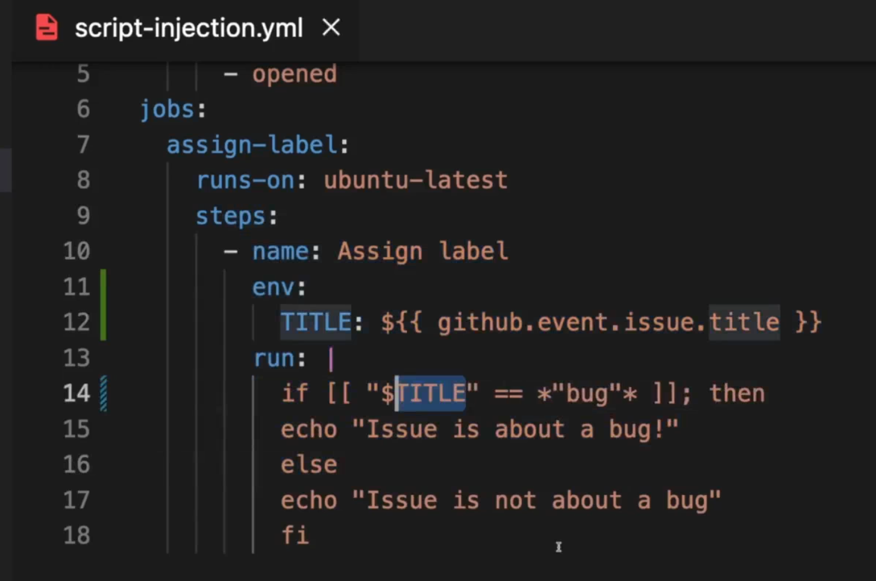

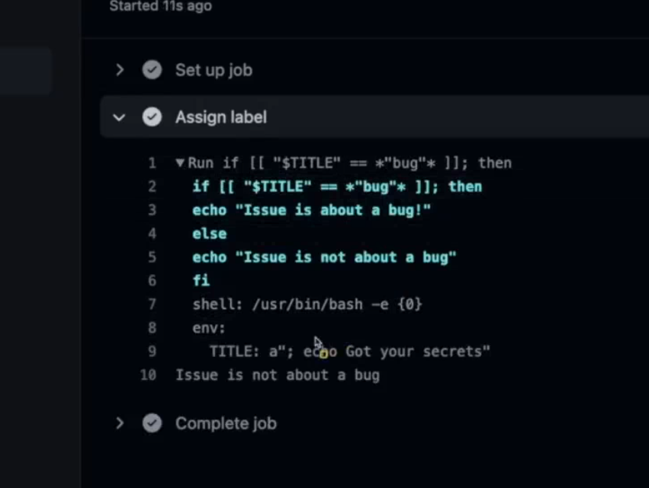

## Increasing Actions Safety

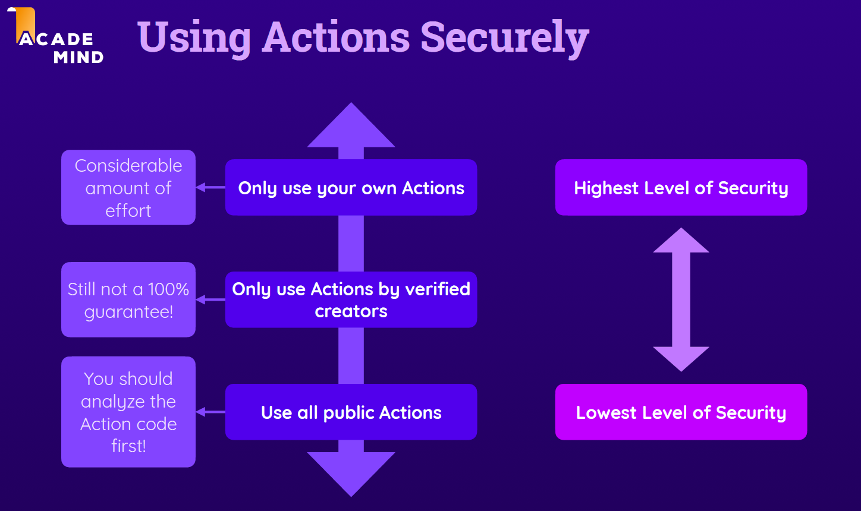

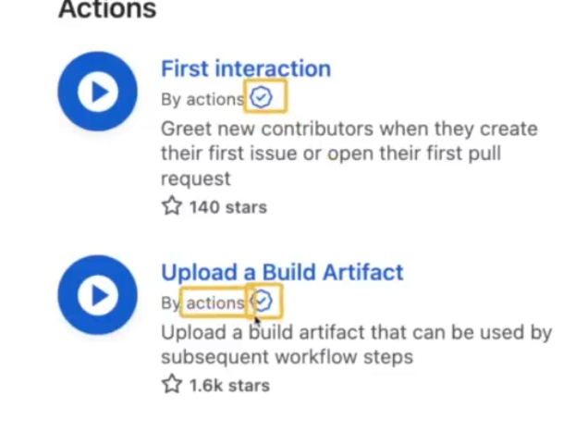

## Understanding Permissions & Potential Issues

name: Label Issues (Permissions Example)

on:

  issues:

    types:

      - opened

jobs:

  assign-label:

    runs-on: ubuntu-latest

    steps:

      - name: Assign label

        if: contains(github.event.issue.title, 'bug')

        run: |

          curl -X POST \

          --url https://api.github.com/repos/${{ github.repository }}/issues/${{ github.event.issue.number }}/labels \

          -H 'authorization: Bearer ${{ secrets.GITHUB_TOKEN }}' \

          -H 'content-type: application/json' \

          -d '{

              "labels": ["bug"]

            }' \

          --fail

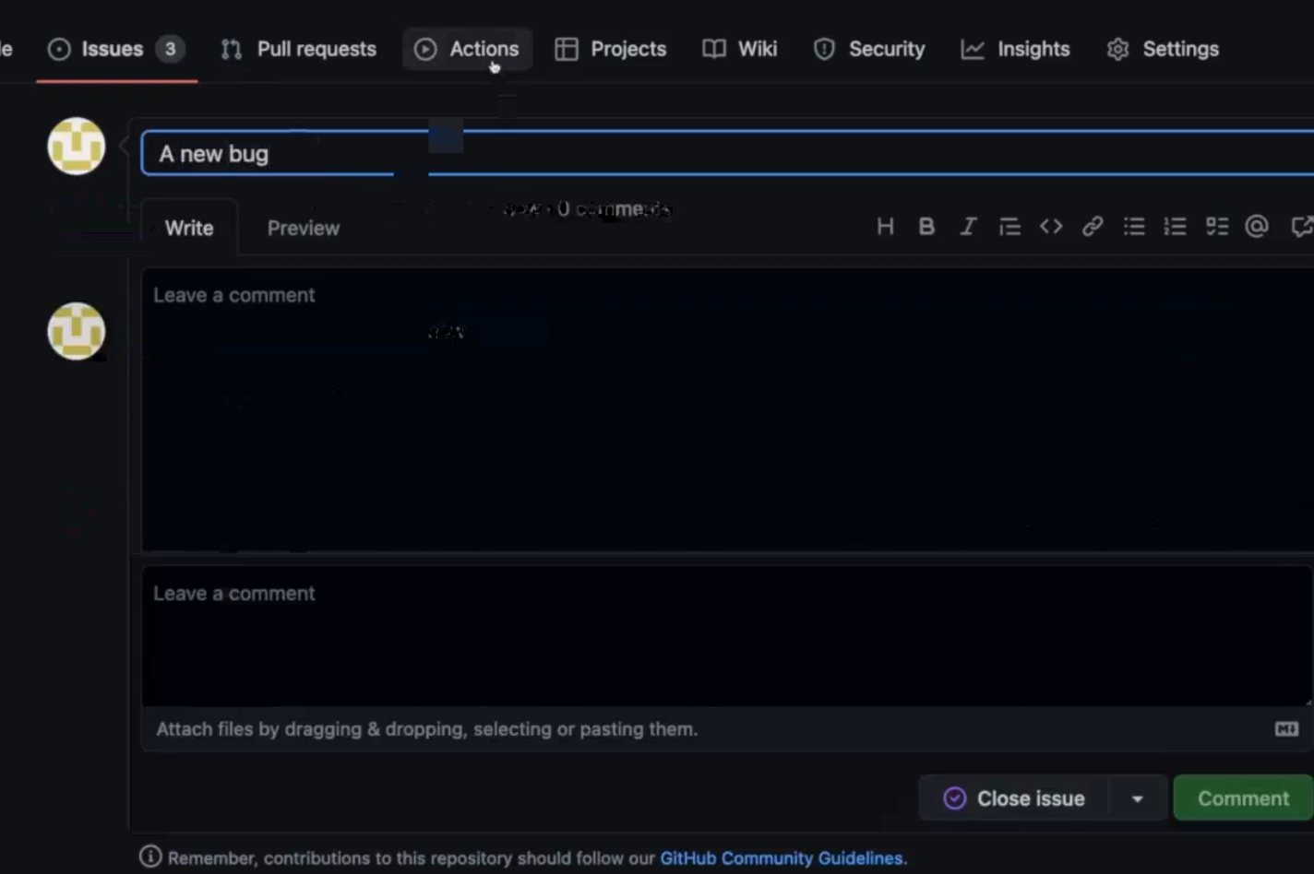

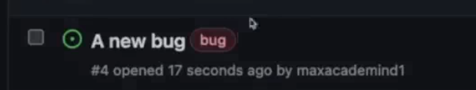

This action needs to interact only with issues and not with pull request or use the code of the repository.

<https://docs.github.com/en/actions/using-jobs/assigning-permissions-to-jobs>

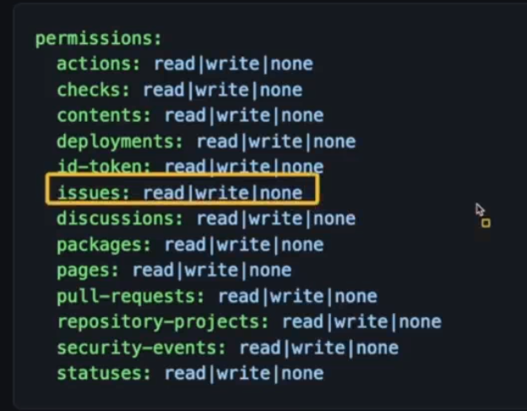

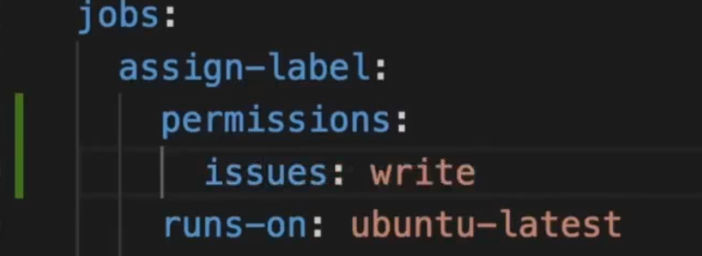

## GITHUB_TOKEN & Managing Permissions

Secretx.github_token is generate automatically by github. Because we need to authenticate the request in the code otherwise every one can change the issue.

The token is valid as long the job is running.

By default most of the actions have read and write permission, but we can change the repo to use more restricted action:

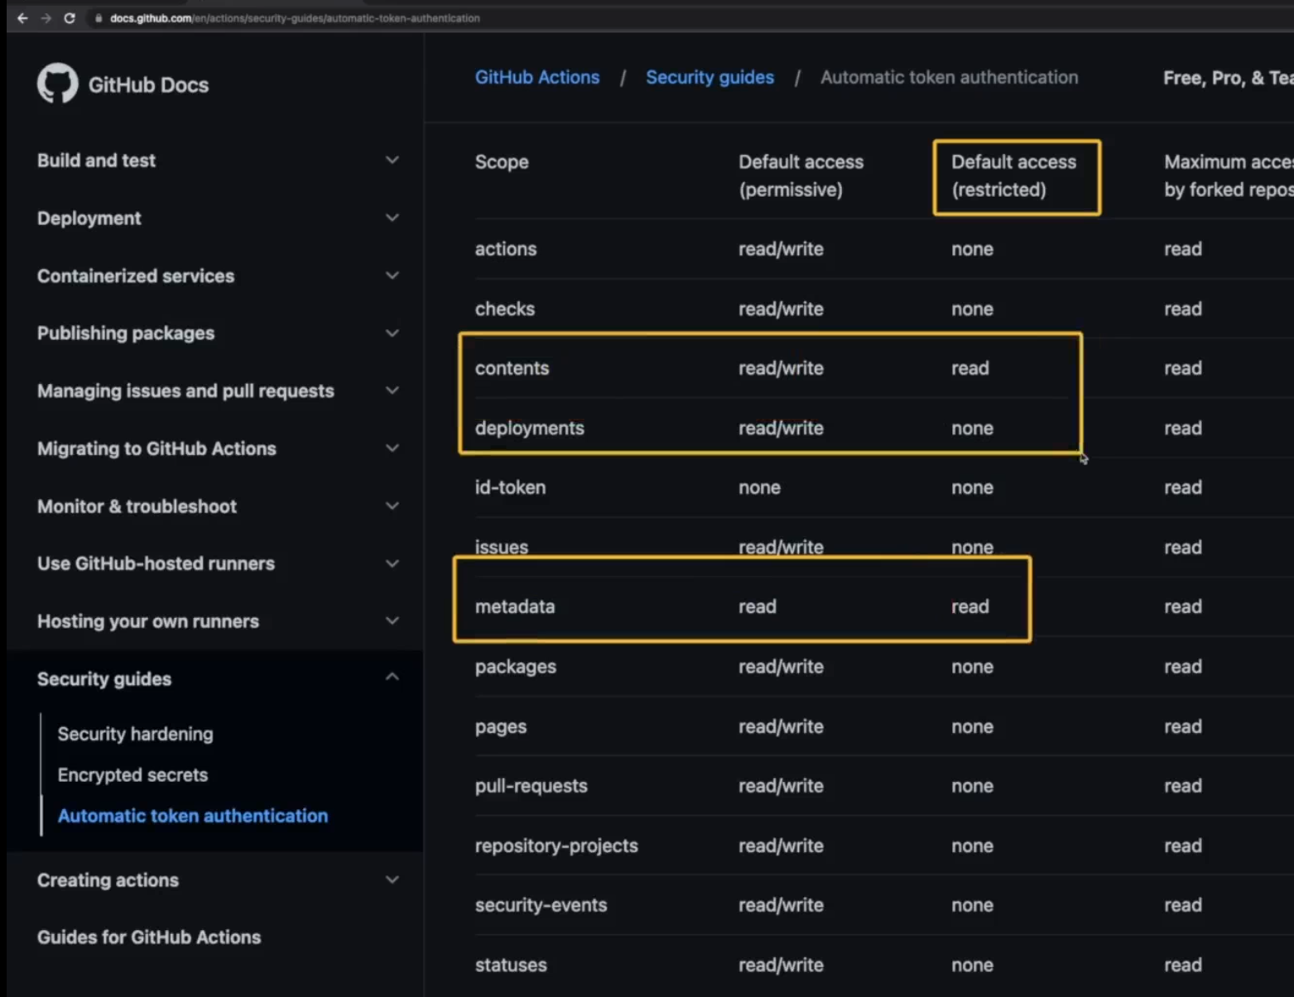

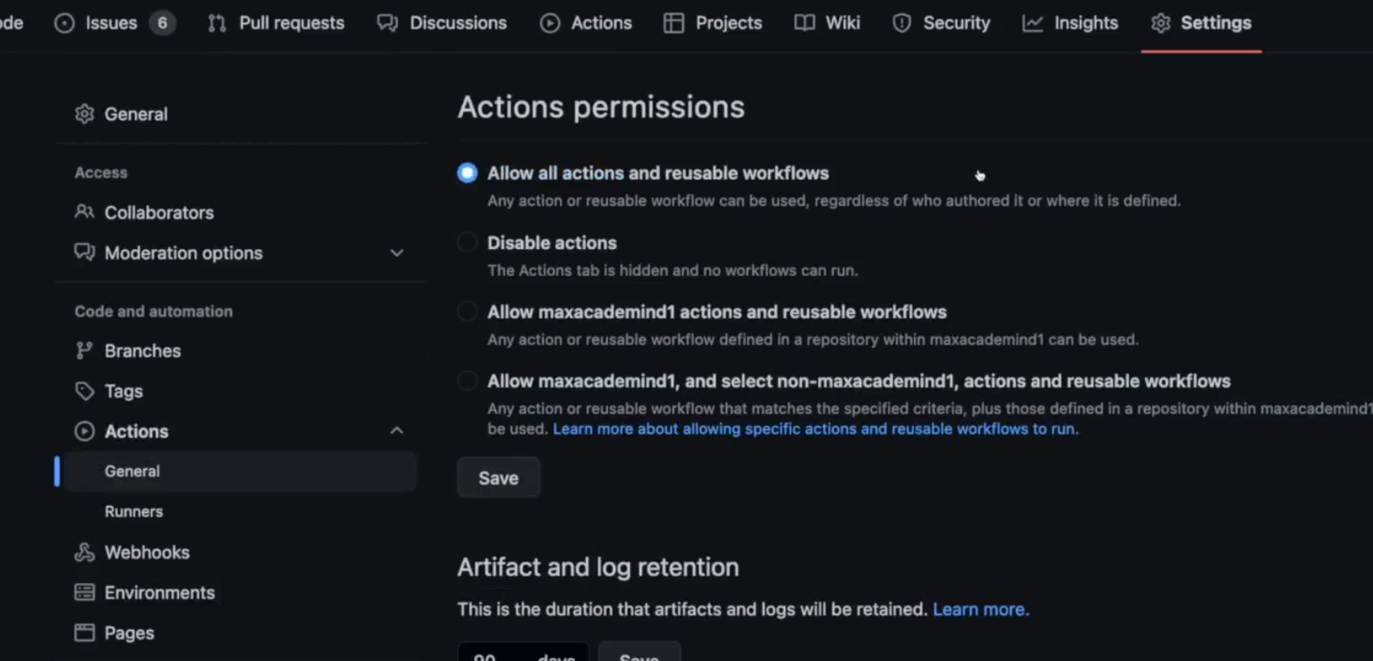

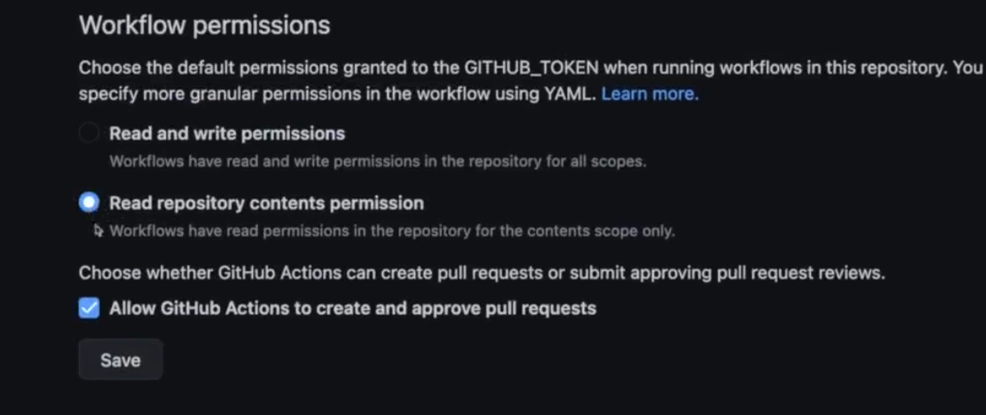

## More Security Settings

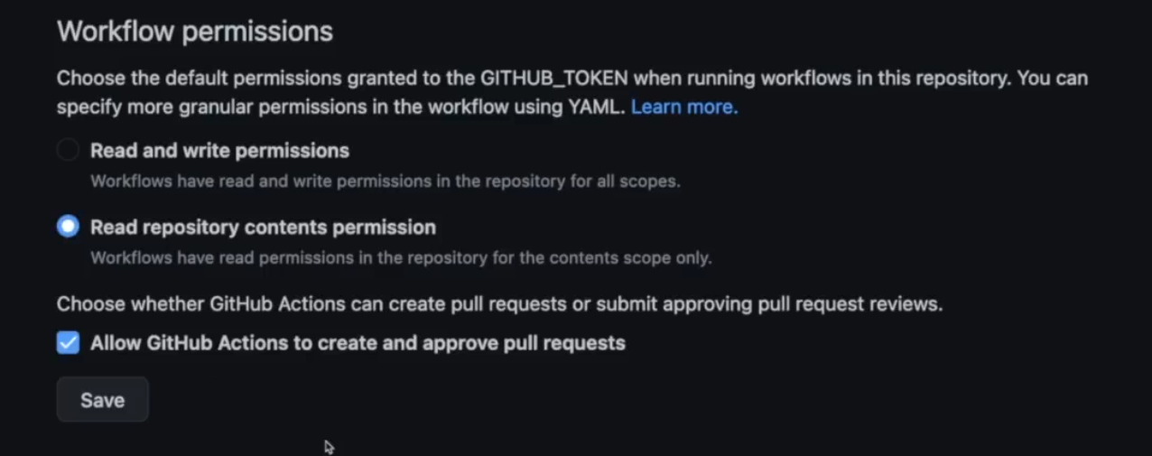

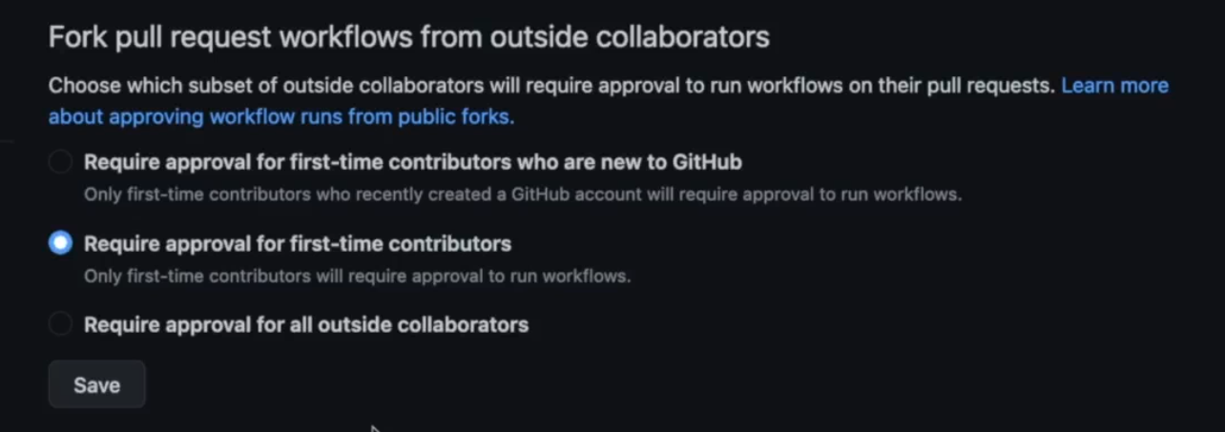

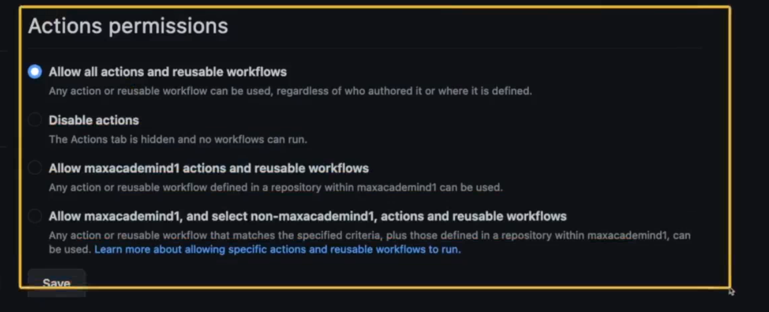

## Working with Third-Party Permissions & OpenID Connect

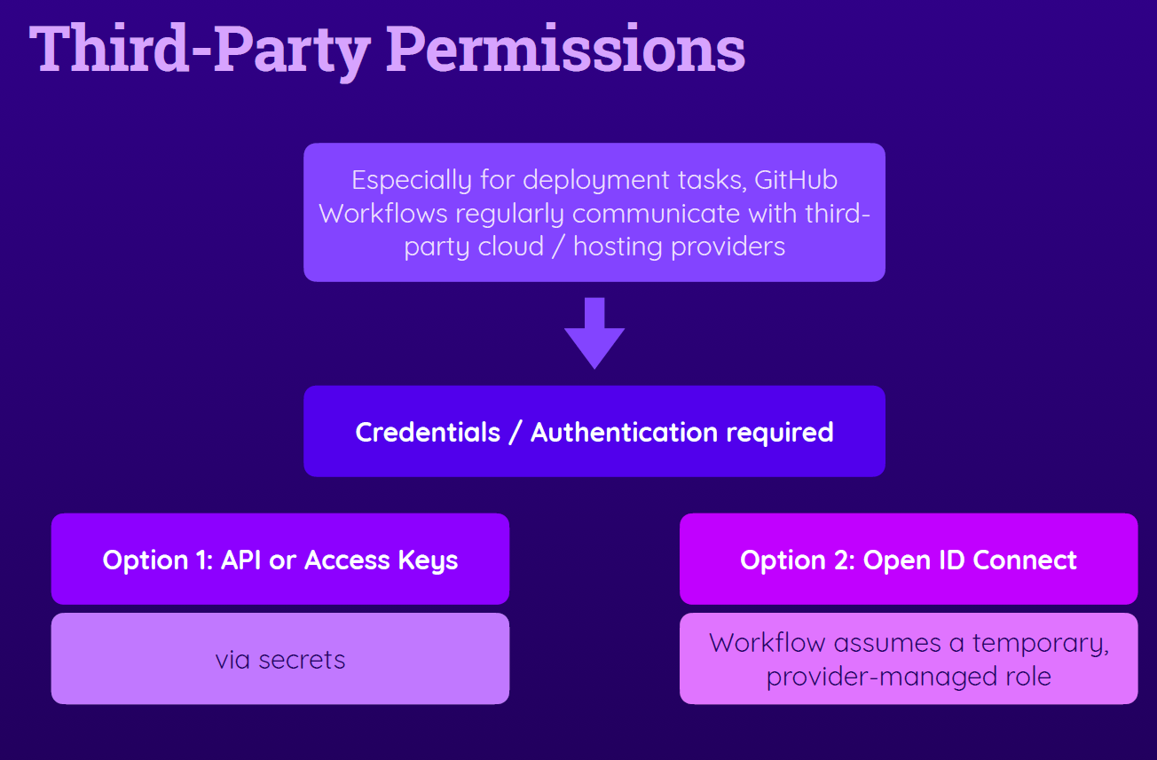

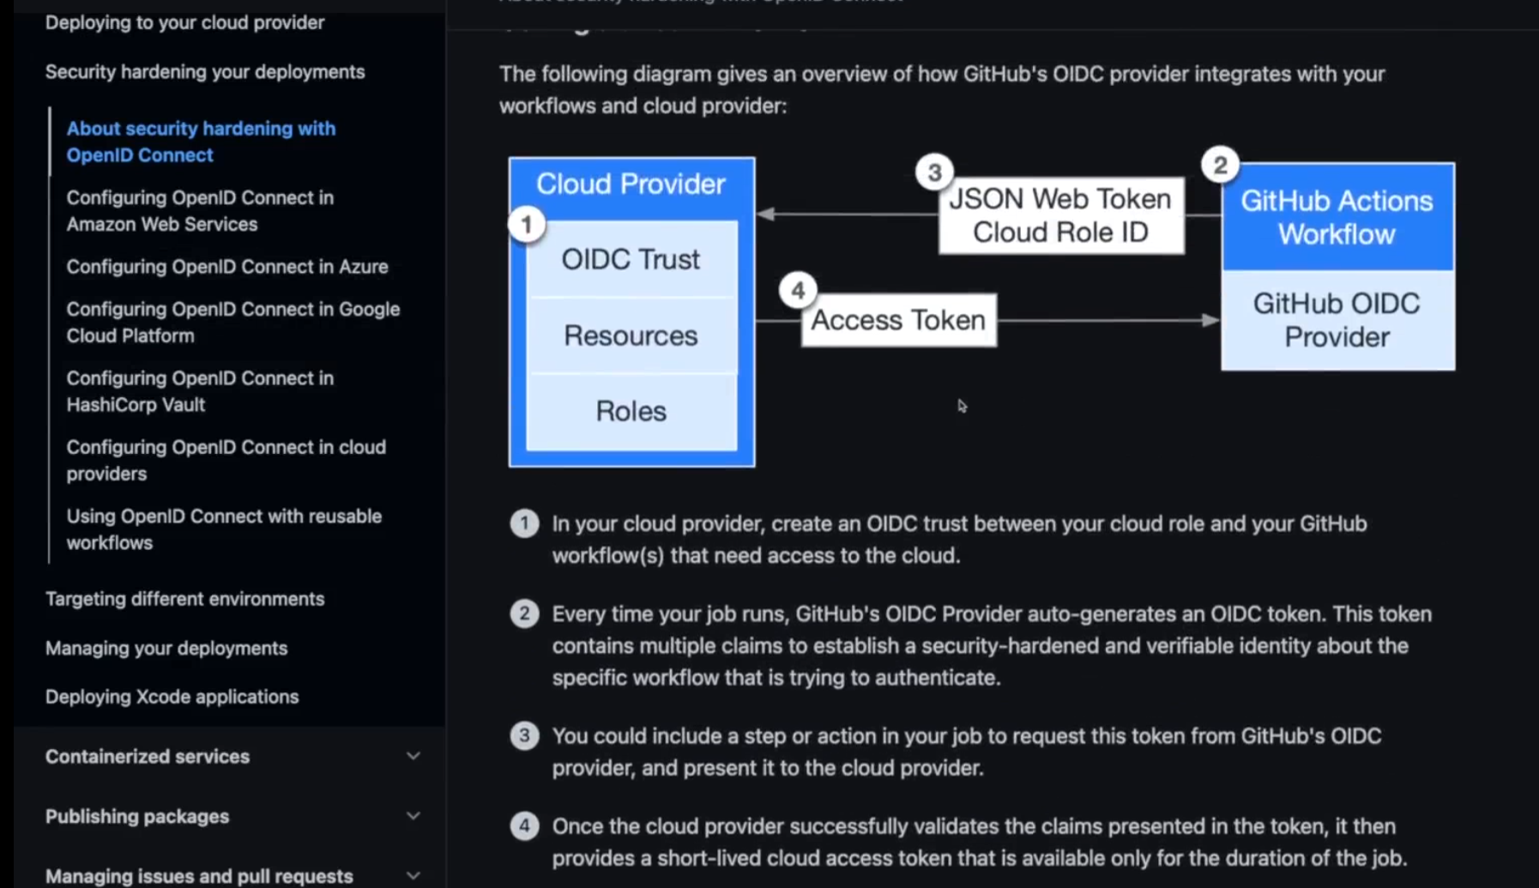

## Example: AWS Permissions

